HubSpot Reporting- Certification

1. Create an account on HubSpot
2. Visit <https://academy.hubspot.com/courses> and find the course HubSpot Reporting

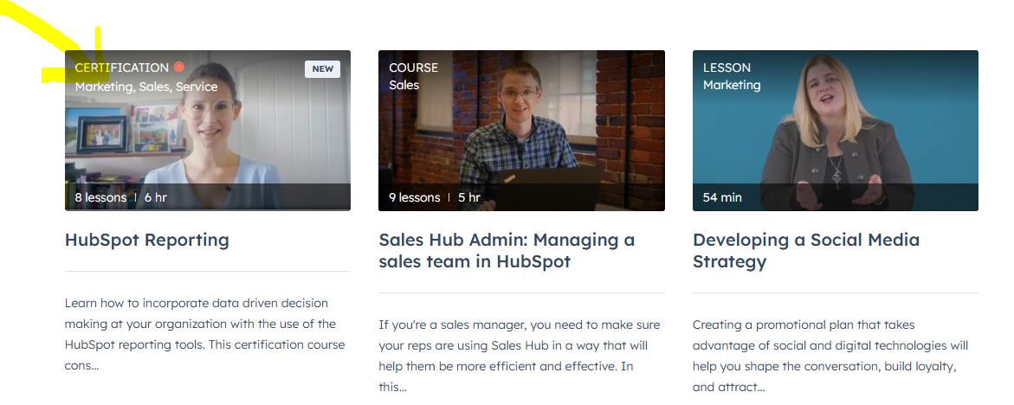

## Create your profile and complete all modules and the final exam to get a certification.

## You are expected to provide a copy of your certificate with your full name (as on your student portal). The certificate should be submitted along with the Word document, which includes the reflection paper documenting your learning process and notes taken during the assignment's completion.

## Your reflection paper should consist of 3-4 pages on your learning experience. The paper should encompass the following: what you have learned, how you would apply it, document your completion of the course along with the challenges you had, what are the major learning points from the course, and how this applies to your overall marketing education.

A CERTIFICATE OF COMPLETION IS MANDATORY; IF IT IS NOT ATTACHED WITH YOUR FULL NAME (AS IN THE PORTAL), YOU WILL RECEIVE 0 POINTS FOR THE ASSIGNMENT.

The assignment value is 10 points.

| **Criteria** | **Meeting expectations** | **Needs Improvement** |
| --- | --- | --- |
| **Identify major theoretical marketing frameworks and software used to aid marketing decision making 5** | Student will be able to identify and understand application of HubSpot tools for marketing decision making. This is shown by completing the certificate program and exam and attaching certificate of course completion. **5** | Certificate is not completed and attached. **0** |
| **Analyze specific marketing phenomena by using specialized marketing software solutions 4** | Student will be able to utilize basic functions of HubSpot software tool too analyse the social media reporting process, Student is expected to document learning experience in the reflection paper documenting their learning experience with HubSpot course (1 PT), outline the major learning points from the course (2 PT) and discuss how these analytics skills can be applied in their overall marketing education (1 PT) **0.5-4** | Reflection paper not included **0** |
| **Formatting 1** | Reflection paper 3 or more pages long (excluding the certificate) (0.5) professional looking formatting. (0.5) **1** | Reflection paper not included |

****