**In the future, all of the world’s most iconic brands will be built on fandom**

***From fitness brand Gymshark to rock-n-roll water company Liquid Death, fan-propelled brands abound. Brand strategy based on fandom is the future for the rest of the world, says Ear to the Ground’s Jack Ward.***

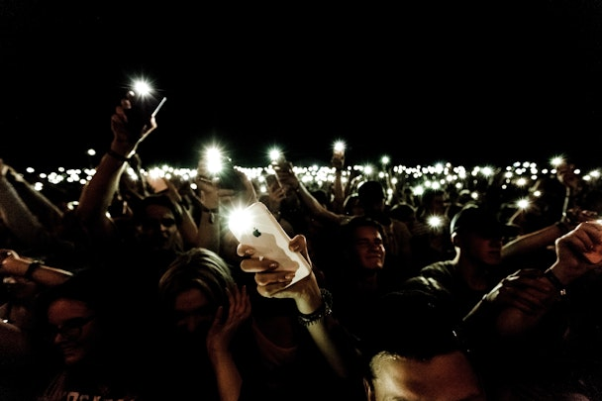

Are fans the fundamental building block of the brands of the future? / Kipras Štreimikis via Unsplash

The most important brands in the world are built on a foundation of true fandom. Okay, that’s probably not a controversial thing to hear from someone at the agency that’s built its reputation on fan intelligence. But we’re pretty certain that the rest of the world is starting to wake up to what we’ve known for a little while.

The future is already here when it comes to the biggest brands using communities of passionate fans to shape their strategy. Whether it’s Gymshark’s army of fitness lovers joining together in cities around the world or Fortnite’s collective of creators shaping new gaming experiences, if you want your brand to be loved, it pays to collaborate with your biggest fans. It’s not just the big guns either; emerging cultural superpowers like streetwear upstarts Corteiz and AI game-changers Midjourney have made fandom a crucial part of their brand masterplans.

Working at Ear to the Ground, I’ve been lucky enough to work on brand strategy projects for organizations that have placed fandom at the core of everything they do. From New Balance Football’s disruptive style of athlete collaboration to PlayStation’s fan-first approach to becoming the most inclusive brand in e-sports and competitive gaming, I’ve seen first-hand how the most innovative companies work with fans to grow their relevance among next-gen audiences.

Advertisement

**Propelled by fans**

What are these fan-driven brands doing differently from everybody else? For a start, they’re moving away from a rigid approach built on tired models, manifestos and design guidelines and towards more open, transparent systems that bring fans into the conversation. These brands collaborate with fans on advertising, create live events where they can meet and create together and reward their loyalty by giving them access to the direction of the business. Rather than create a strict positioning that is dictated to audiences, these brands are creating the conditions for fans to create the narrative with them.

What’s most exciting is how the brands of the future are building communities of fans to collaborate on their strategy. A lot of people in our industry admire the exceptional Liquid Death for its dangerous and hilarious approach to marketing. Yes, there’s a brilliant creative director at the helm of that particular pirate ship, but Liquid Death has also invested in building a die-hard community of fans that is closer in behavior to a metal band’s fandom than that of a canned water company. The brand’s creative work is cutting edge, but without passionate fans to spread the word, there’s a good chance it’d be screaming into the void.

**Fans everywhere**

A cynic might say that this is all well and good for categories that have in-built love and affection. And yes, it’s easier for me to talk about how Manchester City football club or gaming giant Roblox might apply the principles of fandom to their brand strategies than a global financial services firm. But what’s always surprised me is how even just *thinking* of your audience as fans and not “consumers” can make a huge difference to the way your company operates.

Would you rather buyers loved your brand or merely tolerated it? Would your customers honestly care if you went out of business tomorrow? Would they fight for its survival? That’s the difference between brands that are shaped by ‘category fit’ and ones built on true fandom.

This can all feel a bit overwhelming, especially for marketers facing shrinking budgets and ever-increasing complexity. But it’s crucial to start placing fandom at the heart of your brand strategy now, or risk fading into obscurity.

My advice? Start with the baby steps; find out who your brand’s fans are (it’s easier than you think) and figure out a way to bring them into the conversation.

1. **How do global brands navigate the challenges of fostering a genuine sense of community and fandom across diverse cultural landscapes without compromising their core brand identity?**
2. **In the era of digital globalization, how can brands leverage technology to build and sustain communal branding and fandom in ways that transcend geographical boundaries, yet remain culturally sensitive and relevant?**