**Siblings Prada and Miu Miu are world's top brands in Q4 - Lyst Index**

[Prada](https://ww.fashionnetwork.com/tags-prada) really is on a roll with the latest [Lyst](https://ww.fashionnetwork.com/tags-lyst) Index that was released on Wednesday showing that it's once again the hottest brand in the world.

[SEE CATWALK](https://ww.fashionnetwork.com/galeries/photos/Prada,44313.html)

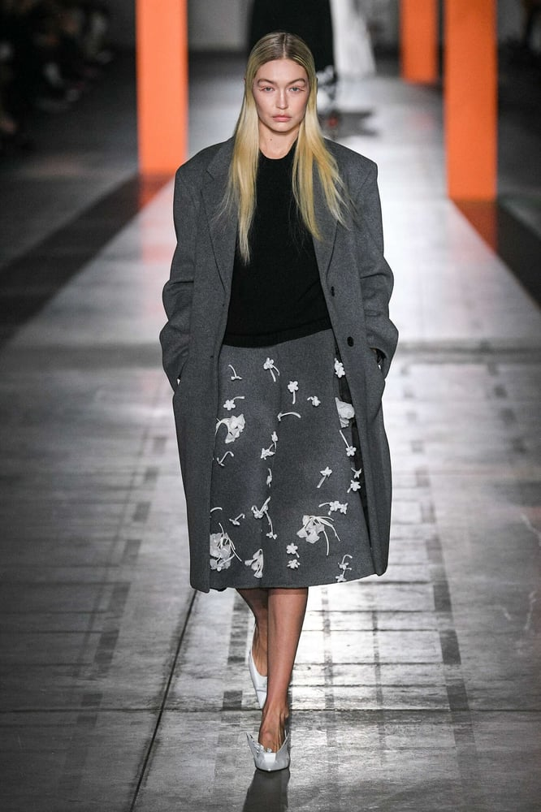*Prada - Fall-Winter2023 - 2024 - Womenswear - Milan - © ImaxTree*  
Despite its woes of the pandemic period, the brand has clearly been bouncing back. It’s topped the Lyst Index three times now since Q4 2022 and in the latest three months it saw searches up 41% year on year worldwide.   
  
With sister brand [Miu Miu](https://ww.fashionnetwork.com/tags-miu-miu) in second place, the Italian luxury business seems to be able to do no wrong for now.

Other strong names in the top 20 this time included [Moncler](https://ww.fashionnetwork.com/tags-moncler), which was up two positions to number five, as well as [Balenciaga](https://ww.fashionnetwork.com/tags-balenciaga), also rising two spots to number 12. [Burberry](https://ww.fashionnetwork.com/tags-burberry) was up one spot at number nine, as was Jacquemus, which has seen a fairly rapid rise to prominence in recent years and regularly features in the top items list. This time it hit eighth place.

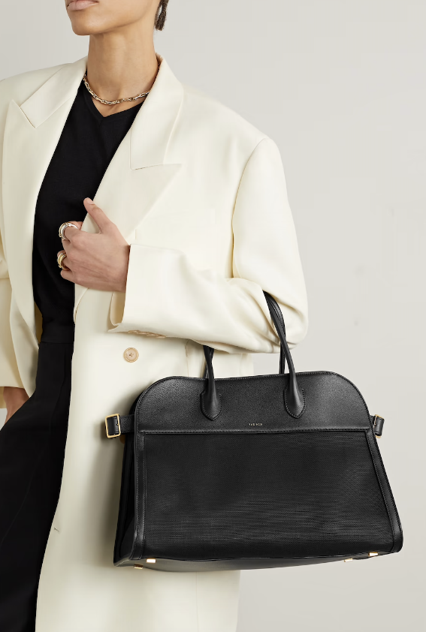Other notable moves included [The Row](https://ww.fashionnetwork.com/tags-the-row) making its debut in the top 20, with searches increasing 93% this quarter. It may not be a coincidence that last year was the era of ‘quiet luxury’, a trend that this label lives and breathes. “With a limited social media presence and a relatively unchanged brand DNA, the label has quietly built a cult following since its 2006 launch, winning six CFDA awards over nearly two decades,” Lyst said.

UGG re-entered the Index in 17th position, with the UGG Tasman slippers entering the hottest products list in sixth position this quarter. The brand was last in the Top 20 in Q4 2022.

Balenciaga, as mentioned, jumped two places “after a busy quarter of new celebrity endorsements and months of image rebuilding”. The rebuilding was very much required after a badly thought out ad campaign saw it garnering lots of negative headlines and dropping off the radar for a number of luxury shoppers. Its pre-fall 2024 show “served as a soft launch for a powerful collection”. And its Erewhon collab capsule collection, which included a hoodie, T-shirt and tote bag “quickly sold out and drove over 10.1 billion views on TikTok and searches increased 7% on Lyst”.

*The Row Margaux bag - Photo: Net-A-Porter*

Meanwhile, Skims was among the fastest risers this quarter, climbing three spots into 14th place. Lyst said the brand “continues to drive momentum after partnering with Swarovski with an exclusive collection made up of body-contouring jewellery and crystal-encrusted shapewear, and being named the official underwear partner for the NBA; the men’s boxer is currently ranked 10th in the hottest products category”.

Overall the top 10 comprised Prada, Miu Miu, [Loewe](https://ww.fashionnetwork.com/tags-loewe), [Bottega Veneta](https://ww.fashionnetwork.com/tags-bottega-veneta), Moncler, [Saint Laurent](https://ww.fashionnetwork.com/tags-saint-laurent), [Versace](https://ww.fashionnetwork.com/tags-versace), Jacquemus, Burberry and [Valentino](https://ww.fashionnetwork.com/tags-valentino). And the rest of the top 20 included [Gucci](https://ww.fashionnetwork.com/tags-gucci) in 11th place then Balenciaga, [Diesel](https://ww.fashionnetwork.com/tags-diesel), Skims, [Dior](https://ww.fashionnetwork.com/tags-dior), [Louis Vuitton](https://ww.fashionnetwork.com/tags-louis-vuitton), UGG, The Row, JW Anderson, and [Fendi](https://ww.fashionnetwork.com/tags-fendi). The quarter’s three ‘Breakout Brands’ (those “rising fast on a powerful and rapid upwards trajectory”) included [Victoria Beckham](https://ww.fashionnetwork.com/tags-victoria-beckham). The business may not yet be profitable but there's no denying that it punches above its weight in terms of the interest it attracts compared to its overall sales.

Following the launch of the Beckham documentary on Netflix, searches for the label spiked 68% on Lyst in October, driven by demand for the viral ‘My Dad Had a [Rolls-Royce](https://ww.fashionnetwork.com/tags-rolls-royce)’ T-shirt. Overall, searches were up 34% this quarter.

It may seem odd that an established name like [Ralph Lauren](https://ww.fashionnetwork.com/tags-ralph-lauren) can be described as a breakout. But Ralph Lauren presented its first Artist in Residence collaboration and that had a big impact. “Embraced for their understated quiet luxury and preppy style, the Slim fit polo T-shirt and Chino baseball cap stand out as hero products this quarter,” Lyst explained, with searches for the brand up 22%.

**Product power**

Meanwhile, a much younger label — running specialist On — was also on the breakout list with searches up a massive 592% and the On x Loewe sneaker emerging as its top trending product.

As for Q4’s other hottest products, The Row’s Margaux bag was number one, “having already been heralded by some as ‘the new Birkin’. Worn by the likes of [Kendall Jenner](https://ww.fashionnetwork.com/tags-kendall-jenner), [Zoë Kravitz](https://ww.fashionnetwork.com/tags-zoe-kravitz) and Jennifer Lawrence, searches for the hard-to-find tote bag spiked 63% this quarter and are up 198% year-on-year,” we’re told.

Victoria Beckham’s [Frame](https://ww.fashionnetwork.com/tags-frame) buckle belt was Q4’s second hottest product, riding the wave of the designer belt category benefitting from a 28% rise in demand, “as belts re-emerge as a hot category, an accessible fix for customers looking to buy into luxury brands on a budget”. 

[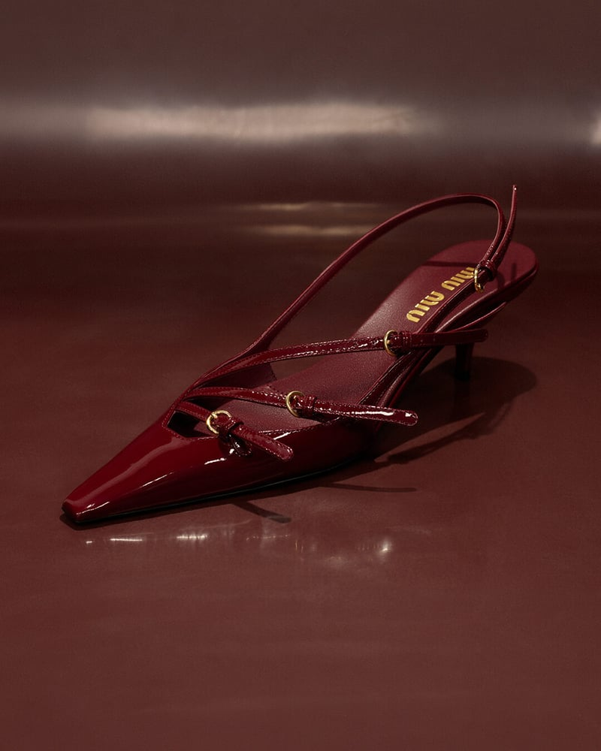](https://media.fashionnetwork.com/m/0441/912b/c05e/92be/c041/4bd2/3b0a/ddad/56a7/4aa3/4aa3.jpg)Miu Miu’s kitten heels were third “and have played into the season’s trend for cherry red, causing a halo effect on the shoe category”. Searches spiked 49% in November.

Away from the full-on luxury sector, [Adidas](https://ww.fashionnetwork.com/tags-adidas) Originals’ Country OG sneakers were fourth and surprisingly, were the only sneakers in the hottest product category this quarter. The growing popularity of metallic silver accessories led to a 14% increase in searches for the ‘70s running shoe.

Prada’s logo sneakers in fifth place helped drive the label into its top spot and the popularity of UGG’s Tasman slippers at number six has already been mentioned.

Meanwhile [COS](https://ww.fashionnetwork.com/tags-cos)’s Wool coat was in seventh place. “Hailed as the ‘Saint Laurent dupe’ on TikTok due to its comparable tailored silhouette, the high street product quickly became a viral sensation and sold out,” Lyst said.

A Ralph Lauren cap was eighth and the Arc'teryx Atom hoody jacket was ninth, “highlighting the blurring lines between style and functionality. A lasting impact from Covid-19, there has been increased interest in nature and outdoor activities, reflected in the continued rise of outdoor sportswear brands”.

**Question Related to CLO 1:**

Analyze how Prada's consistent top ranking in the Lyst Index, despite challenges during the pandemic, reflects on its brand equity. Discuss how the brand's history, marketing strategies, and product offerings contribute to distinguishing Prada from its products, emphasizing the intangible assets that constitute its brand equity. Provide examples from the article to support your analysis."

**Question Related to CLO 2:**

Considering the rapid ascent of Miu Miu to the second position in the Lyst Index and the significant search increase for The Row, evaluate the brand positioning strategies these brands might have employed. Describe the components that contribute to effective brand positioning and how these brands have aligned their marketing, product design, and consumer engagement to develop a strong brand positioning. Use specific examples from the article to illustrate your points.