|  |  |  |  |
| --- | --- | --- | --- |
| **College of Computer Information Technology** | | | |
| **Academic Year** | 2022 -2023 | | |
| **Semester** | ☐Fall | **☒ Spring** | ☐ Summer |
| **Course Code – Name** | CIT 201 – Introduction to Programming | | |
| **Instructor** | Dr. Mohammad Alnasar | | |
|  | ☐ Midterm ☐ Final **☒** **Lab Assignment** ☐ Project | | |
| **Due Date** | **February 19, 2023** | | |

CLOs:

1. Illustrate problem specifications using flowcharts and Pseudocode.
2. Explain the basic principles of algorithms and programming language.
3. Write snippets using variables, different data types, inputs and outputs.
4. Analyze the outputs of code snippets.
5. Apply modularity, repetition, and decisions to design functioning program individually or within a team.

**Student ID:**

**Student Name:**

|  |  |  |  |
| --- | --- | --- | --- |
| **Questions** | **CLO** | **Max Score** | **Student Score** |
| 1-5 | 1+2 | 5 |  |
|  | 3+4 | 7 |  |
|  | 5 | 3 |  |
|  |  |  |  |
|  |  |  |  |
|  | **Total** | **15** |  |

**Assessment: Lab Assignment**

**Submission Instructions:**

Please follow the below rules when submitting your file:

1) The name of the file should with your name and ID

2) In case two assignments are found to be similar, both students will get ZERO.

**Objectives:**

▪ Using flowcharts and Pseudocode.

▪ Writing algorithms.

▪ Using the basic practice on arithmetic operations.

▪ Using the basic practice on selection control.

▪ Using the basic practice on writing simple Python programs.

**Marking scheme**:

|  |  |  |
| --- | --- | --- |
| **Assessment Item** | **Max. Mark** | **Student Mark** |
| Using flowcharts, Pseudocode, and algorithms | 5 |  |
| Code correctness + modularity, etc | 5 |  |
| Run-time errors/Wrong output | 1.5 |  |
| Naming of identifiers | 1.5 |  |
| Indentation | 1 |  |
| Output format | 1 |  |
| **Total** | **15** |  |

**Integrity Statement: Read carefully!**

**Strict directives have been given to me to follow the University’s policy on cheating. Any student caught cheating in any form will be given zero (0) the first time. (We will not get into the issue of who copied from whom!!!). If such act reoccurs, the case will be sent to the University Student Discipline Committee.**

1. Basics Concepts:

**Problem 1: Reverse of a 4-digit number and sum**

**Draw flowcharts, Pseudocode, algorithms and then write a program that asks the user to input an integer number of 4 digits and display the number as well as its reverse and their sum.**

**Sample run (User input in bold):**

**Problem 2: Bookstore Bill**

**Draw flowcharts, Pseudocode, algorithms and then write a program to calculate the 5% tax on a bookstore bill when purchasing books. Your program should prompt the user to enter a book cost. Also, your program should calculate the additional DVD cost, which is 10 percent of the total after adding the tax. Your program should output, the book cost, the tax amount, the DVD amount, and the total bill.**

**Input/ Output Sample:**

1. Selection:

**Problem 3: Characters' Recognition**

**Draw flowcharts, Pseudocode, algorithms and then write a program that prompts the user to enter a letter then the program checks whether the letter is an upper letter, lower letter, digit or others.**

**Input/ Output Sample:  
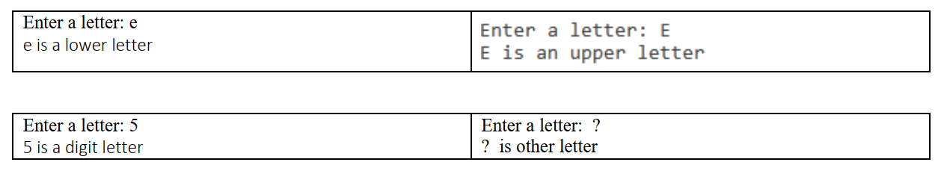**

**Problem 4: Sorting 3 integers**

**Draw flowcharts, Pseudocode, algorithms and then Write a program that prompts the user to enter 3 integers. The program works under the assumption that no number is repeated:**

a. Print the numbers in ascending order, i.e. from smallest to largest.

b. Print the numbers in descending order, i.e. from largest to smallest.

c. Print the sum of smallest and largest numbers.

**Input/ Output Sample:**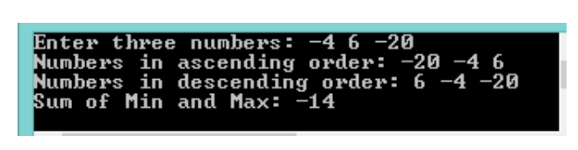

**Problem 5: A leap year**

**Leap years are years where an extra day is added to the end of the shortest month, February. This so-called intercalary day, February 29, is commonly referred to as leap day. Leap years have 366 days instead of the usual 365 days and occur almost every four years.**

**Leap Year Rules:**

* **The year must be evenly divisible by 4;**
* **If the year can also be evenly divided by 100, it is not a leap year;**

**unless...**

* **The year is also evenly divisible by 400. Then it is a leap year.**

According to these rules, the years [2000](https://www.timeanddate.com/calendar/?year=2000) and [2400](https://www.timeanddate.com/calendar/?year=2400) are leap years,  
while [1800](https://www.timeanddate.com/calendar/?year=1800), [1900](https://www.timeanddate.com/calendar/?year=1900), [2100](https://www.timeanddate.com/calendar/?year=2100), [2200](https://www.timeanddate.com/calendar/?year=2200), [2300](https://www.timeanddate.com/calendar/?year=2300), and [2500](https://www.timeanddate.com/calendar/?year=2500) are not leap years.

**Draw flowcharts, Pseudocode, algorithms and then write a program that asks the user to input a year and checks if it’s a leap year or not.**

**Input/ Output Sample:  
