

Assessment

**Task 2**

**Lead team effectiveness**

**BSBLDR414**



**Student Declaration**

To be filled out and submitted with assessment responses

◻ I declare that this task and any attached document related to the task is all my own work and I have not cheated or plagiarised the work or colluded with any other student(s)

◻ I understand that if I am found to have plagiarised, cheated or colluded, action will be taken against me according to the process explained to me

◻ I have correctly referenced all resources and reference texts throughout these assessment tasks.

◻ I have read and understood the assessment requirements for this unit

◻ I understand the rights to re-assessment

◻ I understand the right to appeal the decisions made in the assessment

|  |  |  |
| --- | --- | --- |
| **Unit Title**  **Unit Code** | | |
| **Student name** |  | |
| **Student ID number** |  | |
| **Student signature** |  | **Date** |
| **Task Number** |  |  |

|  |
| --- |
| **------OFFICE USE ONLY-----**  For Trainer and Assessor to complete:  ◻ Student requested reasonable adjustment for the assessment |

| **Completed successfully**  **Did the student satisfactorily:** | **Comments** | **Y** | **N** | **DNS** |
| --- | --- | --- | --- | --- |
| The student has satisfactorily completed and submitted the following:   * Team Charter in Task 2.1A * Project overview in Task 2.1B * Meeting minutes in Task 2.1C * Summary of feedback session with team member in Task 2.2A1 * Feedback from meeting with a team member in Task 2.2A2 * Reflection on meeting with a team member in Task 2.2A3 * Meeting minutes in Task 2.2B * Email to project sponsor in Task 2.2C * Description of team building activity in Task 2.2D1 * Evidence of team building activity in Task 2.2D2 * Reflection on team building activity in Task 2.2D3 * List of ideas chosen by the team in the brainstorming session in Task 2.2E1 * Implementation plan for ideas chosen by the team in the brainstorming session in Task 2.1E2 * Evidence of brainstorming session in Task 2.2E3 * Meeting minutes in Task 2.2F * Evidence of completion of the project deliverables in Task 2.3 * Final survey results in Task 2.4 * Final reflection in Task 2.5 |  |  |  |  |
| Demonstrated ability to:   * Lead team to identify and establish team objectives and work processes * Support team to document identified objectives and work processes according to organisational processes * Encourage team members to incorporate innovation and productivity measures in work plans   This is evidenced by:   * Team Charter in Task 2.1A * Project overview in Task 2.1B * Meeting minutes in Task 2.1C * Final survey results in Task 2.4 * Feedback from trainer and assessor (refer to Marking Sheet) |  |  |  |  |
| Demonstrated ability to:   * Lead and support team members to meet expected outcomes   This is evidenced by:   * Team Charter in Task 2.1A * Project overview in Task 2.1B * Meeting minutes in Task 2.1C * Summary of feedback session with team member in Task 2.2A1 * Feedback from meeting with a team member in Task 2.2A2 * Reflection on meeting with a team member in Task 2.2A3 * Description of team building activity in Task 2.2D1 * Evidence of team building activity in Task 2.2D2 * Reflection on team building activity in Task 2.2D3 * List of ideas chosen by the team in the brainstorming session in Task 2.2E1 * Implementation plan for ideas chosen by the team in the brainstorming session in Task 2.1E2 * Evidence of brainstorming session in Task 2.2E3 * Final survey results in Task 2.4 * Final reflection in Task 2.5 * Feedback from trainer and assessor (refer to Marking Sheet) |  |  |  |  |
| Demonstrated ability to:   * Provide opportunities for input of team members into planning, decision making and operational aspects of work team   This is evidenced by:   * Team Charter in Task 2.1A * Project overview in Task 2.1B * Meeting minutes in Task 2.1C * Meeting minutes in Task 2.2B * Meeting minutes in Task 2.2F * Final survey results in Task 2.4 * Feedback from trainer and assessor (refer to Marking Sheet) |  |  |  |  |
| Demonstrated ability to:   * Support team members to take responsibility for own work and to assist each other in undertaking required roles and responsibilities * Encourage team members to participate in and take responsibility for team activities and communication processes   This is evidenced by:   * Team Charter in Task 2.1A * Project overview in Task 2.1B * Summary of feedback session with team member in Task 2.2A1 * Feedback from meeting with a team member in Task 2.2A2 * Reflection on meeting with a team member in Task 2.2A3 * Description of team building activity in Task 2.2D1 * Evidence of team building activity in Task 2.2D2 * Reflection on team building activity in Task 2.2D3 * List of ideas chosen by the team in the brainstorming session in Task 2.2E1 * Implementation plan for ideas chosen by the team in the brainstorming session in Task 2.1E2 * Evidence of brainstorming session in Task 2.2E3 * Final survey results in Task 2.4 * Final reflection in Task 2.5 * Feedback from trainer and assessor (refer to Marking Sheet) |  |  |  |  |
| Demonstrated ability to:   * Provide feedback to team members on their efforts and contributions   This is evidenced by:   * Summary of feedback session with team member in Task 2.2A1 * Feedback from meeting with a team member in Task 2.2A2 * Reflection on meeting with a team member in Task 2.2A3 * Final survey results in Task 2.4 |  |  |  |  |
| Demonstrated ability to:   * Address or refer issues, concerns and problems identified by team members * Establish open communication with line management * Communicate information from line management to the team * Communicate unresolved issues, concerns and problems raised by the team to line management to action * Communicate issues raised by management to the team to action   This is evidenced by:   * Email to project sponsor in Task 2.2C * Meeting minutes in Task 2.1C * Meeting minutes in Task 2.2B * Meeting minutes in Task 2.2F * Final reflection in Task 2.5 * Feedback from trainer and assessor (refer to Marking Sheet) |  |  |  |  |
| Demonstrated ability to:   * Model expected behaviours and approaches * Ensure own contribution to work team serves as a role model for others   This is evidenced by:   * Team Charter in Task 2.1A * Project overview in Task 2.1B * Summary of feedback session with team member in Task 2.2A1 * Feedback from meeting with a team member in Task 2.2A2 * Reflection on meeting with a team member in Task 2.2A3 * Description of team building activity in Task 2.2D1 * Evidence of team building activity in Task 2.2D2 * Reflection on team building activity in Task 2.2D3 * List of ideas chosen by the team in the brainstorming session in Task 2.2E1 * Implementation plan for ideas chosen by the team in the brainstorming session in Task 2.1E2 * Evidence of brainstorming session in Task 2.2E3 * Final survey results in Task 2.4 * Final reflection in Task 2.5 * Feedback from trainer and assessor (refer to Marking Sheet) |  |  |  |  |
| Individual feedback on the work observed.  How did the student perform as a team leader?   * Active participation in all tasks * Used a collaborative approach * Assisted the team in identifying and establishing objectives and work processes * Encouraged team members to include innovation and productivity measures in work practices * Supported team members to meet expected outcomes * Led by example * Was receptive of feedback from team members * Kept open communication with the project sponsor   Provide feedback in the right column (comments) |  |  |  |  |
| When working with the project team, the student has actively participated in group work with a substantial contribution that can be assessed individually for all this task's requirements. |  |  |  |  |
| **Task Outcome: Satisfactory  Not Yet Satisfactory** | | | | |
| **Student Name:** | | | | |
| **Assessor Name**:  **Assessor Signature:**  **Date:** | | | | |

**Table of Content**

**Student Declaration** 2

**Task 2 – Lead team effectiveness** 9

**Task 2.1 Plan to achieve team outcomes** 13

**Task 2.2 Lead and support the team** 19

**Task 2.3 Project deliverable** 26

**Task 2.4 Survey** 26

**Task 2.5 Final reflection** 29

**Appendix 1 – Case Studies** 30

# **Task 2 – Lead team effectiveness**

| **Task summary and instructions** | |
| --- | --- |
| **What is this assessment task about?** | You have been appointed team leader of a project team.  Form a team of 3-4 students. You will cover both the role of team leader and team member. Take turns playing the two roles in your team as you progress with the assessment tasks.  Document the name of the students in the team below:   |  |  | | --- | --- | | **Student Name** |  | | **Student Name** |  | | **Student Name** |  | | **Student Name** |  |   You will collaborate with the project team in a simulated work environment to carry out your role as a team leader.  Although you will lead and collaborate with the project team, your assessment's work must be individual, and it will be marked as such.  You are required to select a project to work on with your team (Appendix 1).  Your first task is to build the project team to enable it to deliver the project successfully.  You are required to:   * Set the team up * Involve the team in planning activities * Identify the purpose and objectives of the project * Determine roles and responsibilities * Build the team to be agile, innovative, and productive * Champion effective communication * Encourage and support the team to achieve agreed goals * Provide timely and constructive feedback * Recognise and address issues * Lead as a role-model * Encourage team members to participate and take responsibilities for team activities   Form the team and select the project  This task comprises of the following assessment methods:   * Product-based * Direct observation of Role-Play * Case Study * Other (specify)   It has been designed to evaluate your ability to/competency in:   * Lead team to identify and establish team objectives and work processes * Support team to document identified objectives and work processes according to organisational processes * Encourage team members to incorporate innovation and productivity measures in work plans * Lead and support team members to meet expected outcomes * Provide opportunities for input of team members into planning, decision making and operational aspects of work team * Support team members to take responsibility for own work and to assist each other in undertaking required roles and responsibilities * Provide feedback to team members on their efforts and contributions * Address or refer issues, concerns and problems identified by team members * Model expected behaviours and approaches * Encourage team members to participate in and take responsibility for team activities and communication processes * Support team to identify and resolve problems which impede performance * Ensure own contribution to work team serves as a role model for others * Establish open communication with line management * Communicate information from line management to the team * Communicate unresolved issues, concerns and problems raised by the team to line management to action * Communicate issues raised by management to the team to action   Your assessor will be looking for demonstrated evidence of your competency in the above.  You are required to address the following:   * **Task 2.1 Lead and support the team:** * Develop a team charter * Develop a project overview document * Produce meeting minutes * **Task 2.2 Lead and support the team** * Perform a feedback session * Produce meeting minutes * Email the project sponsor about the project progress * Perform a team-building activity * Perform a brainstorming session * **Task 2.3 Project deliverable** * Provide evidence of project completion * **Task 2.4 Survey** * Run a final survey * Undertake a final reflection   Although the assessment requires group collaboration to simulate a work environment, the assessment submission is individual, and it will be marked as such. |
| **What do I need to do to complete this task satisfactorily?** | * submit the completed assessment tasks, according to instructions, * complete the tasks with sufficient detail and present them in a professional manner, * use your own words and reference sources appropriately, * meet the word count where required, * use the scenario provided, * use the templates provided where required, * for your performance to be deemed satisfactory in this assessment task you must satisfactorily address all of the assessment criteria, * if part of this task is not satisfactorily completed you will be asked to complete further assessment to demonstrate satisfactory performance. |
| **Specifications** | **You must deliver/participate in:**   * Three meetings with the team * Collaborate with the team to complete the project * Collaborate with the team to produce a team charter * Collaborate with the team to produce a project overview document * Feedback session with a team member * Team building activity * A brainstorming session * Obtain feedback from the team about your performance as a Team Leader   **You must submit to GOALS**   * Team Charter * Project overview * Meeting minutes x 3 * Summary of feedback session with team member * Feedback from meeting with a team member * Reflection on meeting with a team member * Email to project sponsor * Description of team building activity * Evidence of team building activity * Reflection on team building activity * List of ideas chosen by the team in the brainstorming session * Implementation plan for ideas chosen by the team in the brainstorming session * Evidence of brainstorming session * Evidence of completion of the project deliverables * Final survey results * Final reflection |
| **Resources and equipment** | * Computer with Internet access * Access to Microsoft Office suites or similar software * Learning material * Scenario for assessment as provided * Appendices as provided * Relevant policies and procedures as provided * Templates as provided |
| **Re-submission opportunities** | You will be provided feedback on your performance by the Assessor. The feedback will indicate if you have satisfactorily addressed the requirements of each part of this task. If any parts of the task are not satisfactorily completed, the assessor will explain why, and provide you written feedback along with guidance on what you must undertake to demonstrate satisfactory performance. Re-assessment attempt(s) will be arranged at a later time and date. You have the right to appeal the outcome of assessment decisions if you feel that you have been dealt with unfairly or have other appropriate grounds for an appeal. You are encouraged to consult with the assessor prior to attempting this task if you do not understand any part of this task or if you have any learning issues or needs that may hinder you when attempting any part of the assessment. |

**Complete the following activities:**

Form the team and select a Case Study (project) to work on from Appendix 1 at the end of this document.

Understand the requirement of the project of choice.

From week 1 to week 5, you will lead the team to:

* Structure and organise the team
* Plan the project
* Deliver the project
* Build a cohesive and effective team
* Resolve issues promptly
* Communicate with management

Meet with the team **weekly** and complete **meeting minutes each week** as evidence of your meetings.

* The meetings will cover the key topics addressed during the week.
* The template provided for each week has been contextualised to list those key topics. You must discuss them at the meeting. Additionally, add any other relevant items for discussion.
* Please note: one meeting will cover week 1 and 2.

The trainer and assessor will play the role of the project sponsor and observe your work with the team.

* The trainer and assessor will provide weekly feedback to each team about their progress. **Include the feedback from the project sponsor to the weekly discussion meetings**.
* The trainer and assessor will provide you with individual feedback on your performance as a team leader on the marking sheet.

## **Task 2.1 Plan to achieve team outcomes**

1. **Team Charter**

Develop a team charter.

Consult with your team and agree on:

* Team purpose
* Team values (5)
* Agreed behaviours (5)
* Team goals (2-3)
* Metrics for team success

Use the template below.

**Template 1 -Team Charter**

| **Team Charter** | |
| --- | --- |
| **Team purpose** |  |
| **Team values (5)** |  |
| **Agreed behaviours (5)** |  |
| **Team goals (2-3)** |  |
| **Metrics for team success (3)** |  |

1. **The project**

Review the project of choice with the team and identify:

* Purpose of the project
* Deliverables (what the project must produce/achieve)
* Roles and responsibility (who is doing what in the team)
* Timelines to achieve deliverables (remember that you have until the end of week 4 to complete the project with the team)

Just a **reminder** that you will have to complete the deliverables of the project of choice by week 5. Work on the deliverable progressively with the team and then copy and paste the finalised work in Task 2.4.

Deliverables in a snapshot.

| **Deliverables by project** | |
| --- | --- |
| **Mustang Sally Steakhouse** | You are the Events Coordinator for the Mustang Sally Steakhouse. The business owner has asked you and the rest of the Events team to **plan the opening event** for the first restaurant that seats 300 people.  The **plan** must include:   * the menu for the occasion – it will be a limited menu offering guests a taste of the best that Mustang Sally Steakhouse has to offer:   + five appetisers   + three fish dishes   + five meat options, including two different steak dishes   + three pasta dishes   + three risottos   + three curries   + one couscous dish   + five pizza options   + three salads   + five desserts. * details regarding how guests will be served (buffet, table service, bar service, etc.) * entertainment for the event * timing – Lunch or dinner? Which day of the week? * how the event will be advertised and how guests will be invited * the number of guests that will be allowed to attend * details on how you will create a unique dining experience for all guests * an estimate of the budget for the event. |
| **Spirit & Soul Health Spa** | You are the team leader of the Marketing team at Spirit&Soul Health Spa.  The business owners have asked you and your team to **plan a marketing campaign for the business**.  The **plan** must include:   * definition of the target audience * the marketing communication tools that will be used * the goals the marketing team intends to reach with each tool * the timing of the campaign (duration) * a description of how you are going to evaluate the effectiveness of the campaign * an estimate of the marketing campaign budget (make sure you detail what percentage of the budget will be spent on each marketing communication tool). |
| **LittleBoPeep.com** | You are the team leader of the Product Development team at LittleBoPeep.com.  The owner of the business has asked you and your team to **develop a new maternity wear product**.  Your team must provide:   * a design for the prototype of the new product (this can be a pencil sketching or drawn using computer software, e.g. PaintShop) * a list of the product features including the characteristics that make it unique * details of what materials the product will be made of * an explanation of how this product will appeal to our target market * the estimated selling price. |
| **Fernwood Pharmacy** | Your team must provide the following:   * a tailor-made customer satisfaction survey consisting of ten questions. Please provide one A4 copy in printed format as a sample for viewing. * details regarding how the data will be collected (telephone, internet, mail, in-store feedback questionnaires, etc.) * description of the format in which the results will be presented * an estimate of the required number of surveys to be distributed * an estimate of the total cost of the service. |

Provide an overview of the project of choice and how you plan to execute it with the team.

Use the template below.

**Template 2 -Project overview**

| **Project Overview** | | | | | |
| --- | --- | --- | --- | --- | --- |
| **Purpose of the project** |  | | | | |
| **Deliverables (what the project must produce/achieve)** |  | | | | |
| **Roles and responsibility (who is doing what in the team)** | * **Responsible**- R= Who works on the task * **Accountable** - A = Who is accountable for the task completion * **Consulted** -C = Who needs to be consulted in the team * **Informed** -I = Who needs to be informed in the team | | | | |
| **Task (6-8)** | **<Team Member>** | **<Team Member>** | **<Team Member>** | **<Team Member>** |
|  |  |  |  |  |
|  |  |  |  |  |
|  |  |  |  |  |
|  |  |  |  |  |
|  |  |  |  |  |
|  |  |  |  |  |
|  |  |  |  |  |
|  |  |  |  |  |
| **Timelines to achieve deliverables (remember that you have until the end of week 4 to complete the project with the team)** | **Milestone (4-5)** | | | **Completion date** | |
|  | | |  | |
|  | | |  | |
|  | | |  | |
|  | | |  | |
|  | | |  | |
| **Monitoring**  **(30-50 words)** | <How the progress of the project will be monitored> | | |  | |

1. **Meeting minutes**

Complete the meeting minutes for **week 1 and 2** using Template 3.

**Template 3 -Meeting minutes**

| **Meeting Minutes – Week 1 and 2** | | |
| --- | --- | --- |
| **Date and Meeting Number** |  | |
| **Attendees** |  | |
| **This week's team leader** |  | |
| **Project selection** | <Project chosen and why> | |
| **Project purpose and goals** |  | |
| **Team Charter** | <Discussion about the team charter to seek an agreement> | |
| **Skills and competency** | <What skills and competency each team member brings to the project> | |
| **Innovation and productivity measures** | <What innovation and productivity measures have been identified and applied by the team when setting-up the team and the work plan (project overview). Example: brainstorming ideas; using a design thinking approach; implementing a project management tool like Trello or Slack> | |
| **Communication from project sponsor** | <Weekly communication from project sponsor and follow-up actions> | |
| **<Item >** |  | |
| **Action items** | **Action Item** | **Responsibility** |
|  |  |
|  |  |
|  |  |
|  |  |

## **Task 2.2 Lead and support the team**

You must be able to provide effective leadership and facilitate the work team during the team project's implementation, including decision-making, resolving issues and developing team cohesion.

You must support team members to achieve team goals and objectives, encourage them to take responsibility for their own work, provide feedback to team members and ensure that your own contribution to the team serves as a role model.

1. **Feedback session**

Schedule a time with one of your team members in week 3 of class.

During the meeting (15 minutes):

* Provide feedback on his/her work performance so far (positive and negative constructive feedback)
* Support the team member to take responsibility for their own work
* Ask the team member to support the work of another team member (specify what support is needed)
* Provide advice on how to improve work performance
* Suggest opportunities for professional development

1. Summarise what was discussed during the session.

(30-50 words)

|  |
| --- |
|  |

1. As a team leader, you believe in 360degrees feedback.

Ask the team member to complete a **feedback form** to gather feedback about your performance as a team leader during the meeting.

Use the template below (Template 4). Ask the team member to complete it, send it to you and then scan it and submit it with your assessment.

**Template 4 -Feedback Form**

| **Feedback Form** | | | | | | | | | | | | |
| --- | --- | --- | --- | --- | --- | --- | --- | --- | --- | --- | --- | --- |
| **Team Member** | <Full Name> | | | | | | | | | | | |
| **Date of the meeting** |  | | | | | | | | | | | |
| **Summary of feedback received from the Team Leader** |  | | | | | | | | | | | |
| **I was provided with constructive feedback** | Strongly agree | Agree | | Neutral | | | | Disagree | | | | Strongly disagree |
| **I am clear about what I need to improve on** | Strongly agree | | Agree | | Neutral | | | | Disagree | | | Strongly disagree |
| **I am clear about my responsibilities** | Strongly agree | | Agree | | | Neutral | | | | Disagree | | Strongly disagree |
| **I felt heard and encouraged to do my job** | Strongly agree | | Agree | | | | Neutral | | | | Disagree | Strongly disagree |
| **The team leader was** | Extremely helpful | | Very helpful | | | | Somewhat helpful | | | | Not so helpful | Not at all helpful |
| **What could the team leader improve on?**  **(30-50 words)** |  | | | | | | | | | | | |

1. **Reflect** on your performance as a team leader during the meeting and the team member's feedback.

* Did you act as a role model for the team member? How? Provide an example.
* Have you provided clear guidance to the team member?
* What did you do well?
* What could you improve?

**Summarise your reflection** below (40-80 words)

|  |
| --- |
|  |

1. **Meeting minutes**

Complete the meeting minutes for week 3 using Template 3.

**Template 3 -Meeting minutes**

| **Meeting Minutes – Week 3** | | |
| --- | --- | --- |
| **Date and Meeting Number** |  | |
| **Attendees** |  | |
| **This week's team leader** |  | |
| **Project progress** | <Progress on project tasks> | |
| **Issues** | <Issues and problems identified by the team, and recommended remedial actions> | |
| **Team building** | < Announce the team building activity planned for week 2 (Task 2.2C) | |
| **Communication from project sponsor** | <Weekly communication from project sponsor and follow-up actions> | |
| **<Item >** |  | |
| **Action items** | **Action Item** | **Responsibility** |
|  |  |
|  |  |
|  |  |
|  |  |

1. **Email to project sponsor**

Send an email to the project sponsor to:

* Communicate the project progress to date
* Communicate unresolved issues, concerns and problems raised by the team members
* Provide suggestions to resolve the issues

Use the template below to write the email. Note: you don't need to send the email, just write the email using Template 5.

The email text should be in grammatically correct English, written in an appropriate (polite, business-like) style.

(50-100 words)

**Template 5 -** **Email**

|  |
| --- |
| Email to Project Sponsor |
| **To**: |
| **Cc**: |
| **Bcc**: |
| **Subject**: |
| **Date email is sent**: |
| **Attachments**: |
|  |

1. **Team Building**

Organise a **building activity** for the team in week 4 of class.

1. Describe the team building activity of choice and why you chose it.

|  |
| --- |
|  |

1. Perform the team building activity with the team and provide evidence of the activity (for example feedback from team members and pictures)

|  |
| --- |
|  |

1. Reflect on the team-building activity.

* Was it successful?
* Did it help to enhance team cohesion?
* Did the team members participate actively?

Summarise your reflection below (30-50 words)

|  |
| --- |
|  |

1. **Brainstorming session**

Organise and lead a brainstorming session with the team in week 4 of class to discuss the following:

* How to manage time more effectively
* How to improve emotional intelligence

Use any of the brainstorming techniques from this webpage: <https://blog.hubspot.com/marketing/creative-exercises-better-than-brainstorming>.

1. What ideas/solutionsdid the team choose?

| **Question** | **Ideas (3/question)** |
| --- | --- |
| How to manage time more effectively |  |
| How to improve emotional intelligence |  |

1. How will the ideas/solutions be implemented? Develop a 3 steps action plan:

| **Question** | **Actions** | **Responsibility** | **Completion date** |
| --- | --- | --- | --- |
| How to manage time more effectively |  |  |  |
|  |  |  |
|  |  |  |
| How to improve emotional intelligence |  |  |  |
|  |  |  |
|  |  |  |

1. Provide evidence of the session (pictures or screenshot if the meeting was held virtually)

|  |
| --- |
|  |

1. **Meeting minutes**

Complete the meeting minutes for week 4 using Template 3.

**Template 3 -Meeting minutes**

| **Meeting Minutes – Week 4** | | |
| --- | --- | --- |
| **Date and Meeting Number** |  | |
| **Attendees** |  | |
| **This week's team leader** |  | |
| **Project progress** | <Progress on project tasks> | |
| **Issues** | <Issues and problems identified by the team, and recommended remedial actions> | |
| **Team building** | < Feedback on the team-building activity> | |
| **Communication from project sponsor** | <Weekly communication from the project sponsor and follow-up actions> | |
| **<Item >** |  | |
| **Action items** | **Action Item** | **Responsibility** |
|  |  |
|  |  |
|  |  |
|  |  |

## **Task 2.3 Project deliverable**

It is now week 5. Copy and paste **the work you completed for the project** with the team.

|  |
| --- |
|  |

## **Task 2.4 Survey**

Prepare an online survey, using a free online survey platform, based on the questions below (Template 6) and send it to the team members.

Each team member will have to provide feedback to other team members about their performance as team leaders.

Conduct the survey, collect responses and copy and paste a screenshot of the survey results once all the surveys are in.

Note: if you are not using an online survey platform, provide evidence of all the feedback forms completed and compile the results in summary.

|  |
| --- |
| **Evidence of survey**: |

**Template 6 -Final survey**

**Objectives**

Were the project objectives clearly communicated to you at the outset of the project? Provide an example.

|  |
| --- |
|  |

**Team building**

Did the team leader provide meaningful and effective team-building activities? Provide an example.

|  |
| --- |
|  |

**Decision-making and consultation**

Were you consulted in the allocation of tasks and other decisions that affected you? Provide an example.

|  |
| --- |
|  |

**Team member roles/tasks**

Was your team role clearly explained and outlined to you? What could be improved?

|  |
| --- |
|  |

**Leadership and guidance**

Did your team leader help you to feel confident, inspired and motivated to do the project? Did he/she listen to your feedback? Provide an example.

|  |
| --- |
|  |

**Meeting environment**

Were the meetings well run and effective? Did you have opportunities to raise issues and concerns? What could be improved?

|  |
| --- |
|  |

**Role Model**

Did the team leader's contribution to teamwork serve as a role model for others? Provide an example?

|  |
| --- |
|  |

**Other**

Do you have any other comments? (Optional)

|  |
| --- |
|  |

## **Task 2.5 Final reflection**

**Reflect** on your work as a team leader and the feedback received by the team about your performance as a team leader.

* Address the following:
* What have you done well?
* What could you improve?
* How did you serve as a role model to enhance the organisation's image with the work team?
* How did you support the team to meet the expected outcomes? Provide an example.
* Did you communicate effectively with the project sponsor?
* Did the team perform well? Why?
* What have you learned in this unit that you will use in your own work?

Provide a summary of your reflection. (100-150 words)

|  |
| --- |
|  |

# **Appendix 1 – Case Studies**

**Case study 1: Mustang Sally Steakhouse**

Mustang Sally Steakhouse **Business Plan**

*Objectives*

Mustang Sally Steakhouse's objectives for the first three years of operation include:

* Growing one new restaurant per year for the first three years of operation.
* Keeping food costs less than 30% of revenue.
* Keeping employee labour cost between 10–15% of revenue.
* Averaging sales in each location between 4–5 million dollars per year.
* Maintaining strict controls on costs and operations by hiring a managing partner/ proprietor for each location and utilising automated computer/internet control.

*Mission*

Mustang Sally Steakhouse will strive to be the leading buffet restaurant in the local marketplace. We want our guests to have the ultimate dining experience when visiting Mustang Sally's Steakhouse. Not only will our guests receive a great meal, they will also experience an exciting atmosphere every time they enter the restaurant. We will be doing unique things (such as serving all-you-can-eat choice grass-fed sirloin steaks, which are grilled on the spot by our barbecue chefs) that will set us apart from the competition. We will ensure that the dining experience is as pleasing to the senses as it is to the palate.

Our main focus will be serving quality food at a great value. We will feature a large selection of freshly prepared food, most in full view of our guests. We will feature over 100 items daily that are full of flavour and come from a range of different cuisines from around the world.

Customer satisfaction is our number one priority. We will strive to satisfy even the most demanding customers and food critics. We aim to be the first choice for adults and children, families and couples, friends and colleagues. We will also be the ideal location to hold corporate functions, conferences and business meetings.

We will value our staff as our number one resource. We will promote a happy and safe working environment. We will reward our employees for their contributions and they will reap the benefits of our success.

We will combine delightful dishes, a fun atmosphere, and friendly personnel to create a complete and unique restaurant encounter in order to reach our goal of overall value in the dining/entertainment experience.

*Organisational chart*

The following chart displays the organisational structure of Mustang Sally Steakhouse.

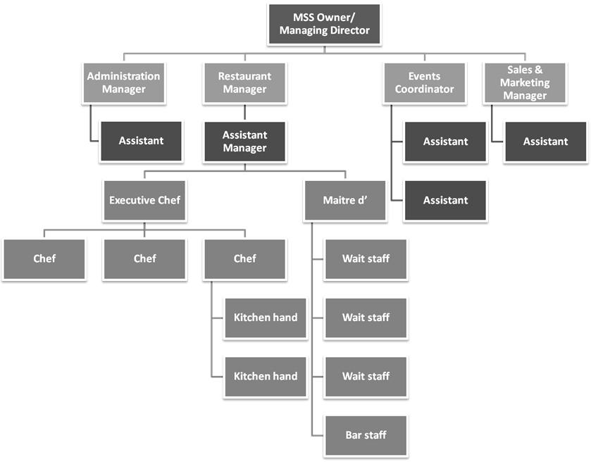

**Your project, should you choose the Mustang Sally Steakhouse:**

You are the Events Coordinator for the Mustang Sally Steakhouse. The owner of the business has asked you and the rest of the Events team to plan the opening event for the first restaurant which seats 300 people. The plan must include:

* the menu for the occasion – it will be a limited menu offering guests a taste of the best that Mustang Sally Steakhouse has to offer:
  + five appetisers
  + three fish dishes
  + five meat options, including two different steak dishes
  + three pasta dishes
  + three risottos
  + three curries
  + one couscous dish
  + five pizza options
  + three salads
  + five desserts.
* details regarding how guests will be served (buffet, table service, bar service, etc.)
* entertainment for the event
* timing – Lunch or dinner? Which day of the week?
* how the event will be advertised and how guests will be invited
* the number of guests that will be allowed to attend
* details on how you will create a unique dining experience for all guests
* an estimate of the budget for the event.

**Case study 2: Spirit & Soul Health Spa**

Spirit & Soul Business Plan

*1.1 Objectives*

The objectives for Spirit & Soul Health Spa are outlined below.

* Substantial sales revenue by end of second year.
* Profit before tax by end of second year.
* Have clientele return rate of 90% by end of first year.
* Become established community destination by end of first year.

*1.2 Mission*

Spirit & Soul will provide a comforting, yet stimulating, atmosphere in which customers will be able to relax their body, mind and soul, reconnecting their daily lives to their true purpose through a wide range of holistic methods including massage, body treatments, energy treatments, and hair styling. Spirit & Soul will become a desirable destination to which customers can always come in order to escape the rat-race, and rejuvenate their bodies, energies, and souls.

*Keys to success*

* Talented employees familiar with energy treatments and oriented to a holistic health approach.
* Establishing a reputation within the community for taking care of customer's needs during every visit.
* Easily accessible location.
* Effective advertising.

*Organisational chart*

The following chart displays the organisational structure of Spirit & Soul Health Spa.

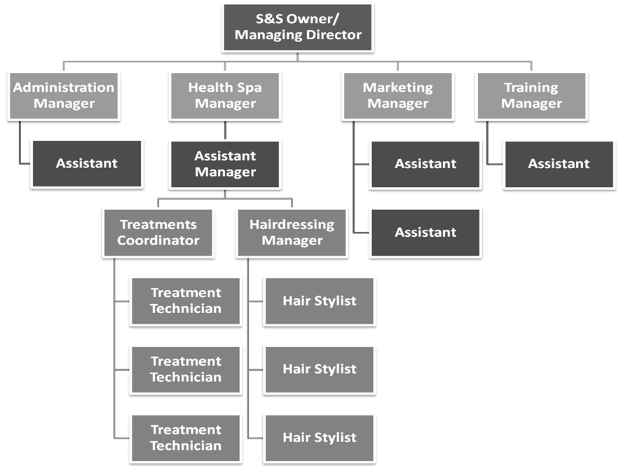

**Your project, should you choose the Spirit&Soul Health Spa:**

You are the team leader of the Marketing team at Spirit&Soul Health Spa. The owners of the business have asked you and your team to plan a marketing campaign for the business. The plan must include:

* definition of the target audience
* the marketing communication tools that will be used
* the goals the marketing team intends to reach with each tool
* the timing of the campaign (duration)
* a description of how you are going to evaluate the effectiveness of the campaign
* an estimate of the budget for the marketing campaign (make sure you detail what percentage of the budget will be spent on each marketing communication tool).

**Case study 3: Little BoPeep Maternity Wear**

LittleBoPeep.com Business Plan

LittleBoPeep.com is a new online business providing fun, comfortable and easily accessible maternity wear via our own website and an eBay store.

LittleBoPeep.com has ad space commitments from several online expecting sites, and dozens of leads for direct sales and public relations.

Our targeted market includes both the many pregnant women who like to dress casually and comfortably, and the friends and family members of expecting women who will buy items of maternity wear as gifts.

The popularity and brand success of eBay, combined with its built-in tools for new merchants, will help us to build a solid customer base for our new product.

*1.1 Objectives*

* Create a unique maternity wear product by the end of year one.
* Generate retail sales of over $1,000,000 in year one, both on our website and on our eBay store.
* Maintain a gross margin of over 55%.
* Achieve 200 eBay customer positive feedback comments in one year.

*1.2 Mission*

* To offer unique, comfortable and readily available maternity wear for women who want to dress casually yet fashionably, even while pregnant.

*Organisational chart*

The following chart displays the organisational structure of LittleBoPeep.com.

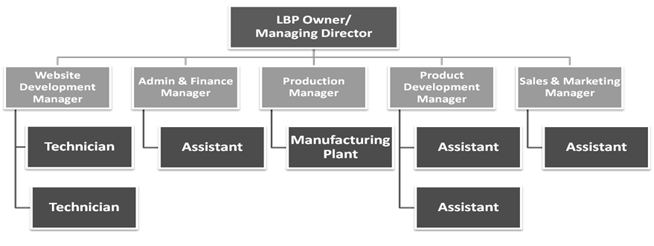

**Your project, should you choose LittleBoPeep.com:**

You are the team leader of the Product Development team at LittleBoPeep.com. The owner of the business has asked you and your team to develop a new maternity wear product. Your team must provide:

* a design for the prototype of the new product (this can be a pencil sketching or drawn using computer software, e.g. PaintShop)
* a list of the product features including the characteristics that make it unique
* details of what materials the product will be made of
* an explanation of how this product will appeal to our target market
* the estimated selling price.

**Case study 4: Fernwood Pharmacy**

Fernwood Pharmacy Business Plan

Fernwood Pharmacy is an innovative, professional business tailored for the rural demographic. Fernwood Pharmacy is an innovative company that was established by three registered pharmacists.

Fernwood provides tailor-made services for the immediate community and for those more remote areas in Australia where health services are deteriorating and the opportunity for business growth exists. This is achieved by compounding specialist lines, and promoting this type of care to consumers and health prescribers, including doctors, dentists and other health care professionals. Fernwood values innovation and this is reflected by its focus on the diverse roles of a pharmacist, with the objective of strong returns for its shareholders.

*1.1 Objectives*

The objectives for the first three years include the following.

* Enhance community understanding about compounding pharmacy and its services.
* Increase the number of customers by more than 30% per year.
* Develop a business that survives off its own cash flow.
* Initiate and facilitate a community committee by the end of the first year of business.
* Make Fernwood Pharmacy the leading pharmacy in Western Australia by offering knowledgeable and professional customer service. Customer service will be measured through repeat business (our goal is that 70% of our customers will return within six months for an additional purchase).

*1.2 Mission*

Fernwood Pharmacy will:

* be the pioneers of individualised health care for rural communities in Western Australia
* strengthen relationships with our local health care professionals and other health care facilities in order to gain greater community presence as the destination rural compounding pharmacy
* be recognised as the leading rural compounding pharmacy as we expand our business into other rural regions of Australia
* employ innovative strategies to attract and retain talented staff in order to maintain a professional and positive work culture
* strengthen community ties by way of a community liaison committee and participation in community events

**Your project, should you choose Fernwood Pharmacy:**

You are the team leader of a team of market research consultants. Fernwood Pharmacy has employed your organisation to create a customer satisfaction survey for their company.

The following chart displays the organisational structure of your company, Southbank Market Research.

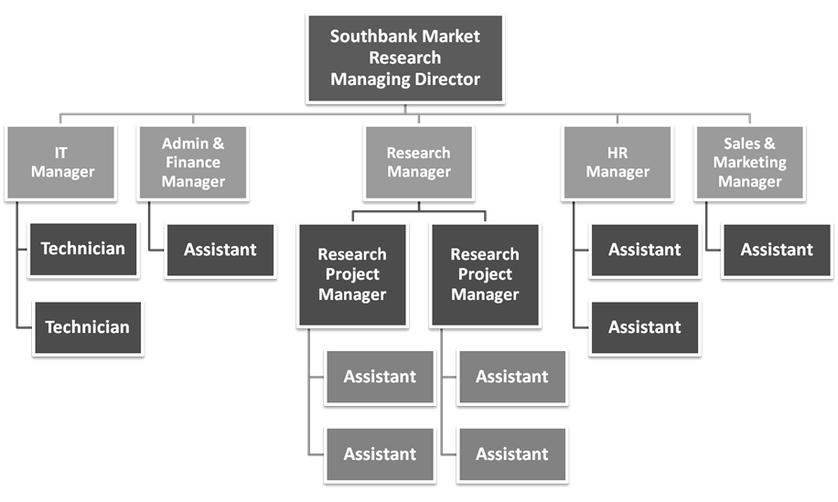

Your team must provide the following:

* a tailor-made customer satisfaction survey consisting of ten questions. Please provide one A4 copy in printed format as a sample for viewing.
* details regarding how the data will be collected (telephone, internet, mail, in-store feedback questionnaires, etc.)
* description of the format in which the results will be presented
* an estimate of the required number of surveys to be distributed
* an estimate of the total cost of the service.