

Assessment

**Task 1**

**Undertake project work**

**BSBPMG430**

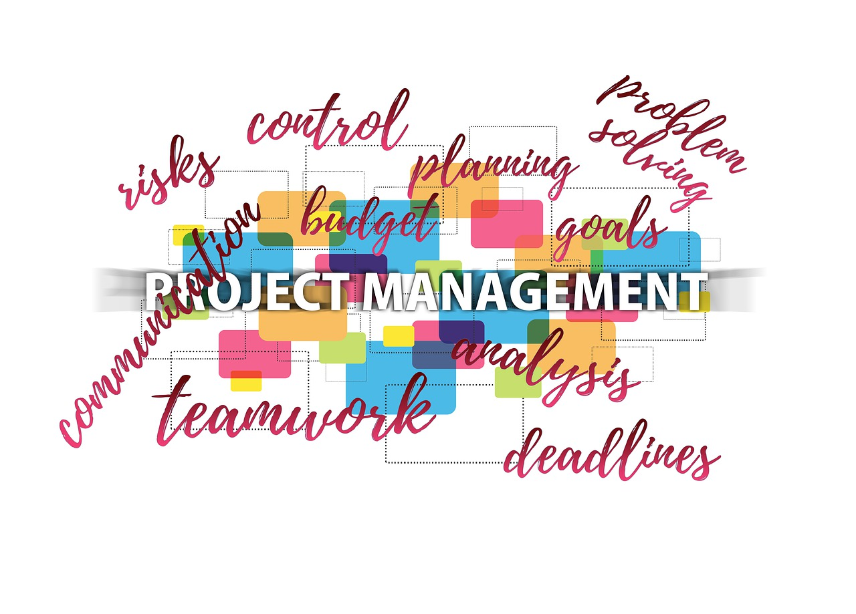

**Student Declaration**

To be filled out and submitted with assessment responses

◻ I declare that this task and any attached document related to the task is all my own work and I have not cheated or plagiarised the work or colluded with any other student(s)

◻ I understand that if I am found to have plagiarised, cheated or colluded, action will be taken against me according to the process explained to me

◻ I have correctly referenced all resources and reference texts throughout these assessment tasks.

◻ I have read and understood the assessment requirements for this unit

◻ I understand the rights to re-assessment

◻ I understand the right to appeal the decisions made in the assessment

|  |  |  |
| --- | --- | --- |
| **Unit Title**  **Unit Code** | | |
| **Student name** |  | |
| **Student ID number** |  | |
| **Student signature** |  | **Date** |
| **Task Number** |  |  |

|  |
| --- |
| **------OFFICE USE ONLY-----**  For Trainer and Assessor to complete:  ◻ Student requested reasonable adjustment for the assessment |

|  |  |  |  |  |
| --- | --- | --- | --- | --- |
| **Question** | **Marking Sheet - Assessor to complete.**  **Did the student satisfactorily address each question as instructed:** | | | |
| **Completed satisfactorily** | | | |
| **S** | **NYS** | **DNS** | **Comments** |
| **Question 1** |  |  |  |  |
| **Question 2** |  |  |  |  |
| **Question 3** |  |  |  |  |
| **Question 4** |  |  |  |  |
| **Question 5** |  |  |  |  |
| **Task Outcome: Satisfactory  Not Yet Satisfactory** | | | | |
| **Student Name:** | | | | |
| **Assessor Name**:  **Assessor Signature:**  **Date:** | | | | |

**Table of Content**

**Student Declaration** 2

**Task 1 – Knowledge Questionnaire** 5

**Question 1** 6

**Question 2** 7

**Question 3** 7

**Question 4** 7

**Question 5** 7

**Appendix 1 – Scenario** 9

**XYZ Organisational Chart** 10

**Ownership** 10

**Key to Success** 10

**About the Product** 10

**Target Market** 11

**Objectives** 11

**Vision** 11

**Mission** 12

**Values** 12

**Strategic Direction** 12

**The project** 13

**Project conditions** 15

**Project management policy** 15

# **Task 1 – Knowledge Questionnaire**

| **Task summary and instructions** | |
| --- | --- |
| **What is this assessment task about?** | This assessment is a written questionnaire with a mix of objective and subjective questions.  The questionnaire is designed to meet the knowledge required to meet the unit requirements safely and effectively.  The questions focus on the knowledge evidence required for this unit of competency:   * project management tools * types of documents and other sources of information commonly used in defining the parameters of a project * mission, goals, objectives and operations of the organisation * relevant legislation and regulations, including work health and safety (WHS) requirements, for project planning * project management processes according to policies and procedures of the organisation and including: * lines of authority and approvals * quality assurance * human resources * budgets and finance * risk management * recordkeeping * reporting.   Your assessor will be looking for demonstrated evidence of your ability to answer the questions satisfactorily, follow instructions, conduct online research and review real or simulated business documentation as instructed. |
| **What do I need to do to complete this task satisfactorily?** | * submit your answers to the questions within the set timeframe, * answer all questions as instructed, * answer all questions using your own words and reference any sources appropriately, * all questions must be answered satisfactorily.   It is advisable to:   * review the questions carefully, * answer the questions using online research and the learning material provided for the unit and by reviewing real or simulated relevant business documentation (such as policies and procedures), * further research the topics addressed in each question. |
| **Specifications** | **You must submit to GOALS the**   * assessment coversheet, * answers to all questions, * references. |
| **Resources and equipment** | * computer with Internet access, * access to Microsoft Office suites or similar software, * learning material. |
| **Re-submission opportunities** | You will be provided feedback on your performance by the Assessor. The feedback will indicate if you have satisfactorily addressed the requirements of each part of this task. If any parts of the task are not satisfactorily completed, the assessor will explain why, and provide you with written feedback along with guidance on what you must undertake to demonstrate satisfactory performance. Re-assessment attempt(s) will be arranged at a later time and date. You have the right to appeal the outcome of assessment decisions if you feel that you have been dealt with unfairly or have other appropriate grounds for an appeal. You are encouraged to consult with the assessor prior to attempting this task if you do not understand any part of this task or if you have any learning issues or needs that may hinder you when attempting any part of the task. |

**Answer all the questions below:**

## **Question 1**

**Provide four (4) examples of project management tools and outline how they contribute to a project**.

| **Project Management tool** | **Contribution to a project**  **(30-50 words/tool)** |
| --- | --- |
|  |  |
|  |  |
|  |  |
|  |  |

## **Question 2**

**Select five (5) types of documents and other sources of information that are commonly used when defining a project's parameters and describe them.**

| **Document or other sources** | **Description**  **(30-50 words/item)** |
| --- | --- |
|  |  |
|  |  |
|  |  |
|  |  |
|  |  |

## **Question 3**

**Read the scenario in Appendix 1- Scenario at the end of this document. Outline the organisation's mission, goals, objectives and operations and how the project relates to them.**

**(80-100 words)**

|  |
| --- |
|  |

## **Question 4**

**Refer to the scenario in Appendix 1- Scenario at the end of this document. Outline the legislative and regulatory context of the organisation concerning project work, including WHS requirements. (80-100 words)**

|  |
| --- |
|  |

## **Question 5**

**Refer to the scenario in Appendix 1- Scenario at the end of this document. Outline the organisation's procedures and processes that are relevant to managing the project. Please use the table below.**

| **Procedures and Processes** | **Outline (30-50 words/item)** |
| --- | --- |
| **Lines of authority and approval.**  *For example: who makes key decisions about the project?* |  |
| **Quality assurance**  *For example: what are the processes to ensure that the project quality requirements are met?* |  |
| **Human Resources**  *For example: how is the project team selected and managed?* |  |
| **Budget and finances**  *For example: who signs off on the budget? How are financial records kept? Who approves variations in the budget?* |  |
| **Risk Management**  *For example: what is the relevant policy? Who is responsible for managing risks?* |  |
| **Recordkeeping**  *For example: how are documents version controlled? Where are they stored? For how long they are kept?* |  |
| **Reporting**  *For example: what are the reporting procedures for the project?* |  |

# **Appendix 1 – Scenario**

XYZ Pty Ltd trading as ZEEMH was founded by husband and wife John Cluber and Marla Bennet. The couple decided to start an online business in 2013 to allow more flexibility in their family life. ZEEMH was an instant success, and it has grown progressively in its years of operation.

Website: <https://projectdipem.wixsite.com/zeemh> .

Starting as an online retailer of exclusive coffee brands for home-consumption, the company changed its business model by launching into the production of its own brand of coffee and serving a market of both B2B and B2C customers.

ZEEMH (pronounced Zeem –H) is an innovative Australian online retailer for premium coffee. ZEEMH:

* produces creative and high-quality coffee blends, roasting coffee in its own facilities,
* sources coffee beans from around the world, searching for the best quality coffee,
* is an online retailer of its very own coffee brand: 100% Australian owned and operated,
* delivers its products within Australia (nationwide),
* focuses on a niche B2B and B2C target market.

ZEEMH coffee is:

* quality and innovation-driven,
* a champion for sustainability,
* delivered fast,
* Fair Trade approved,
* customisable.

Since 2013, the organisation has grown and expanded, moving from the spared room of a house in Surrey Hills, Victoria, to a comfortable 2 level office in Port Melbourne, where they also have the coffee roasting and packaging plant (same building). Warehouse operations are outsourced to MCW Logistics (MCW looks after the importing operations relate to importing coffee beans in Australia and the inventory management – for raw and refined products). MCW logistics is located close to the ZEEMH headquarter.

So fare their market has only focused on the Australian market.

## **XYZ Organisational Chart**

## **Ownership**

ZEEMH is a Proprietary Limited company, 100% Australian owned and operated.  The majority of the company is owned by founders John Cluber (40%) and Marla Bennet (40%). Steven Yun, an investor owns 20% of the company and he is also part of the Board of Directors as an executive director.   They have recruited experienced and highly skilled board members.

## **Key to Success**

ZEEMH has identified four keys that are instrumental to its success:

* develop a niche product that aims to reach a market of boutique coffee lovers,
* deliver exceptional customer service in all aspects of the business cycle,
* attract and retain quality staff,
* creativity, innovation and quality are the pillars the company is founded on.

## **About the Product**

Coffee beans are sources from selected producers around the world and they must meet the following characteristics:

* organics and Fair Trade approved,
* be produced on small to medium farms,
* pass the quality control standards of ZEEMH coffee roaster's experts.

The product:

* is roasted daily – an efficient inventory process is key to allow for the product to be shipped and re-stocked fast,
* has won several quality awards from Australian coffee associations,
* delivered free of charge for orders over $ 80.00,
* is packaged using earthbags products ( <https://www.thepackagingpeople.com.au/product/earth-bags/?gclid=EAIaIQobChMI5K3_zNai3QIViGkqCh2mgQX2EAQYBCABEgIjhvD_BwE> ).

## **Target Market**

ZEEMH has identified three distinct customer segments:

* B2B – start-up independent coffee shops that aim to establish themselves as a boutique coffee shop,
* B2B – established independent coffee shops that aim to differentiate their offering from their competition,
* B2C – coffee drinkers that enjoy making good quality coffee at home (speciality coffee drinkers). These buyers buy the beans whole to grind the coffee themselves, for the freshest cup possible. ZEEMH has made a strategic decision not to sell ground coffee (this would increase the cost of production).

## **Objectives**

ZEEMH's objectives are:

* to make ZEEMH an icon brand for speciality coffee drinkers,
* to develop an effective, well-placed e-commerce site for sales of coffee blends direct to the public,
* to expand their market (to increase sales) without giving up on the exclusivity of the brand,
* to maintain and improve infrastructure for the fulfilment of Web-based sales.

## **Vision**

ZEEMH's vision is to be the leader in the innovative and creative production and distribution of superior coffee blends for true coffee lovers.

## **Mission**

ZEEMH's mission is to provide the finest in coffee blends using the Internet to lower the cost to consumer's.  ZEEMH exists to attract and maintain customers who love quality and boutique coffee.  ZEEMH's services are designed and delivered to exceed the expectations of its customers.

## **Values**

ZEEMH:

* strongly values its people,
* promotes quality in every part of the business,
* champions innovation in our approach to business growth,
* supports creativity in our product offering,
* is committed to sustainability in everything we do,
* displays integrity in the way we do business,
* shows care and respect for our customers.

## **Strategic Direction**

ZEEMH's strategy is based on capturing the higher end of coffee lovers' market.

Also, ZEEMH aims to create a premium brand, so that they can eventually capture market share across broader geographic lines.

ZEEMH's competitive edge is:

* quality coffee,
* easy-to-use website,
* superior customer service,
* coffee blends customisation for clients.

The strategic objectives identified by the board of directors are:

* increase brand awareness among B2C and B2B customers,
* increase market share among B2C clients by 20% in the next five years,
* expand to international markets,
* increase market share among B2B clients by 3% in the next three years,
* expand the product line to coffee equipment and Zeemh merchandise,
* identify strategic alliances to expand the company's footprint nationally and internationally,
* consider a HR strategic plan to attract and retain talent in the company,
* improve quality management practices to decrease production and logistic costs and establish the brand as synonymous of quality first,
* improve customer retention and loyalty.

An integrated digital marketing campaign is recommended by the board. However, the board has highlighted how a more traditional form of marketing, such as direct marketing, should be integrated into the overall strategy. ZEEMH's clients like a personal approach to sales and interaction with the company.

The board has committed to:

* $ 210,000 in marketing expenditure for the next financial year
* $ 450,000 in recruitment and improvement of HR practices (including professional development for staff)
* $ 190,000 to quality improvement (including improvements to the roasting facilities in Port Melbourne)

## **The project**

ZEEMH has engaged you as a Project Manager to develop a website for its B2C online coffee making training courses. The courses are part of the marketing strategy to improve brand awareness and recognition, expand to international markets and create strategic alliances.

The parameters of the project That you will have to clarify with the project sponsor are:

* website planning, development, testing and launch to be completed within 3 months from the day the Project Brief is approved,
* budget: $ 35,000 including the project team's wages (Project Manager and Project team member engaged for the duration of the project),
* the online course development is excluded from the scope of the project (courses be developed by a strategic partner, expert in course design), however the material for the courses must be provided by ZEEMH,
* you can employee-only 1 new resource for the project, the rest of the project team will be internal, and it will comprise of:
* 1 marketing officer, Jack Green, seconded to the project team 2 days/week,
* 1 client service officer, Marcel Red, seconded to the project 3 days/week,
* 2 remote team members from the sales team seconded to the project 1 day/every 2 weeks, Sarah White and Steven Black,
* 1 front desk officer to help with administrative duties in her role as a receptionist for ZEEMH, Laura Brown,
* use of ZEEMH facilities for the duration of the project is approved,
* 2 laptops to be purchased for the project team,
* statement of work:
* plan the website,
* source web developer,
* liaise with the web developer and oversee their work,
* support website testing,
* decide on coffee making courses and liaise with the course developer (example of courses include coffee fundamentals, coffee and spices, cooking with coffee, coffee making at home, filter brewing, cold coffee, speciality coffee, coffee art),
* pricing strategy,
* collect material for coffee making courses (procedures, recipes, information and data) to provide to course developer,
* upload online courses,
* plan website launch: communication strategy via social media including content development,
* plan sales strategy for the first months after launch to achieve 250 enrolments,
* define key messages for the launch,
* quality requirements:
* reduce user's cognitive effort,
* web site in English, French, Italian, Spanish, Japanese,
* user sign up in max 3 easy steps,
* one clear call to action,
* functional links,
* branded for ZEEMH, conforms with ZEEMH website,
* each page to contain appropriate metadata,
* correct functionality of dynamic content and applications,
* foreground and background colour provide sufficient contrast for both images and text,
* browser compatibility,
* high quality images,
* google analytics,
* SEO,
* provide a seamless and engaging user experience,
* other projects undertaken by ZEEMH at the same time:
* process improvement for coffee production,
* staff training in using new CRM,
* identify and pursue a strategic alliance to export coffee to Japan,
* known risks:
* staff seconded to project work is already at capacity, additional workload may impact on their work performance,
* lack of project management knowledge in the organisation,
* competing priorities due to concurrent projects,
* use of internal staff could stretch the project team capabilities,
* high-staff turnover in the client service team,
* product recall for a new blend of coffee due to safety risk to client has negatively impacted ZEEMH' s reputation for quality and a public relation effort is currently under way,
* financial resources are stretched due to investment in different projects.

## **Project conditions**

1. Six to eight team members (two to four students plus four virtual team members) who must be utilised and budgeted for. COO (project sponsor, the assessor), will determine the composition of the project team.
2. The structure of the work should include roles for project sponsor, technical experts, quality assurance of deliverables, project manager (yourself initially and, after provisional approval, as negotiated with your team), and roles and responsibilities for each team member to achieve the deliverables according to standards, etc.
3. All reasonable resources (e.g. access to a room, computers, software and templates) will be provided. (Paper and telecommunications costs, for example, to be covered by students.) All resources must be costed and included in your budget.
4. Your COO (project sponsor, the assessor) will clarify project deliverables—for example, presentations, information sessions, posters, promotional materials, etc. You may determine your own specific deliverables so long as they are agreed to with stakeholders, meet project objectives, and adhere to budgetary constraints.
5. Project timeframe 3 months from the day the Project Brief is approved.
6. The project should include design, development, implementation and evaluation stages (with periodic quality review).
7. Project status reports are due at 25%, 50% and 75% of allotted timeframe.
8. The project must be coordinated with other organisational projects, operations, etc.
9. XYZ policies and procedures are provided in a separate folder.

## **Project management policy**

**Purpose**

This policy outlines principles and responsibilities associated with the management of projects at XYZ Pty Ltd (XYZ).

XYZ is coXYZtted to the adoption of a standard approach to project management that reflects the mission and values of the company and the consistent use of project management procedures and templates to facilitate the implementation of strategic priorities, operational plans and events.

This policy is designed to specify the minimum essential elements in the management of projects to assist in articulating scope, involving stakeholders, managing risk and maximising project benefits.

Not all projects require high and complex levels of governance, documentation and reporting and the aim of the project management model outlined by this policy is to provide a set of guidelines that can be adapted to suit the requirements of each project.

XYZ may deliver :

* **Project** - Has a defined start and endpoint and specific objectives that, when attained, signify completion
* **Program** - Is defined as a group of related projects managed in a coordinated way to obtain benefits not available from managing the projects individually

Policy and Procedures

Project Approval Process

1. A Project Proposal (Business Case) is presented to relevant stakeholders according to the project size and budget
2. Once the Project Proposal is approved, a project charter is developed for approval
3. Once the Project Charter is approved, a project plan is developed for approval. Depending on the complexity of the project, XYZ may decide to plan and deliver a program rather than a project
4. Change Management Process applies
5. Evaluation Reports are presented to relevant stakeholders

There are **five main phases** of any project and one core template to be completed in each phase:

1. **Initiation** Business Case and Project Charter

2. **Planning** Project Plan

3. **Implementation** Implementation documents and reports

4. **Monitoring** Monitoring documents and systems

5. **Finalisation** Post-Implementation Review Reports

When managing a program, the Program life-cycle is presented below:

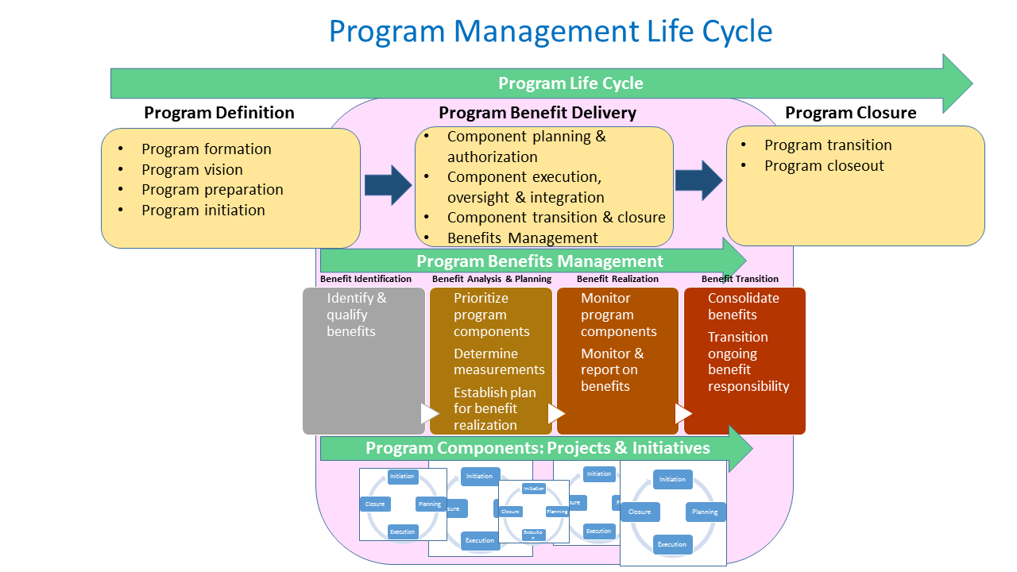

At a minimum, projects ( or programs) require the following governance structure (to be determined by the Project Sponsor and confirmed by the Project or Program Manager):

**Project Register**

XYZ values strong collaboration and networking across departments and the benefits of fostering project (and program) management knowledge to enhance the quality of event management practices.

A **Project Register** will be established and maintained to assist staff to develop project management knowledge. Project Sponsors and Project Managers are encouraged to record and update project information on the Project Register to:

a) increase the visibility of projects and processes to the organisation and wider community;

b) raise awareness and understanding of the scope of project work undertaken by XYZ;

c) improve the way in which projects are monitored and managed as they progress; and

d) provide information about the history and status of projects to ensure appropriate scoping of future projects (lesson learned).

When managing a program, the Program Manager will be in charge of the register from each individual project.

Change Management Process:

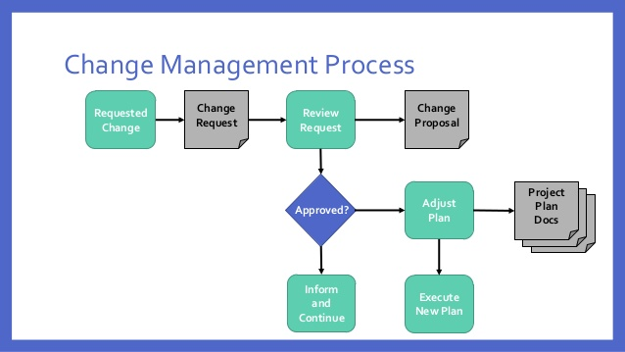

**Applicability**

a) This policy applies to projects undertaken at XYZ. Projects within a program will typically have shared objectives that are linked to the organisational strategic plans.

b) The project management model outlined by this policy has been designed to accommodate project needs across all departments at XYZ.

c) Projects must operate in the context of policies and procedures of XYZ including but not limited to the Risk Management Policy, and the Procurement Policy.

**Procedures**

| Step | Brief Description | Responsibility |
| --- | --- | --- |
| 1 | Determine the size and nature of the project.  Determine if a program is a better choice to deliver on the XYZ initiative. | Project/ProgramManager |
| 2 | Prepare a Business Case (Project Proposal ) | Project Manager/Program Manager |
| 3 | Project Proposal to be approved | According to approval process |
| 4 | Prepare a Project Charter | Project Manager |
| 5 | Project Charter to be approved | According to approval process |
| 6 | Prepare Project/Program Plan | Project/ProgramManager |
| 7 | Project Plan to be approved | According to approval process |
| 8 | Implement Project Plan  Undertake project activities as set in plan. | Project/ProgramManager  Project/Program Team |
| 9 | Manage changes  Monitor risks manage issues and changes in circumstances. | Project/Program Manager  Area Managers  Project/Program Program Board |
| 10 | Monitoring  Monitor progress towards project deliverables. | Project/ProgramManager  Project/Program Team |
| 11 | Finalisation  Collect feedback and prepare project evaluation reports. | Project/ProgramManager  Project/Program Team |

**Quality Management**

Projects and programs must be delivered within the framework of the XYZ Quality Management Policy and Procedures.

The Quality Management Policy describes XYZ Pty Ltd strategic approach to quality management and continual improvement, which is guided by its Mission and Vision with a strong statement regarding quality and excellence in the business.

Assessing the quality of our work outputs across the organisation is how we maintain our continuous improvement culture. Quality Assurance evaluates the data we collect about our performance and contextualises the numbers to allow us to produce results to key QA areas, including:

* Customer Service
* Operations
* Sales
* Marketing
* Sustainability initiatives

The policy applies to all XYZ staff, and it supports the development of a quality culture in which all staff assume responsibility for quality and engage in quality management at all levels and areas of the company. Please refer to the XYZ Quality Management Policy and Procedures for more details.

When managing projects and programs:

* State the quality objectives in terms of the project and program objectives and/or the organisational objectives. Determine quality objectives in consultation with relevant stakeholders. There may be overall organisational quality objectives or policies that the project/program can reference.
* Identify which quality standards are relevant to the project/program and how to satisfy them. Identify and define appropriate quality metrics and measures for standards for project processes, product functionality, regulatory compliance requirements, project deliverables, project management performance, documentation, testing, etc.
* List and define the quality tools that will be used to measure project quality and level of conformance to defined quality standards/metrics.

**Quality Control**

Quality Control is the process of making sure that application is made to consistently high standards. Performing quality control (**QC**) involves monitoring specific project/program results to determine whether they comply with relevant quality standards and identifying ways to eliminate causes of unsatisfactory results.

Identify those monitoring and controlling actions that will be conducted to control quality throughout the project’s life. Define how it will be determined that quality standards comply with the defined standards outlined. Identify owners of ongoing monitoring and improvement of project/program processes.

**Quality Assurance**

Quality assurance (**QA**) is the application of planned, systematic quality activities to ensure that the project/program will employ all processes needed to meet requirements.

Identifying and defining those actions, and the metrics to measure them provides the confidence that project/ quality is in fact, being met and has been achieved. Relate these actions to the quality standards defined in the planning section of this document.

**Human Resources**

Projectsand programs must be delivered within the framework of the XYZ HR Policy and Procedures.

Projects and programs may be planned and executed using a project team that comprises of:

* Existing employees
* New hires
* Temp staff
* Contractors
* Outsourced services

When managing projects/programs:

* Understand:
* How existing groups or individual employees within and outside the organisation will be involved
* How they will interact
* How their skills and competencies will be used in the project/program
* Work in collaboration with the HR department at XYZ
* Assign clear roles and responsibilities using:
* A RAM chart
* A RACI chart
* Provide PDs when appropriate
* Set clear performance expectations
* Induct and train staff on all organisational relevant policies and procedures and project/program management standards
* Provide training and support to project/program team members as needed
* When working with existing XYZ staff, work in collaboration with relevant area managers to ensure that appropriate workforce planning is applied
* Performance management of staff should be conducted under the supervision of the HR department
* Relevant HR legislation and regulations apply

**Budget and Finance**

Projects and programs must be delivered within the framework of the XYZ Financial Management Policy and Procedures.

When managing projects:

* Estimate what the work may cost and the value of its expected benefits. These estimates are made and refined in parallel with other planning processes for establishing the scope of work and estimating schedule, resources and risk.
* The balance of cost and benefit is analysed using investment appraisal techniques and documented in the business case. Work is approved if it can be shown not only that the benefits outweigh the costs, but also that the organisation cannot get a better return by investing the same funds elsewhere.
* The process of securing funds continues in parallel with these steps. During the early phases of the life cycle, funds may only be committed in principle, pending a more detailed understanding of the work.
* As plans are defined in ever greater detail, with increasing levels of confidence, funds will be fully committed, and approval given to commence work. Financial governance therefore involves:
* initially: committing funds to the concept phase of the life cycle and reserving funds for the definition phase;
* at the end of the concept phase: committing funds for the definition phase and reserving funds for delivery;
* at the end of the definition phase: committing funds for delivery, or at least the first stage or tranche of work;
* at each review: funds for the next stage or tranche will be dependent upon results and a review of changes in circumstances,
* Project budgets are pre-approved by the area manager (small projects) and then sent to the Finance Department for analysis.
* Final approval for project budgets is given by:
* The CEO and CFO for medium projects
* The Board of Directors for large projects
* As work proceeds, cost-control mechanisms need to be implemented. These will forecast when funds need to be released and track progress of actual expenditure against planned. Funding is reviewed at the end of each stage or tranche of work. Funds are never unlimited, and costs have to be balanced against time and scope in accordance with stakeholder requirements.
* The Project/Program Manager is responsible for:
* Plan and implement financial control across all phases of the project/program life cycle
* Liaise with the Financial Department for guidance
* Report to the Finance department by-weekly on project expenditure
* Compile and file a final financial report, with the assistance of the finance department, at the end of the project

Note: when delivery programs, Project Managers will be responsible for the financial management of their individual projects and supervised by the Program Manager.

**Record Keeping**

Projects and programs must be delivered within the framework of the XYZ Record Keeping Policy and Procedures.

Managing project records is the responsibility of the individual Project Managers who must ensure that every document or file is properly designed, formatted, communicated, secured, stored, and archived.

The PM should also keep the records up-to-date and relevant

As a process, project records management is characterised by the following items:

* **Inputs**: any essential information to be recorded and saved for the project
* **Resources**: equipment, systems, software, communication tools, HR etc.
* **Guidelines**: document management policies, document standards, filing procedures, etc.
* **Outputs:** document flows, files, catalogues, record sheets, etc.

When managing projects:

First ensure that there’s a framework for documenting and filing events occurring within the project (the inputs). By using systems and software (the resource), your teams can record activities and events and create documents. They follow prescribed procedures for event recording and documenting (the guidelines). Finally running the process allows you to develop necessary documentation, files and records (the outputs).

Follow the process below:

1. **Create Project Files**

When you create a project file, you must be sure you do it in accordance with the standards and requirements of file management within XYZ.

There’re five common requirements to project file creation:

* Prompt. A file is to be created as early and quickly as possible.
* Simple. File content should have a structure that is as simple as possible.
* Separate. Every file is a single and separate record; two or more files can’t be combined; if there’s a need to combine the content of several files, a new file should be created.
* Up-to-date. When a project file is updated, a versioning number as well as the date revised should be added to the file header.
* Confidential. A file should be maintained with complete confidentiality; only authorised personnel can access the file and its content.

1. **File Project Documents**

Once you have created a file according to the XYZ file management policy and requirements, you can proceed with filing project documents. It means you must put all your documents and white-papers into respective files. Below I list the key **documents and data** you should add to your project files:

* Official mail and email correspondence, including letters, attachments, pictures
* Papers if project meetings
* Project request, proposal, brief.
* Stakeholder contact details
* Change and variance requests
* Project diary
* Issue logs/risk logs/decisions made
* Status reports and summaries
* Procurement papers
* Team guidelines, instructions, notes, etc.
* Handover/closure documents

You should be sure that every piece of this data is put into a file. There should be version control to ensure that the project files are updated and changed properly. The following details are required: revision number, revision date, author, editor, link to an electronic copy (if any).

Please use the XYZ shared file system. Contact the HR Department that will liaise with the IT services to create a specific folder for you.

1. **Archive and Destroy Project Records**

Once all of your project documents and relevant data have been filed, your next step is to manage the records and move them to archive. Archiving project records means making documents no more available within the given environment while ensuring that the records are retrievable for further projects and lessons learned.

When you project is over, you may need to destruct the records, instead of archiving them. Refer to the archiving and destructing procedures of your XYZ when treating your project records.

As a general rule:

* Contract documents and advice records: store this type of project records for at least 5 years after the contracts are fulfilled.
* General project records: these are kept in accordance with the function that they support.
* Research data records: from 5 to 7 years, depending upon the nature of the research.
* Legal issues and case records: a minimum of 7 years.
* Finance records are kept 5 years long.
* Other types of project records are archived for the period of 5-7 years.

Best practice of document archiving says that an organisation should try to retain a project file for the longest possible period of time. Contact the HR Department for guidance on specific procedures.

Note: when delivery programs, Program managers will design a communication and record management process to eb adopted by all project teams.

**Reporting**

When managing projects and programs:

* At decision points, Project/Program Managers should consult with relevant stakeholders regarding decisions about the project and adjust the control factors, if necessary.
* The Project Managers is required to provide the project sponsor, the Area Manager, the CEO and the Board of Directors (for large projects only) with bi-weekly reports on the progress of the project. If delivering a program, Project Managers will send the reports directly to the Program Manager.
* Reports may include:
* Project Status Report (Such as financial, schedule and resources)
* Executive Report
* Ad-hoc Reports
* Lesson Learned
* End-of-Project/Program Reports

Reports are sent in attachment via email to relevant stakeholders. Meetings can be organised for important and urgent reports that require urgent consideration from the CEO and the Board of Directors.

**Change Control**

Change control is the process through which all requests to change the baseline scope of a project, are captured, evaluated and then approved, rejected or deferred.

Rigorous change control process must be established and maintained on all projects.

The process must allow all stakeholders to submit their suggestions for changes to scope and typically comprises five steps:

1. **Request:** The stakeholder who requests a change must provide relevant information on the nature of the change. The request is entered into a change register which records all requests and their status (e.g. pending, approved, rejected or deferred).
2. **Review:** The change request is reviewed to determine its high-level impact on outputs and benefits. If necessary, further clarification may be sought before deciding if it is worthwhile performing a detailed assessment. The proposed change may be rejected without further evaluation, in which case the reasons for rejection will be recorded, and the stakeholder informed.
3. **Assessment:** All options relating to the change are captured and evaluated. The detailed impact on plans and schedules is estimated, and a recommendation to approve, reject, defer, or request more information is made. Thresholds are set to determine whether the project manager, sponsor, or other members of the management team can make the decision.
4. **Decision:** The decision is communicated to the team and stakeholders as outlined in the communication management plan and the configuration management plan.
5. **Implementation:** Relevant plans and schedules are updated if a change is approved and before the changes are made to existing products, or specifications for future products.

If an unauthorised or emergency change is identified, it should be retrospectively put through the change control process.