General advices for Critical Essay.

The major piece of assessed work for this module is the critical essay. This essay ensures that you have engaged with all parts of the module. This document provides details about the assessment. Please read it carefully and ensure that you understand it fully. Despite our best efforts, every year people submit otherwise good work that does not answer the question, and they get a poor grade as a result. Please make this year the exception. Please pay particular attention to the words that are in italics or in bold below. If you do not understand them, please ask.

Essay Title: Silviculture in a changing world – a case study

Your essay will consider a ***specific****case study* chosen by you. The overall aim of this essay is for you to demonstrate your understanding that in a changing world, ‘business as usual’ is sometimes not an option, but through thoughtful application of the principles that you have understood during this module, the future can be an improved version of the present.

In discussion forum last year, there was a short exchange between a few students in which it was noted that silviculture is hard because there seem to be so many options these days. To this, someone replied that they think that we are living through an interesting time in silviculture for that very reason, and they wondered what learning forestry was like in Bangor 50 years ago. I replied (jokingly) suggesting that they ask Alec Dauncey, because he did his undergraduate forestry degree here in Bangor some years ago (but probably not 50 years ago😉). I can confirm that many things were very different back then, but that smart people (such as Alec) keep up with the times; retaining the wisdom of the past, but discarding some old approaches that are no longer fit for purpose. My hope is that you will follow suit, and this assignment is intended to help foster this attitude.

Your essay will be structured in *four* sections. You are strongly encouraged to *use the section headings below as sub-headings* for your essay. If you take a moment now to check the marking criteria, you will see that there are specific criteria that relate to each of these sections. Incredible though it may sound, some people do not follow this structure, they leave out some sections entirely, and they score a corresponding zero for that section. To help avoid this problem, and so that we can provide you with feedback on your work at an early stage, you will submit your essay in **two** instalments: the first instalment will cover section 1 and the second instalment will cover sections 2, 3 and 4. Please note that these four sections are equally weighted – hopefully this indicates to you that you should devote (roughly) one quarter of your effort to each section. By implication, this means about 1000 words for each of the four sections. Although the final section is arguably the most important, the content of this section will build strongly on the content of the previous sections.

You should include a word count at the end of each of the two submitted instalments - instalment 1 should be no longer than 1000 words (excluding references), and instalment 2 should be no longer than 3000 words (again, excluding references). The second instalment should include an opening sentence that indicates the case study that you are considering. This is because your work will be graded anonymously and it is not possible to link your second instalment back to your first instalment.

Please note that there is no variation in this word limit - anything after the word limit will not be considered. You cannot 'carry over' words from the first instalment into the second instalment (because they're marked anonymously).

Let me again remind you that this is a silviculture module, and that silviculture is a technical activity. Forest management and silviculture are **not** synonyms, but rather silviculture is a component of forest management. For your case study, you will identify one of the silvicultural aspects of a specific forestry situation, and although you may relate this to forest management, *your focus will be on the silviculture* itself. From this is should be clear that you need to select a case study that includes silviculture, i.e. choosing an area where there are no silvicultural activities (e.g. a strictly protected area) would be a bad idea. The other factor that you will consider carefully when choosing your case study is the idea that the world is changing. (This is nothing new, by the way; the world and everything in it is continuously changing which is why it looks so different to the moon). You may choose to consider any relevant aspect of change, whether climatic, biotic or economic.

One final stipulation is that your case study should be from your home region. You can interpret 'region' here as suits you – your local forest or woodlands, somewhere else in your home country, or somewhere in the same bioclimatic zone. A sensible approach to determining a suitable case study for this assignment is to think about the specific context in which you might one day find yourself working. When that happens, the future may well be the present. If you want to make a specific case for choosing a case study outwith your home region, then you will need to agree with with me in terms of, for example, your career aspirations.

To help you identify a suitable case study, an assignment has been created called 'case study selection'. This is a simple blackboard 'test' that you should complete. It's not graded, and it's not in fact compulsory. Having said that, if you don't complete it, and then don't get the grade you were hoping for because your case study was not suitable, then I hope that you did something spectacular the few minutes of time that you've saved yourself by not doing the test.

Whatever your chosen topic, your work should be structured as follows (remember - consider using these as sub-heading to signpost your work)

Section 1: The **current situation**

An overview of the silvicultural situation you have selected. This might include, for example: the way silviculture is *currently* used to underpin the functions and uses of forests and trees in a specific location, the way silviculture is *currently* used to mitigate specific problems (disease, abiotic disturbance) or the way silviculture is *currently* used to improve forest condition (*i.e.* derelict or degraded forest). You might consider any forest type (*i.e.* natural or plantation, native or exotic, monospecific or mixed *etc etc*), but your chosen forest should be in your home region (region here is a loose term, that you can define yourself, within reason). The important point here is that this introductory section will describe the silvicultural activities in a setting that, if we had a magic carpet, we would be able to see somewhere in the world, today.

Section 2: The external **driver of change** you have chosen to consider

A detailed description of the changing context that you have selected. This might include, for example: predicted changes in the climate in the area that your case study is located; emerging threats to the forests (*e.g.* pests and diseases); changing demand for forest products; the changing role of forests in society. You will come to appreciate, during the programme, that these various types of change are highly interconnected, but in this case, you are advised to limit yourself to considering one, or at the most two, aspects of the changing world.

Section 3: The **impacts of the predicted change** on your chosen silvicultural situation

Depending on the type of ‘change’ that you are considering, here you may need to consider both direct/indirect impacts, as well as short/medium/long term impacts. For example, if you decide to look at changing climate, you might need to consider increased or decreased damage from drought, floods, storms or fires; changes in phenology and natural regeneration; increased or decreased pest and disease attack; the desirability of specific timber or non-timber characteristics. Remember to keep this focused on the silvicultural situation that you have identified in section 1. Keep in mind that some changes, for example, technological innovations such as remote sensing, environmental monitoring and computer modelling, offer the possibility of bringing *positive* impacts, so it's not necessarily the case that this section will be all about negative impacts.

Section 4: **Future silvicultural practices** that might help mitigate the impacts of change

Here you should make informed suggestions for silvicultural practices that could mitigate any undesirable impacts that you have identified in section 3, or enhance any positive impacts of change. Ideally, you will suggest a number of options and make a specific recommendation based on a critical evaluation of these options. For example, you might want to consider alternative silvicultural systems; changes in species/provenance; changes in species composition; changes in regeneration method, or tending & harvesting practice. You should also consider the *process* of change from current to future practice, and identify specific ways in which the process of change would be facilitated.

Finally, let me reiterate how important it is that you consider the logical flow of your essay, i.e.

current silvicultural practices (section 1)

+

external driver of change (section 2)

->

impact of change (section 3)

->

future silvicultural practices (section 4)

You are strongly advised to think about all of these sections at the outset - if you find that you cannot provide content for each section, then you have two options: 1) Think harder, or 2) Choose another case study.

If you have any uncertainty about whether your case study is suitable, here are a few questions you can ask yourself:

* Is it about silviculture?
* Am I providing details about current silvicultural practice?
* Do I provide supporting evidence for statements about the change that I am describing?
* Have I identified impacts on silviculture?
* Have I identified specific ways in which future practice will differ from ‘business as usual’?
* Have I identified any barriers to changing practice?

Answering yes to all these questions means that you are on the right track, although you will probably not be able to answer all of the later questions until you have started your reading. If you find that there are some questions, or parts of the essay, that confound you even after you have thought about it extensively and discussed it with your colleagues, then please do get in touch with me directly.

You should write in an academic style, using formal language, normally in the third person, and including terminology and technical phrases suited to the subject. One of the fundamental qualities of academic language is that it strives to be objective. Being objective includes presenting a balanced argument or case. Criticism of other points of view or work needs to be fair; academic language avoids personal and emotive language. The other hallmark of quality academic writing is that it is critical. Please don't think that 'critical' means negative. What it means is that you should not accept people's opinions as presented without digging deeper to determine the basis on which those opinions have been formed. You will find all manner of opinion on the internet, only some of which is based on an objective evaluation of all the available evidence. You will find people that will selectively aggregate snippets of supporting evidence and ignore counter evidence; yes, they are presenting an evidence-based narrative, but no, it is not defensible, and if you adopt it wholesale, then you are not being critical.

You will use examples and references from your wider reading to support your ideas and arguments. Many or most of your cited references will be papers from academic journals. All references should be listed correctly and consistently. It is important that you pay particular attention to referencing because this is an area in which LLMs are notoriously poor and therefore this is an area where we are easily able to discern the difference between content generated by AI and content generated by students. If you do use AI, then please include a reference indicating which software, and the contribution that the AI made.

The submission area for the final instalment will become visible to you only *after* you have completed a module evaluation form. The link to the online module evaluation form will be shared well in advance, so please do not wait until the final submission deadline before completing the module evaluation.

* ​
* Use of fibre board ​
* Circular cycle and “cascading” (Reference John Healey paper)​
* Replacing concrete with timber for construction etc​
* Demand for wood is expected to grow as the circular bioeconomy expands and new products are developed (e.g., engineered and modified timber construction products, silvi-chemicals, textiles and biocomposites)[4](https://www.nature.com/articles/s41467-021-24084-x#ref-CR4),[26](https://www.nature.com/articles/s41467-021-24084-x#ref-CR26)​

<https://doi.org/10.1016/j.ccst.2022.100057>​

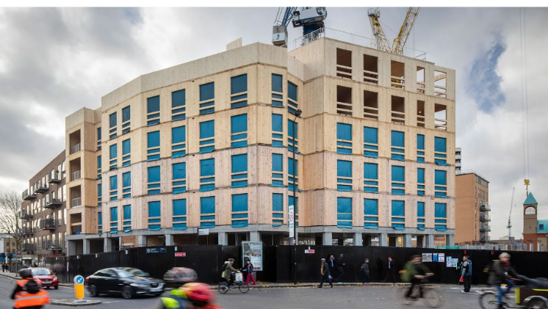

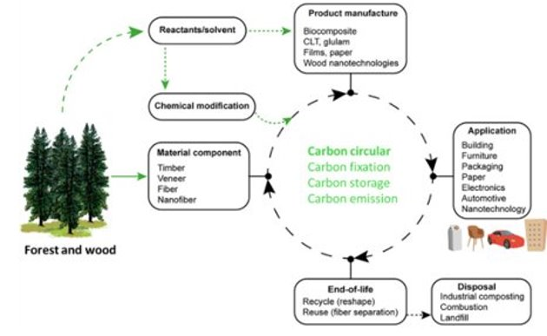

[Carbon cycle](https://www.sciencedirect.com/topics/earth-and-planetary-sciences/carbon-cycle) for forest and wood ([Montanari et al., 2021b](https://www.sciencedirect.com/science/article/pii/S2772656822000288?via%3Dihub#bib0087))

\cite{Ramage2017}