SECTION I NOTES:

Introductory points about the motivation and approach of module DXX-4517 Forest Ecology and Resources
- The module seeks to link a scientific understanding of how natural forests function, as systems (the “ecology”) with how humans use them as “resources” (human needs, resource exploitation and management, their impacts on the ecological function of the systems). An example is (i) how the tree species composition and diversity of forests influences productivity and then, (ii) how forest resource exploitation affects biodiversity.
- While I, as module lecturer, do have a lot of relevant experience to share with you, it is also really important that the learning in the module is informed by: (i) the knowledge that each of you bring, from your experience around the world; (ii) the research (reading, critical assessment, synthesis) that each of you do as individuals and in groups during the module in preparation for the group presentations (you will rapidly discover knowledge that is new to me).
- A key objective of the module is for you to gain a critical understanding of the scientific evidence needed to decide between different options for managing forests, not just for you to learn descriptions of the properties of different forests or the different ways that they have been managed. There is hardly ever a single best forest management practice that is applicable in all contexts. How local conditions influence the predicted effectiveness of different management options is crucial for sustainable forest management.
- A good introduction to controversies in current popular thinking about the world’s forests and the challenges we face in achieving their sustainable management is provided by the WWF/Netflicks “Our Planet” film about global restoration (https://www.ourplanet.com/en/video/how-to-restore-our-forests/). It promotes the idea that a high priority is to establish a new generation of plantations. You may not agree, but by the end of this module you should be able to provide a more informed critical assessment of this issue.
- IUFRO: This is the “International Union of Forestry Research Organisations. The most prestigious global organisation covering research in forestry. Bangor University is a member. IUFRO has recently identified five priority themes (https://www.iufro.org/discover/strategy/):
5.1 Forests for People
5.2 Forests and Climate Change
5.3 Forests and Forest-based Products for a Greener Future
5.4 Biodiversity, Ecosystem Services and Biological Invasions
5.5 Forest, Soil and Water Interactions.
IUFRO has a big focus on the science-policy interface: respond to knowledge needs; acting as an honest broker of knowledge. A key identified need is to bridge the perspectives and activities of policy makers (often short-term) and forest researchers (often long term).
- The FAO State of the World’s Forests 2018 report (http://www.fao.org/documents/card/en/c/I9535EN/) contains a valuable list of key issues for global forestry including: landscape-scale approaches, healthy cities need trees, evidence of value of forests to influence policy, ownership and access. It also links forestry to the need for a holistic approach to food security, thus emphasising the crucial interface between agriculture and forestry.

Key aspects of forest ecology for forest management and assessment

I.1 The main components of ecology
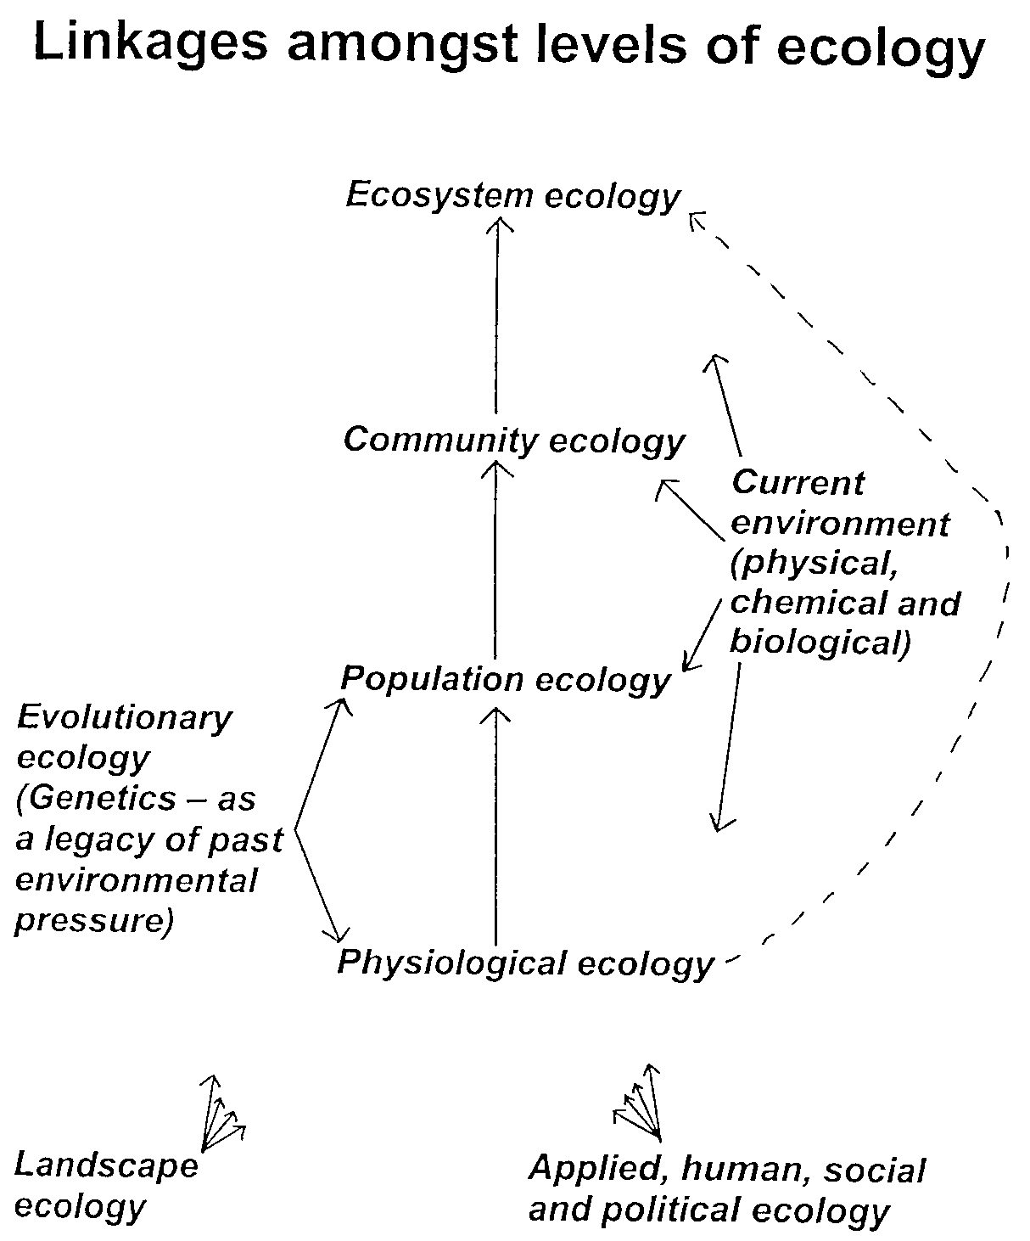

The hierarchical-response framework (HRF). This conceptual framework depicts the hierarchy of mechanisms underlying ecological change (either positive or negative) as ecosystems are exposed over time to chronic (press) resource alterations (black line). Ecological change variables include, but are not limited to, biodiversity, net primary productivity, nitrogen retention, energy balance, trophic structure, and decomposition. In this framework, relatively modest ecosystem responses are initially driven by (A) relatively rapid individual-level (physiological/metabolic, mortality) responses of the biota to changing resource availability. The magnitude and extent of this response will be limited by the degree of physiological/metabolic acclimation and local-scale adaptation possible for the resident species. Large shifts in ecosystem response are expected to emerge with (B) reordering of species in the community as a result of some species being favored by changing conditions at the expense of others. This phase may require longer periods of time depending on the rate of population turnover or may be attenuated depending on the strength of internal interactions. Finally, (C) new species that are better suited for these new resource levels may immigrate into the ecosystem resulting in the largest change in ecosystem response. The lag period prior to this immigration phase will be determined partially by the regional species pool and dispersal limitation, and by the strength of internal interactions in the community. In contrast to this nonlinear series of responses, gradual linear change (gray line) in ecosystem response would occur if the magnitude and rate of change were similar for all three mechanisms (A, B, and C). The hierarchical progression of change ideally depicted by the HRF has potential exceptions. (D) Ecosystems dominated by very long-lived species with slow turnover rates, such as forests, may appear to be resistant to change as resources accumulate over time. Their primary response may be limited to physiological acclimation for decades or centuries until disturbance or a large-scale mortality event results in population/community turnover. Conversely, ecosystems that become susceptible to invasion by exotic species or pests/pathogens due to resource alterations may bypass changes driven by physiological or community reordering and (E) experience large changes in structure and function in a relatively short period of time.
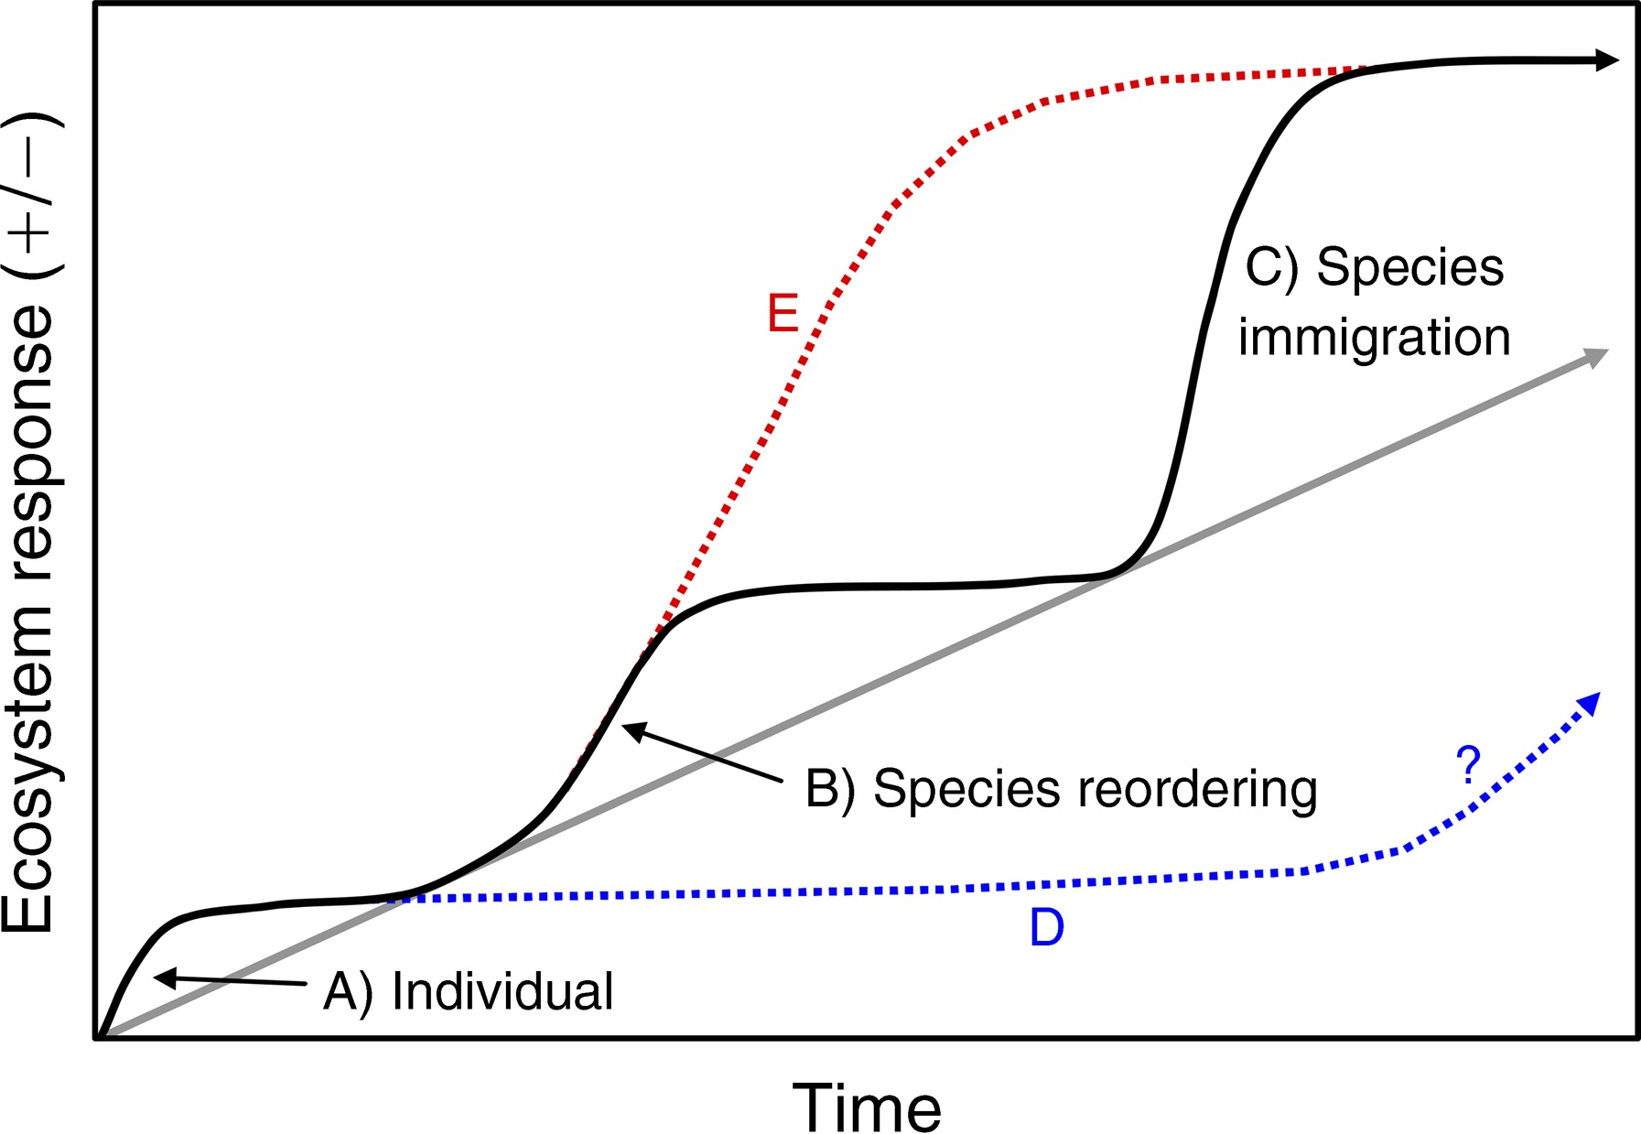
Smith, M.D., Knapp, A.K. & Collins, S.L. (2009). A framework for assessing ecosystem dynamics in response to chronic resource alterations induced by global change. Ecology 90, 3279-89. doi: 10.1890/08-1815.1.

I.2 The landscape context: patches and the matrix, fragmentation, corridors, edges, patch size and shape, the landscape continuum – this links to ‘deforestation’:
(SLIDES IN POWERPOINT)
How does landscape function vary between species? E.g. how strictly dependent are they on certain patch types? how much of a barrier is the matrix?
Effect of edge width on area of inner habitat. Pros and cons of “single large versus several small patches”, and of compact versus elongate patches
.
I.3 The crucial context of the disturbance regime – this links more to forest ‘degradation’:
For individual events:
- spatial-scale
- intensity
- duration
- (species) specificity
The sum of these characteristics of individual event defines the disturbance regime for which one critical additional property is:
- frequency
in determining impact on the forest and its subsequent recovery -
- tolerance: resistance and resilience (properties of individual species’ populations or of the forest as a whole; whole forest resistance and resilience are both increased by species richness and structural diversity)
Disturbance dimension | Examples of tolerance mechanism
spatial-scale | seed dispersal (resilience)
intensity | thick bark (resistance) or seed coat (resilience)
duration | can repeatedly coppice (resistance) or long seed viability/dormancy (resilience)
(species) specificity | specific anti-herbivore chemicals (resistance)
frequency | rapidly reach sexual maturity (short-life cycle) (resilience)

DIAGRAM ON POWERPOINT
- natural versus human disturbance regimes (refer to DXX4034 West African case study)
NB the stochastic nature of natural disturbance (this is part of what defines a force as “disturbance”). Therefore, trying to imitate this in the forest management/harvesting regime may not be feasible. However, more loosely staying within the broad boundaries defined by the natural disturbance regime may be more feasible as a guide for management.
Note how critical the stochastic component of disturbance is in maintaining natural processes/biodiversity (interesting link to current “non-equilibrium” and “neutral” theories of species co-existence).
NB natural fire may (or may not) be a far more intense form of disturbance than even clear-fell logging because of its potential destruction of organic matter, seedlings and seeds.
Note that such analysis of disturbance impacts does not just relate to timber harvesting, or the impact of agriculture. It could also be important, for instance, in assessing hunting or gathering regimes. For hunted animals the rate of killing is compared with the reproductive rate of the population. For the populations of non-wood forest products species we also need to assess whether their exploitation kills the individual, or indeed has any negative impact on its survival, growth and reproduction rates. Even timber harvesting may not kill the cut tree (if it can regrow through coppicing). However, on average harvesting timber causes more disturbance to the remainder of the forest habitat because it such a high volume/high weight commodity that is being removed.
Why has coppicing become such a favourite method for “conservation management” of woodlands and does it really make sense for conserving the most “important” biodiversity values? Undisturbed “neglected” woodland may lack obvious visible species-richness, e.g. of understorey herbaceous plants, butterflies or birds. Coppicing disturbance does increase the richness of these groups. But the populations of many plant species may persist in the mature phase of less frequently disturbed “wildwood” in the soil seed bank. Some of these taxa may even be competitively excluded in more disturbed coppice woodland (soil seed bank seeds germinate but plants cannot then reach reproductive maturity). Also increasing importance is being attached to the “dead wood habitat” (standing or fallen) characteristic of less frequently disturbed woodlands, particularly for rare woodland beetles and other taxa. We will try to quantify it in the module field practicals.
Other examples of management of the disturbance regime in forest management to consider are:
- the management of grazing regimes in woodland habitats (Frans Vera’s hypothesis suggests that natural grazing (and that of early human pastoralists) was the critical factor determining the dynamics structure and biodiversity of north and west European forest landscapes (#4) – POWERPOINT SLIDES
- the control of an invasive species population: e.g. should we use fire, browsing, cutting, harvesting/thinning, crushing, chemical disturbance, specific predators or soil cultivation? But past disturbance was very often the key factor enabling the invasion to occur in the first place: disturbance often increases ecosystem vulnerability to new or re-invasion. So planned disturbance may give you short-term control, but will this be at the cost of longer-term vulnerability? To answer this we need to know what are the relative disturbance tolerances of: the invasive species; species that can potentially out-compete them; other priority species (e.g. of conservation value).

I.4 Distinction between primary succession, secondary succession and regeneration in gaps
Difference in subsequent ecosystem recovery process following different disturbance events (#3.1).
Succession |  | Regeneration
High intensity disturbance | Lower intensity disturbance | Ongoing turnover of individual trees
Primary | Secondary
Note the huge misunderstanding perpetuated by the legacy of out of date succession theory. Empirical evidence does NOT support the generality of convergence towards some theoretical “climax” community. The trajectory and rate of succession are very variable and strongly influenced by even small variations in initial conditions. There is often an underlying tendency towards a certain community type, but this is “probabilistic” not “deterministic”.
Note also the huge problems of confusing terminology the term ‘primary forest’ is used to mean forest that has never been cleared (or even disturbed) by human beings. It has nothing to do with primary succession (if anything it implies something at the other end of the spectrum). But since there is probably no forest that is truly primary by that definition, the term is best avoided altogether. The term ‘old-growth forest’ is a much better neutral alternative.
The term ‘secondary forest’ does usually better correlate with ‘secondary succession’ – it is forest that still shows evidence of having regrown following human, or natural, clearance (though it could equally arise through ‘primary succession).
Over time (provided another intense disturbance event does not intervene) we would predict all ‘secondary forest’ to develop into old-growth forest. There is no clear distinction between the two, but we should simply use the term that best describes the forests visible/measurable characteristics.
The regeneration cycle, niche, regeneration niche context.
DIAGRAMS ON POWERPOINT
Note that forestry is an intervention at different stages of the tree regeneration cycle, e.g. the nursery stage (germination/establishment); seedling (growth/survival); thinning/pruning (building).
Regeneration: plants versus animals: plants stand still (ref. pre-emptive space occupation), so, in general, in an intact forest, a new tree cannot reach maturity until an old one has gone. This leads to, on average, one for one individual canopy tree replacement, which provides a powerful approach to modelling community dynamics. In both plants and animals growth rate will vary between individuals within populations because of genotypic differences. However, in plants there will be additional variation because of the difference in site conditions between the locations where each individual is rooted (whereas animals can move to find the habitat conditions that suit them). This has many consequences, e.g. (i) large differences in the habitat concept between plants and animals; (ii) greater developmental/phenotypic plasticity in plants (e.g. in response to change in environmental conditions experienced during their life spans); (iii) weaker size-age relationships between plants as they develop, however (unlike most animals) plants do continue to grow throughout their life spans.

I.5 Ecological groups of species and different sources of individuals that colonise gaps; functional traits; what are “pioneers”?
- Which species dominate the stages of ecosystem recovery following different disturbance events (#3.1)?
- Why do we need to group species by their ecology?
- At what point does a forest become so species rich that we can no longer target the management to the ecological requirements of each individual species, but instead have to work with species groups?
- But even where we can target individual species, is the species an adequate ecological unit? Note huge intra-specific variation (e.g. breeding system in Hevea brasiliensis), hybridization in plants and the context of phylogeny.
Germination: | LD – Pioneer ¹ | ST - Non-pioneer ²
Seedling: | LD | NPLD | ST
LD = ‘light-demanding’; ST = ‘shade-tolerant’; NPLD = Non-pioneer light-demander.
¹ the term pioneer continues to cause immense confusion: most people take it to mean an early colonising species in succession. This is NOT the same as the classification shown here of light-requirements for germination. Germination light-demanders may be effective early colonisers in succession, but they may not. From the perspective of forest ecology, I recommend distinguishing ‘coloniser’ species (early in successional) from ‘pioneer’ species (germinating in gaps during the forest regeneration cycle).
² in their original paper proposing this binary split, Swaine & Whitmore used the term ‘primary’ for this group of species, but this has now been dropped as it compounded still further all of the confusion with this term mentioned above.
- The definitions are based on light. But light is far from a simple variable. The quantity of “photosynthetically active” radiation generally limits the rate of photosynthesis and thus growth, but this produces a continuum of responses – not a good basis for a classification.
Net photosynthetic rate

Light (PAR, photon flux density)
- Therefore, the primary classification is based on a physiological switch (not a gradual response) based on the quality of light (its spectral composition), the ratio of red : far red light triggers germination in pioneer species via the phytochrome system (as well as other morphological responses in seedlings).
- Light-demanding pioneer and shade-tolerant species can co-exist in the same forest, and at times they will show a clear distinction in their population structures (DIAGRAM ON PREVIOUS PAGE)
- But at the seedling stage we have to use the response to light quantity (more based on survival rate rather than growth) to refine the classification into NPLD and ST species. However, note that light is not the only important limiting resources in forest ecosystems that vary during the regeneration cycle (there are also water, nutrients etc.). ECOLOGICAL CORRELATIONS OF THIS 3-WAY CLASSIFICATION ARE SHOWN ON POWERPOINT.

The character suites for each group of moist tropical tree species relevant to silviculture
Group I II III
Type Light-demanding Intermediate Shade-tolerant
coloniser (pioneer) (non-pioneer (non-pioneer)
light-demander)
WHOLE TREE
Longevity two groups: 5 - 20; or 40-200 100 - 300 > 300
(years)
Height two groups: smallish, often emergents canopy height or less
or canopy height (many sub-canopy spp.)
Wood light, pale, soft, perishable, pale - dark, dark, heavy, close-grained,
e.g. Ochroma lagopus medium weight hard, often salicaceous,
(Balsa) "mahogany" blunten saws, e.g. Chlorocardium
rodiei (Greenheart)
------------------------------------------------------------------------------------------------------------------------------------------------------------------------------
SEED TRAITS
Seed size usually small very variable usually large, but some are small
Seeding high: annual or more often, intermediate, sometimes low: up to very long
frequency tending to continuous with masting years intervals (even 40 years)
Seed very efficient: in tropics often most wind-dispersed, e.g. ? - often unclear, may be
dissemination vertebrate vectors, esp. birds mahoganies with winged animals, seeds often big
& bats, fruit pulpy, may take seeds; this causes a and heavy, and fewer in
seeds to another gap; in large seed shadow number
temperate more often by wind
Seed long: months to years, so weeks to months (rubber none/days: many species
longevity high abundance in the soil seeds had to be taken on have no dormancy, and
(dormancy) seed bank (longevity greater the fastest ships from germinate within days or
than previously thought) Brasil to U.K.) weeks
Germination open sunlight conditions closed/open, various closed (but not obligate for
conditions (from soil seed bank/rain) (from seed rain/ bank) all spp.), seedling bank
------------------------------------------------------------------------------------------------------------------------------------------------------------------------------
SEEDLING/SAPLING GROWTH AND SURVIVAL
Growth in open very fast intermediate slow
sunlight: height 2-10 m y-1 (Paraserianthes 1-5 m y-1 < 1 m y-1
falcataria)
diameter 10-20 cm y-1 5-15 cm y-1 < 10 cm y-1
Growth in none slow/ stagnant slow but sure if small canopy
shade openings present
Survival period short medium long
in shade
------------------------------------------------------------------------------------------------------------------------------------------------------------------------------
MORPHOLOGY
Shoot form multilayer ----------------- monolayer
Root:shoot ratio low (more shoot) ----------------- high (more root)
Protection spines, ants, stings, pubescence, ----------------- Very particular chemical protection,
very edible, only generalist toxins, some species have many toxic
few secondary compounds, chemicals in leaves and wood, very
opportunist species decay resistant timber
Leaf size often very large (macrophyll) ------------------ more "normal" (mesophyll)
Leaf shape/ very variable (often compound) ------------------ elliptic leaves with drip tips, very uni-
form form (evidence for parallel evolution)
Leaf life span short ------------------ long
------------------------------------------------------------------------------------------------------------------------------------------------------------------------------
Invasibility
(weed problems) great less no
Notes:
Dotted lines show where Group II species are thought to have intermediate characteristics (or where you can’t generalise about them, e.g. where it is a two-state character).
Longevity: age determination of trees in the tropics very difficult because of the lack of annual growth rings.
Longevity: there is a clear trend between the groups in minimum age, it is much less clear for maximum age.
Height: the maximum height reached is very variable within and between the groups – so generalizations are not safe.
Seeding frequency: mast fruiting (link to DXX-3301 section 4.2.2)
Seed dissemination: temperate areas have fewer animals (because of winter) and are more windy
Growth in open sunlight: it is in height growth that Group I species are especially rapid.
Shoot form: architectural diversity, multi- versus mono-layered trees (link to DXX3301 section 5.2.2.1)
Protection: in Group I species may be more against the large mammals that are predominant in open/disturbed forest areas (rather than just insects), ref. T. Struhsaker. Whereas in Group III species it is predominantly against insects.
Leaf traits: these are correlated with the branching patterns of species, e.g. Group III species tend to have more branching orders and their leaves tend to be placed in the optimal arrangement for light capture, compared with the more crude arrangement of leaves in Group I species.
Physiological differences are discussed in DXX-3301 section 5.2.2.2. Do not assume that they are any more robust in dividing the groups than the traits shown here, e.g. there are many exceptions to the generalisation that light-demanding species having higher rates of CO2 fixation.
DETAILS OF MORE COMPLEX CLASSIFICATION SCHEMES APPLIED TO EUROPEAN TREE SPECIES BY ELLENBERG ON POWERPOINT
This links to the theoretical issue of the niche concept and the distinction between the ‘fundamental’ and ‘realised’ niche of species.
Note that in hot/dry (e.g. long dry-season) environments, many non-pioneer species may not just be shade-tolerators but, in fact, shade-demanders (at least in terms of the survival of newly planted seedlings and their growth up to a certain size (e.g. of root system development)). Ref. L. Sack & P.J. Grubb; K. McLaren & M.A. McDonald papers. In contrast in moist temperate or tropical forests very few tree seedlings are shade-demanders (provided their root systems do give them access to adequate moisture).
Note also that classification of forest types (and indeed of individual species) as “evergreen” or “deciduous” is very naïve. Many of the world’s forests contain species with a wide range of different leaf phonologies. Many species are not absolutely deciduous or evergreen (e.g. Sambucus nigra).

I.6 Relationship between understanding species’ ecology, of gap dynamics and silviculture :
All of these will be covered in greater detail in module DXX4504; here is just a brief overview.
The importance of disturbance frequency as much as size of disturbed patch, e.g. this is relevant to the role of pre-felling treatments
Note that so many of the highest value timber species are non-pioneer light demanders, so it is their requirements that silviculture is so often direct at.
I. Example of silvicultural system of high intensity, but low frequency, is the Malayan Uniform System in which all trees bigger than a threshold size were cut at the same time. This failed when only shade-tolerant species are left in the seedling/sapling layers, they have little capacity to respond to canopy opening and so the site tends to be swamped by weedy pioneers (leads to secondary succession). So it can only work if the felling is timed just after the mast seeding of the commercially-valuable NPLD dipterocarp species, when they had a large populations of seedlings in the understorey. But then the unpredictability of Dipterocarp masting makes forward planning of forestry operations impossible. A more reliable way of ensuring valuable NPLD species are abundant in understorey is pre-felling treatment (thinning of the canopy) to promote their seed production or seedlings survival.
VI. At the other extreme with low intensity but high frequency is single tree selection – leads to regeneration that tends to favour more ST species, with just occasional success by NPLD. To be sustainable the selection must consider the favouring of future crop trees just as much as selecting which are the most valuable trees to fell now. This leads to methods such as ‘liberation thinning’ (IV below).

 | MUS | Intermediate (strip-clearcut, shelterwood, liberation thinning) | Single-tree selection
intensity | High |  | Low
frequency | Low |  | high

In between are:
II Strip clearcut (fell trees only in a narrow strip to limit disturbance area and components of intensity). Intensity of disturbance within each strip is low, but is higher over a larger spatial scale.
III Shelterwood (maintain a partial canopy over a large area to limit disturbance intensity); leads to two or three disturbance events in quick succession (high frequency) followed by a long period with no disturbance.
IV Group selection or liberation thinning (spatially target felling, so that intensive disturbance is only applied where there is are established trees of desirable trees that can immediately benefit from the increase in resources). In liberation thinning you select the tree to promote rather than to fell. Note that mortality is a natural process as tree populations grow (shown by the ‘survivorship curve’), i.e. ‘self-thinning’ will occur. In our management, by artificially thinning we are accelerating this natural process and selecting which trees are thinned and which are most likely to survive (thus increasing the proportion of biomass production that goes into the growth of future harvested trees).

I.7 Gap definitions - horizontal and vertical – gap partitioning
How far does the environmental influence of the gap extend? SEE DIAGRAM IN POWERPOINT.
- Horizontal gap definition: note centre and edge zone;
change as adjacent trees grow/dieback.
For how long does the environmental influence of the gap last
(as the new regenerating trees grow up to the canopy)?
- Vertical gap definition: damage and recovery.

I.8 Limiting factors/environmental cues
centre of gap
Environmental cues: gap formation not only leads to more light; also to more water because of less canopy interception as well as less uptake by root sink; also to more nutrients -–pulse from leaf decay in crown zone, also less uptake by root sink in root zone.
Note properties of light: (i) total energy (leads to scorching of shade leaves etc.); (ii) Photosynthetically Active Radiation (PAR, 400-700 nm); (iii) R:FR [including their daily and seasonal variations].

NB Ecological (interactions) component of modern biodiversity definitions
e.g. plant-animal interactions (details in section III)).

I.9 Maintenance of biodiversity; species relative abundance
What regulates the abundance of each species in the habitat/community (and hence its overall biodiversity)? Debate emanating from explanations of maintenance of species richness: each species with a unique niche and function in the ecosystem versus much species redundancy (ref. DXX3301). The regeneration niche and thus the importance of the gap phase of the regeneration cycle. Niche partitioning (e.g. J. P. Grime vs D. Tilman), thus gap partitioning (Denslow) versus density- (or frequency-) dependent selection (against more abundant species versus non-equilibrium and lottery models (S. Hubbell, S.Pacala etc.) – more details in section III.

I.10 Summary - ecology: (the study of) the relationship between organisms and their environment

Site location
Short Time scale long

CO₂ Temperature

Nutrients Plant communities (NVC, ESC etc.) ¹

Water

Light ⁴

Forest structure and dynamics ²

Natural disturbance and Forest management history³

Pollution ⁵

¹ NVC = “National Vegetation Classification”; ESC = “Ecological Site Classification”
² Some interaction: site with forest structure and dynamics + vice versa. Forest structure and dynamics will affect nutrient and water availability
³ Windiness is indicated in UK by “DAMS” but note need to better model catastrophic events which are key to forest dynamics. Management influence on felling, planting, weeding, cultivation, animals, fire etc. also directly impact on the plant community.
⁴ Light was not traditionally considered a factor determining plant communities, but in forests the level of canopy shade has a major impact on the ground layer community.
⁵ Recent pollution is changing CO₂ concentrations much more rapidly than previously.

A more ecological characterisation:

Group I II III
Type Light-demanding Intermediate Shade-tolerant
coloniser (pioneer) (non-pioneer (non-pioneer)
light-demander)
Germination in no yes yes
shade

Seedling survival no short-lived long-lived
in shade

Soil seed bank yes intermediate no

Seed rain often/abundant variable infrequent/few

Seedlings/ very rare intermediate/intermittent, abundant/constant,
saplings in shade may be young seedlings include old saplings
only

Most favourable large patch/intense moderate-intensity very low-intensity
disturbance disturbance (even if high-frequency periodic disturbance
regime frequency is low) disturbance

In gaps expect to dominate variable subordinate

Population
size-class
distribution in
closed-canopy
forest

Probable probably probably intermediate must be shade tolerant
tolerance intolerant
of shade

Local population not probably not uncertain
in short-term
equilibrium

Population age- composed of discrete variable probably composed of a wide
class structure ¹ age cohorts range of ages

Change in local
population
size-class
distribution
over time

(one cohort during
its development)
-------------------------------------------------------------------------------------------------------------------------------------------------------------
Notes
¹ – at a local scale and where intense disturbance is periodic

