**Coca-Cola CEO: Knowing ‘what not to prioritise’ is just as important for growth**

***Enhanced data capabilities have enabled Coca-Cola to understand better where and how its growth is generated, CEO James Quincey says.***

Coca-Cola’s success has come from knowing “what not to prioritise” as much as chasing new opportunities, says the company’s CEO James Quincey.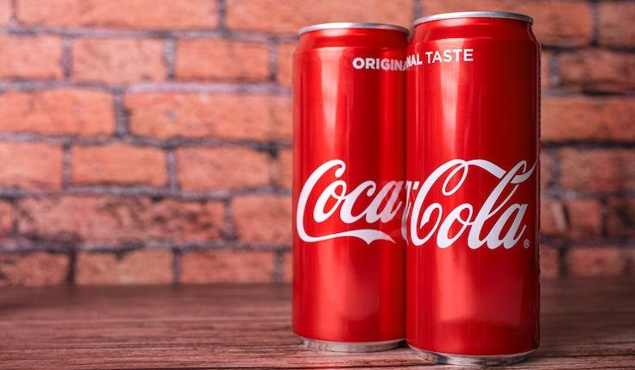

The soft drinks giant is using data to better understand how to deploy its resources, including marketing spend and investment for innovation, to fuel topline growth.

“We’ve got clearer and clearer where and how money is made,” he said, speaking at the Barclays Global Consumer Staples Conference today (7 September).

The company takes an approach that combines “insight and culture” to understand how to deploy investments. This determines how it launches innovations and expands new categories such as ready-to-drink alcohol in particular markets.

Quincey said there is a risk that the company overextends itself when trying to move into new areas, which would spread its resources too thin. It uses data to go after “not just… the best opportunities but the most winnable opportunities in the short term”.

He highlighted the dynamism of what he termed the company’s “all-weather approach”. The past few years have been chaotic on a macro-level, he said, with the world going from crisis to crisis.

“We can’t tell what the weather’s going to be like next year or any particular year,” he said, while stating this year had served as further proof that Coca-Cola is equipped for topline growth regardless of macroeconomic “weather”.

***In the end, you’re doing marketing to support, sustain and grow the business.***

In its [most recent results](https://www.marketingweek.com/coca-cola-credits-world-class-marketing-as-it-ups-growth-forecast/) for the three months ended 30 June 2023, Coca-Cola upped its revenue guidance for the year, after “delivering on its strategy” and generating net revenue growth of 6% in its second quarter.

That strategy has included a transformation of Coca-Cola’s marketing to create a more “harmonised” function. This has included reducing the number of agencies the company works with and creating more “synchronised” systems.

Speaking to an audience consisting mainly of investors at the Barclays conference, Quincey explained the primary goal of the marketing transformation is to drive commercial growth.

“In the end, you’re doing marketing to support, sustain and grow the business,” he said.

The metric Coca-Cola uses to judge this goal is increasing “weekly plus drinkers”, which means acquiring consumers to grow its brands.

Quincey said he and Coca-Cola CMO Manolo Arroyo are aligned on this goal for the marketing transformation, however, he acknowledges that other measures of success will layer up to this.

The marketing system works best when the company itself, retailers and bottlers are aligned on commercial goals, he added.

**Question 1: Implement the principles of market segmentation by identifying the STP process followed by Coca-Cola.**

**Question 2: Explain the concept of the marketing mix(4Ps) and its significance in marketing strategy for Coca-Cola**