**Table of contents**

**Introduction**

**(200–300 words)**

• Define entrepreneurship and the entrepreneurial mindset.

• Explain the importance of studying entrepreneurial ventures in various contexts.

• Outline the scope of the analysis (e.g., examining the mindset and evaluating similarities/differences).

• State the purpose and objectives of the paper.

**The Entrepreneurial Mindset (500–600 words)**

“The end of all the cognition and motivation of entrepreneurs is to take some action in the world” (Bird & Schjoedt, 2009, p. 327)

2.1 *Characteristics of the Entrepreneurial Mindset*

• Define the entrepreneurial mindset and its key traits (e.g., innovation, risk-taking, resilience).

• Use academic sources to support the definition and characteristics.

• Examples of entrepreneurs with distinct mindsets.

2.2 *Nurturing and Encouraging the Entrepreneurial Mindset*

• Discuss how the entrepreneurial mindset can be developed and nurtured in different population groups (e.g., youth, women, underrepresented communities).

• Highlight government initiatives, education programs, and private-sector efforts.

• Include examples of programs or case studies (e.g., accelerators, incubators).

2.3 Supporting New Ventures Through Mindset

• Explain how the entrepreneurial mindset contributes to the success of new ventures.

• Provide examples of entrepreneurs whose mindset led to successful ventures.

• Discuss the role of mentors, networks, and resources.

**Evaluation of Entrepreneurial Ventures (500–600 words)**

*Types of Entrepreneurial Ventures*

• Define different types of entrepreneurial ventures (e.g., lifestyle businesses, scalable startups, social enterprises).

• Provide examples of each type and the industries they are in.

Entrepreneurial ventures can be categorized into different types, including:

1. Small Business = Typically family owned businesses focused on sustainability rather than rapid growth(Burns, 2016)

2. Scalable startups = High grow companies aiming for large market opportunities, often funded by venture capital (Blank,2020)

Airbnb

3. Social enterprise=Ventures that prioritize social impact over financial gains (Dees, 2018)

Patagonia

4. Large company entrepreneurship = Referring to companies like Disney, google and Microsoft who have finite life cycles, meaning that they keep innovating around the core product line

Amazon

*Similarities and Differences Between Ventures*

• Compare the types of ventures in terms of objectives, resources, and growth potential.

• Use specific examples to illustrate similarities and differences.

*Traits and Characteristics of Entrepreneurs*

• Discuss the traits commonly seen in entrepreneurs across different ventures (e.g., leadership, adaptability).

• Analyze how the traits may vary depending on the type of venture.

• Provide examples from a range of entrepreneurs to illustrate diversity.

Insights From Interviews (300–400 words)

• Summarize key findings from interviews with local entrepreneurs, sole traders, or small business founders (if applicable).

• Highlight factors that encouraged and supported their entrepreneurial journey (e.g., access to funding, community support, personal motivation).

• Reflect on how these insights connect to the academic concepts discussed earlier.

**Conclusion (200–300 words)**

• Summarize the key findings about the entrepreneurial mindset and types of ventures.

• Reflect on the importance of supporting entrepreneurial ventures for economic and social growth.

• Provide actionable recommendations for fostering entrepreneurial initiatives (e.g., policies, educational frameworks).

**References**

Appendix 1

Poster

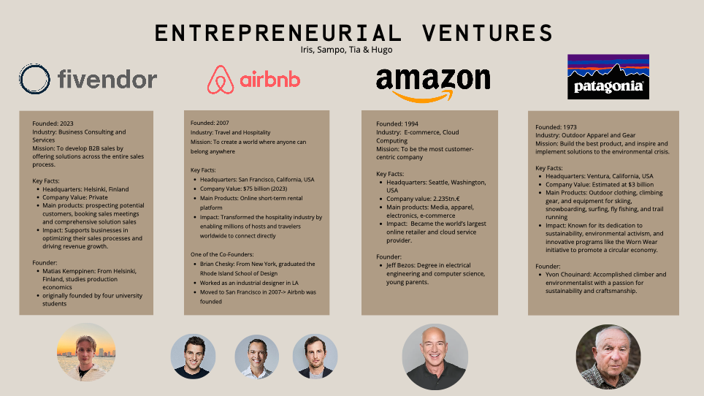

Appendix 2

Full Interview

**Ismo Jokinen's interview**

**First of all, what inspired you to start your own business?**

Well, I was inspired to become an entrepreneur out of necessity. I mean, I got fired. This happened back in 1993, so it’s been quite a long time. But it was a necessity in the sense that I lost my job during a recession when job opportunities were scarce.

On the other hand, my background is that my father was always an entrepreneur, and he constantly advised me never to become one because it would bring too many difficulties. He also told me never to hire anyone. That’s the background.

But then I became unemployed. I received a good severance package, which was equivalent to eight months’ salary. When I registered as unemployed, the employment office manager interviewed me and said, “You clearly have an entrepreneurial personality.” And he was probably right.

It was a combination of being forced to think of something new and having the kind of personality that naturally approached work with an entrepreneurial mindset. That’s what led me to entrepreneurship.

**What kind of challenges or difficulties did you face in the beginning?**

**And was there anyone who served as a role model or mentor, someone who ultimately influenced your decision to pursue entrepreneurship?**

A local city official responsible for supporting entrepreneurship, who also happened to be my friend, was the person who told me that I clearly had an entrepreneurial nature. He provided a lot of advice, we had numerous discussions, and he even helped come up with the name for my first business. He was very much involved in the process.

As for deciding the business sector, that partly came from my hobbies. I had been performing since I was 13 years old. I had worked as a DJ, hosted events, and done other similar gigs. So, my business naturally focused on being a performer—voice production, radio work, and so on.

In this, I was supported by people who already had businesses in the field. For example, the owner of an audio advertising company was someone I talked to about how much demand there might be for voice-over work.

So those were the mentors and people who encouraged and advised me back then.

**What were the biggest challenges at the beginning, and did they change over time?**

**Also, did you need financial support, or did you take out a loan?**

Since it was a one-person business without significant investments, the main expenses were my own salary and living costs. The biggest challenge was marketing, how to market with minimal funds and find the right channels to promote my services. At that time, local radio stations were just starting to gain traction, and more TV channels were emerging. There was work available, but figuring out how to find it was challenging.

Building credibility was another issue, convincing clients that I was good at what I did and capable.

Financially, I was supported by the employment office manager, who advised me to apply for a startup grant (starttiraha). I received it for a year, first for six months, and then for another six months. That, along with the eight months of severance pay, helped me financially during the initial phase.

Between getting fired and starting the business, there was about a six-month gap due to the startup grant requirements. At that time, you had to be unemployed for six months to qualify, and the law had just changed before I was laid off. I was lucky to be eligible under the new regulations.

**Did you face financial difficulties despite the available support?**

No, I didn’t face major financial problems thanks to the severance package and the startup grant. At that time, there probably weren’t as many financial support options for small entrepreneurs as there are today.

**What are the most important traits for becoming an entrepreneur?**

In my opinion, having an entrepreneurial mindset is crucial. Even when I worked for others, I had a proactive attitude, I didn’t limit myself to just doing the bare minimum. I used my creativity and various skills in my job.

Starting a business requires being willing to prioritize work over everything else, especially in the early stages. Many new entrepreneurs don’t have much free time, as all their energy goes into getting the business off the ground.

Your mindset should be focused on making things work, not just doing the minimum required. Whether you’re working for someone else or yourself, the approach should always be: “What can I do to make this successful?”

**Did you take any courses or formal education to support your business?**

It was mostly on-the-job learning for me. The industry I ended up in TV production, didn’t have as many educational opportunities back then as it does now.

At that time, people were hired based on their potential, and I tried to learn as much as possible from experienced professionals. It wasn’t always easy, as the industry was competitive, but once I proved I was a good fit and not a threat to others, I received a lot of valuable advice.

For example, an experienced cameraman once told me how to carry a heavy 12-kilo camera without hurting my back. I also learned lighting techniques from experts who had decades of experience in TV production.

These opportunities to learn from experienced professionals were invaluable, and I approached them with humility and a willingness to learn.

**Did you encounter any difficulties with business registration or permits?**

No, I started with a sole proprietorship, which at the time required just filling out a form at the police station. However, with a sole proprietorship, I was personally liable for everything.

Later, I transitioned to a limited partnership, and eventually, I established a limited liability company.

**How has innovation and technology affected your business?**

The TV industry has changed drastically over the past 30 years. Back then, professional equipment was expensive, and only trained professionals could do the work. Today, anyone can create a TV program using just a smartphone.

Editing used to require special skills and equipment, but now it’s accessible to everyone. This shift has made it easier to enter the industry but has also increased competition.

**What advice would you give to someone starting a business today?**

Nowadays, there are numerous advisory services available for entrepreneurs, governmental, municipal, and industry-specific. It’s important to seek advice and find a mentor.

Be humble enough to acknowledge what you know and what you need to learn. Look for training opportunities that can be done alongside your work.

On the financial side, it’s crucial to have trustworthy partners who understand investment, loans, and financial planning.

Also, from day one, take care of all the legal and administrative aspects, such as taxes and insurance. That way, you won’t face surprises later on.

**What impact did the COVID-19 pandemic have on your business?**

During the pandemic, many small businesses, especially sole proprietorships, struggled significantly. The financial support available for solo entrepreneurs was minimal, often just a few hundred euros.

I was able to receive some unemployment benefits while still working on small projects, but it was a tough period.

Many businesses with larger investments and employees went bankrupt quickly due to ongoing expenses and the lack of incoming revenue.