[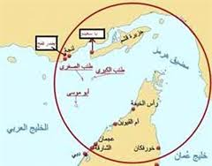](http://www.google.ae/imgres?imgurl=http://www.alanba.com.kw/articlefiles/2011/04/190061-2p47.jpg&imgrefurl=http://www.alanba.com.kw/ar/arabic-international-news/190061/24-04-2011&h=236&w=300&tbnid=SjmjyuQBAHQMhM:&zoom=1&docid=wk3_hm63pQb3eM&ei=viB3VPKmGczvaLWfgZgJ&tbm=isch&ved=0CHsQMyhVMFU&iact=rc&uact=3&dur=1884&page=4&start=77&ndsp=20)

**Chapter - 3**

**Development Theories**

**What Does Represent to the GCC Countries?**

Development is the **set of relations** among people, including their **social status** and **roles.**

By extension, society denotes the people of a region or country, sometimes even the world, taken as a whole.

Used in the sense of an association, a society is a body of individuals outlined by the bounds of functional interdependence, possibly comprising characteristics such as [**national**](http://en.wikipedia.org/wiki/National_identity) or [**cultural identity**](http://en.wikipedia.org/wiki/Cultural_identity), [**social solidarity**](http://en.wikipedia.org/wiki/Social_solidarity), [**language**](http://en.wikipedia.org/wiki/Language) or [**hierarchical organization**](http://en.wikipedia.org/wiki/Eusociality)**.**

Human societies are characterized by patterns of relationships between individuals sharing a distinctive[**culture**](http://en.wikipedia.org/wiki/Culture) and [**institutions**](http://en.wikipedia.org/wiki/Institutions).

Like other communities or groups, a ***society*** allows its members to achieve needs or wishes they could not fulfill alone.

Those interested in the history of nations, from the ancient ages till the present time would realize that the growth of nations in a distinctive manner relies upon how interested people are in education and culture as propelling factor for achieving progress.

In order for us to be an integral element of the civilization, we have to make sure our culture is reliant on sold knowledge and education.

The yard stick by which progress is measured, is the achievement in culture and science.

It is an incessant movement towards a **bright future** a **wide horizon.**

**Development means that practical efforts to invest and mobilize all resources, human and material resources to achieve the objectives of the community.**

**Development** was defined as:

“**All the processes and efforts that are planned and designed to produce a sequence of social and economic changes intended and designed to increase the overall welfare of members of society, and take the society from a social and economic status is set to better.”**

**Development** identified as;

**“The goal of general and comprehensive dynamic process occurring in the community and find their manifestation in the series of structural and functional changes that affect components of society.**

This process is dependent on controlling the **size** and **quality** of material and **human resources** available to reach their fullest possible use, to the maximum period of feasible in order to achieve economic prosperity and social objectives for the majority of members of the community.”

More broadly, a ***society*** is an [**economic**](http://en.wikipedia.org/wiki/Economic)**,** [**social**](http://en.wikipedia.org/wiki/Social) or [**industrial**](http://en.wikipedia.org/wiki/Industry) [**infrastructure**](http://en.wikipedia.org/wiki/Infrastructure), made up of a varied collection of individuals. Members of a ***society*** may be from different [**ethnic groups**](http://en.wikipedia.org/wiki/Ethnic_group)**...**

The word ***society*** may also refer to an [**organized**](http://en.wikipedia.org/wiki/Organization)[**voluntary association**](http://en.wikipedia.org/wiki/Voluntary_association) of people for religious, benevolent, cultural, scientific, political, patriotic, or other purposes.

A ***"society"*** may even, though more by means of **metaphor** refer to a [**social organism**](http://en.wikipedia.org/wiki/Social_organism) such as an [**ant colony**](http://en.wikipedia.org/wiki/Ant_colony)**.**

According to anthropologist [**Maurice Godelier**](http://en.wikipedia.org/wiki/Maurice_Godelier)**,** one critical novelty in human society, in contrast to humanity's closest biological relatives **(**[**chimpanzees**](http://en.wikipedia.org/wiki/Chimpanzees) and [**bonobo**](http://en.wikipedia.org/wiki/Bonobo)**),** is the parental role assumed by the males, which were unaware of their "father" connection.

Sociologist [**Gerhard Lenski**](http://en.wikipedia.org/wiki/Gerhard_Lenski) **differentiates societies** based on their level of **technology, communication and economy:**

**1-**Hunters and gatherers,

**2-**simple agricultural**,**

**3-**Advanced agricultural,

**4-**Industrial,

**5-**Special (e.g. fishing societies or maritime societies).

This is somewhat similar to the system earlier developed by [**Anthropologists**](http://en.wikipedia.org/wiki/Anthropologists) **Morton H. Fried**, **a conflict theorist,** and [**Elman Service**](http://en.wikipedia.org/wiki/Elman_Service)**,** an **integration theorist**, who have produced a system of classification for societies in all human cultures based on the evolution of [**social inequality**](http://en.wikipedia.org/wiki/Social_inequality) and the role of the [**state**](http://en.wikipedia.org/wiki/Sovereign_state).

This system of classification contains ***four categories:***

**1=** [**Hunter-gatherer**](http://en.wikipedia.org/wiki/Hunter-gatherer) bands (categorization on duties and responsibilities.)

**2=** [**Tribal**](http://en.wikipedia.org/wiki/Tribe) societies in which there are some limited instances of [social rank](http://en.wikipedia.org/wiki/Social_rank) and prestige.

**3=** [**Stratified**](http://en.wikipedia.org/wiki/Social_stratification)structures led by [**chieftains**](http://en.wikipedia.org/wiki/Tribal_chief)**.**

**4=** [**Civilizations**](http://en.wikipedia.org/wiki/Civilization), with complex social hierarchies and organized, [**institutional governments**](http://en.wikipedia.org/w/index.php?title=Institutional_governments&action=edit&redlink=1)**.**

In addition to this there are:

[**Humanity**](http://en.wikipedia.org/wiki/All_humanity)**,** mankind that upon which rest all the elements of society, including society's beliefs .

[**Virtual society**](http://en.wikipedia.org/wiki/Sociology_of_the_Internet) is a society based on online identity, which is evolving in the [**information age**](http://en.wikipedia.org/wiki/Information_age)**.**

Over time, some [**cultures**](http://en.wikipedia.org/wiki/Cultures)have progressed toward more-complex forms of [**organization**](http://en.wikipedia.org/wiki/Organization)and control.

This [**cultural evolution**](http://en.wikipedia.org/wiki/Cultural_evolution) has a profound effect on patterns of community.

**1-Hunter-gatherer** tribes settled around seasonal food stocks to become [**agrarian villages**](http://en.wikipedia.org/wiki/Neolithic_Revolution)**.**

**2-Villages** grew to become towns and **cities.**

**3-Cities** turned into [**city-states**](http://en.wikipedia.org/wiki/City-state) and [**nation-states**](http://en.wikipedia.org/wiki/Nation-state)**.**

Today, anthropologists and many social scientists vigorously oppose the notion of ***cultural evolution*** and rigid "stages" such as these.

In fact, much anthropological data has suggested that complexity (civilization, population growth and density, specialization, etc.) does not always take the form of hierarchical social organization or stratification.

Also, [**cultural relativism**](http://en.wikipedia.org/wiki/Cultural_relativism) as a widespread approach/ethic has largely replaced notions of **"primitive,"** better/worse, or "**progress"** in relation to cultures (including their material culture/technology and social organization).

**Civil society**

Is composed of the totality of voluntary civic and social organizations and institutions that form the basis of a functioning[**society**](http://en.wikipedia.org/wiki/Society) as opposed to the force-backed structures of a [**state**](http://en.wikipedia.org/wiki/Sovereign_state)(regardless of that state's political system) and commercial institutions of the [**market**](http://en.wikipedia.org/wiki/Market) **.**

There are myriad definitions of **civil society** in the post-modern sense.

The [**London School of Economics**](http://en.wikipedia.org/wiki/London_School_of_Economics) **Centre** **for Civil Society's** working definition is illustrative:

**Civil society** refers to the arena of uncoerced [**collective action**](http://en.wikipedia.org/wiki/Collective_action) around shared [**interests**](http://en.wikipedia.org/wiki/Interests), purposes and [**values**](http://en.wikipedia.org/wiki/Value_(personal_and_cultural))**.**

In theory, its institutional forms are distinct from those of the [**state**](http://en.wikipedia.org/wiki/Sovereign_state)**,** [**family**](http://en.wikipedia.org/wiki/Family) and [**market**](http://en.wikipedia.org/wiki/Market)**.**

Though in practice, the boundaries between state, civil society, family and market are often complex, blurred and negotiated.

**Civil society** commonly embraces a diversity of spaces, actors and institutional forms, varying in their degree of formality, autonomy and power.

**Civil societies** are often populated by organizations such as: - **registered charities, development non-governmental organizations, community groups, women's organizations, faith-based organizations, professional associations,** [**trade unions**](http://en.wikipedia.org/wiki/Trade_union)**, self-help groups,** [**social movements**](http://en.wikipedia.org/wiki/Social_movement)**, business associations, coalitions and advocacy groups.**

The process of **Development** is a **Social Action** directed towards creating structural transformations which would lead to the formation of the basic foundation and the launching of self-production capacity.

This would **enhance** the average productivity of the individual as well as the capacity of community within a framework of social relations.

The idea of effort and reward is asserted and the participation in providing of the basic needs and the safeguarding of the individual social and national security is ensured.

To understand well the **Process of Development** we have to go through the following **Theories** of **Development.**

**Development theories**

**Is** a conglomeration of [**theories**](http://en.wikipedia.org/wiki/Theory)about how desirable change in society is best to be achieved**?**

Such theories draw on a variety of social scientific disciplines and approaches.

**1= Modernization Theory**

Is a theory of development which states that the development can be achieved through following the processes of development that were used by the currently [**developed countries**](http://en.wikipedia.org/wiki/Developed_countries)**.**

Scholars such as [**Walt Rostow**](http://en.wikipedia.org/wiki/Walt_Rostow) and [**A.F.K. Organski**](http://en.wikipedia.org/wiki/A.F.K._Organski) developed stages of development through which every country develops. [**Samuel Huntington**](http://en.wikipedia.org/wiki/Samuel_P._Huntington) determined development to be a

[**Linear process**](http://en.wikipedia.org/w/index.php?title=Linear_process&action=edit&redlink=1) which every country must go through .

**Modernization Theory**, in contrast to [**Classical Liberalism**](http://en.wikipedia.org/wiki/Classical_Liberalism)**,** **viewed the** [**state**](http://en.wikipedia.org/wiki/Sovereign_state) **as a central actor in modernizing "backward"** or **"underdeveloped"** societies.

[**Talcott Parsons**](http://en.wikipedia.org/wiki/Talcott_Parsons)**'** **action theory** defined the qualities that distinguished **"modern"** and **"traditional"** societies.

**1-**[**Education**](http://en.wikipedia.org/wiki/Education)was viewed **as key** to creating modern individuals.

**2-**[**Technology**](http://en.wikipedia.org/wiki/Technology) played a **key role** in this development theory because it was believed that as technology was developed and introduced to lesser developed countries it would spur [**Economic Growth**](http://en.wikipedia.org/wiki/Economic_growth)**.**

One key factor in **Modernization Theory** is the belief that development requires the assistance of developed countries to aid [**developing countries**](http://en.wikipedia.org/wiki/Developing_countries) to learn from their development.

In addition, it was believed that the lesser developed countries would develop and grow faster than developed countries.

**Thus,** this theory is built upon the theory that it is possible for equal development to be reached between the developed and lesser developed countries.

### 2= Dependency theory

While **Modernization Theory** understood development and [**underdevelopment**](http://en.wikipedia.org/wiki/Underdevelopment)as a result from **internal conditions** that differ between economies,

**Dependency theory** understood development and underdevelopment as relational.

It saw the world's nations as divided into ***a core*** of **wealthy** **nations** which dominate ***a periphery*** of **poor nations** whose main function in the system is to provide cheap labor and raw materials to the **core.**

**Dependency theory** shared many points with **Rosa** **Luxembourg's** and **V.I. Lenin's** earlier, **Marxist**, **theories** of **imperialism**; and **dependency theory** was embraced by many **Marxists** and **neo-Marxists.**

**Dependency theorists** held that for underdeveloped nations to develop, they must **break their ties** with developed nations and pursue **internal growth**.

One type of policy crafted from this insight was [**Import substitution industrialization**](http://en.wikipedia.org/wiki/Import_substitution_industrialization)**.**

### 3= World systems theory

In response to some of the criticisms of **Dependency Theory** came **World Systems Theory**, which the division of periphery and center was further divided into a remodel system consisting of the **core**, [**semi-periphery**](http://en.wikipedia.org/wiki/Semi-periphery) and **periphery.**

In this system, the **semi-periphery** lies between the **core** and **periphery** and is exploited by the **core** and exploits the **periphery.**

This division aims to explain the industrialization within lesser developed countries.

**World** **Systems Theory** was initiated by [**Immanuel Wallerstein**](http://en.wikipedia.org/wiki/Immanuel_Wallerstein) in, among other writings, [**World Systems Analysis**](http://en.wikipedia.org/w/index.php?title=World_Systems_Analysis&action=edit&redlink=1) and focuses on [**inequality**](http://en.wikipedia.org/wiki/Inequality)as a separate entity from growth in development and examines change in the global [**capitalist**](http://en.wikipedia.org/wiki/Capitalism) system.

One distinguishing feature of this theory **is distrust** for the state and a view in which the state is seen as a group of elites and that industrialization cannot **be equated** with development.

Out of this theory stem [a**nti-systemic**](http://en.wikipedia.org/w/index.php?title=Anti-systemic&action=edit&redlink=1) movements which attempt to reverse the terms of the system's inequality through [**social democratic**](http://en.wikipedia.org/wiki/Social_democratic)and [**labor movements**](http://en.wikipedia.org/wiki/Labor_movements)**.**

### 4= State Intervention theory

In response to the distrust of the state in **World Systems** **Theory**, is [**state intervention theory**](http://en.wikipedia.org/w/index.php?title=State_theory_(politics)&action=edit&redlink=1).

**State Intervention Theory** is based upon the view that the economy is intertwined with [**politics**](http://en.wikipedia.org/wiki/Politics)and therefore the take-off period in development is unique to each country.

**State Intervention Theory** emphasized the effects of class relations and the strength and autonomy of the state on historical outcomes.

Thus, development involves interactions between the **state** and **social relations** because class relations and the nature of the state impact the ability of the state to function.

Development is dependent upon state stability and influence externally as well as internally.

**State Intervention Theorists** believe that a [**develop mentalist**](http://en.wikipedia.org/wiki/Developmentalism) state is required for development by taking control of the development process within one state.

**5= Uneven and combined development**

Is a [**Marxis**t](http://en.wikipedia.org/wiki/Marxist) concept to describe the overall dynamics of human history**?**

It was originally used by the **Russian revolutionary** [**Leon Trotsky**](http://en.wikipedia.org/wiki/Leon_Trotsky) around the turn of the [**20th century**](http://en.wikipedia.org/wiki/20th_century)**,** when he was analyzing the developmental possibilities that existed for the economy and civilization in the [**Russian empire**](http://en.wikipedia.org/wiki/Russian_empire)**,** and the likely future of the **Tsarist regime in Russia.**

It was the basis of his political strategy of [**permanent revolution**](http://en.wikipedia.org/wiki/Permanent_revolution)**,** which implied a rejection of the idea that a human society inevitably developed through a uni-linear sequence of necessary [**"stages"**](http://en.wikipedia.org/wiki/Modernization_theory)**.**

At first, **Trotsky** intended this concept only to describe a characteristic evolutionary pattern in the worldwide expansion of the [**capitalist**](http://en.wikipedia.org/wiki/Capitalim) mode of production from the **16th century** onwards.

Through the growth of a world market which connected more and more peoples and territories together through [**trade**](http://en.wikipedia.org/wiki/Trade)**,** [**migration**](http://en.wikipedia.org/wiki/Migration)**,** and [**investment**](http://en.wikipedia.org/wiki/Investment)**.**

The concept of **uneven and combined development** to the whole of human history, and even to processes of

[**Evolutionary biology**](http://en.wikipedia.org/wiki/Evolutionary_biology)**,** as well as the formation of the [**Human personality**](http://en.wikipedia.org/wiki/Personality_development) **.**

**Chapter -- 4**

1. **Characteristics of the GCC Countries**

|  |
| --- |
|  |

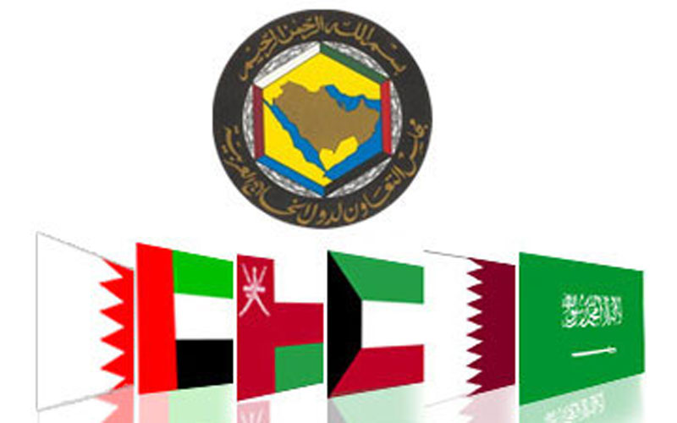

On 21st Rajab **1401 A.H** corresponding to **25th May 1981**, their Majesties and highnesses, the leaders of the **UAE, State of Bahrain (kingdom of Bahrain) State of Qatar , State of Kuwait, Kingdom of Saudi Arabia and Sultanate of Oman met in Abu** **Dhabi, UAE,** where they reached a cooperative framework joining the six states to effect **coordination,** **integration** and **inter-connection** among the **Member States** in all fields in order to achieve **unity,** which means deepening and strengthening of relations, links and areas of cooperation among their citizens.

Confirm the **special relations**, **common qualities** and **similar systems** founded on the need of **Islam,** faith in a common destiny and **sharing one goal,** and that the cooperation among these states would serve the sublime objectives of the **Arab Nation**.

The main objectives of the **GCC** are to effect **coordination,** **integration** and **inter-connection** between **Member States** in all fields, strengthening ties between their peoples, formulating similar regulations in various fields such as (**economy, finance, trade, customs, tourism, legislation,** **administration,** as well as fostering scientific and technical progress in **industry, mining, agriculture, water and animal** **resources,** establishing **scientific research centers** **setting up joint ventures**, and **encouraging cooperation of the sectors).**

The creation of the **Gulf Cooperation Council** is a response to the historical, social, cultural, political, and strategic realities of the **Arabian Gulf** region past and present.

The situation in the region is more critical now than at any time in the past and regional problems must be solve for the benefit of the region’s popup.

Following the sum of positive and effective bilateral and collective steps taken thus far, the **natural solidarity** which links the **Arab Countries** of the **Gulf** is such that it warrants a collective framework and deserves to emerge in more enhanced and perceptible mode for the benefit of the region’s peoples.

The present age is moving towards larger political and economic units to preserve **stability**, **security** and **progress,** and to resolve the rifts which have befallen many states in other parts of the world, states which have learnt their lesson after paying a high price in **blood, lives** and **money.**

Such rifts are the result of long- standing and unresolved regional disputes which waste **efforts, energies** and **lives.**

If the challenges are sufficient to create effective cooperation in any region in the world, the circumstances of the **Gulf region** are more favorable.

Here, we constitute part of a **“nationality”** with one religion; we have a common **cultural heritage**, **common values** and **customs.**

And in view of our geo-political location and our oil wealth, which exposes us to international political ambitions to a degree verging on extortion, we are all driven towards joint cooperation.

The world today stresses the importance of mutual ties between nations, and, therefore, regional integration in the gulf will aid and support the aims of the **Arab** and **Muslim** nations; it will become more pressing and there will be a greater domestic desire for it in this historical period.

The effective mobilization of resources and skills in the building of the **Gulf** region will lead to consolidation and will carry this **Arab** region to horizons of balanced development, thereby, benefiting the entire population of the region in particular and the **Arabs** in general.

The challenges confronting the region have multiplied with the increasing need of the industrial world for oil.

**Gulf** **integration** has become the crucial factor in a new and comprehensive orientation towards formulation social and economic policy by which the region is kept away from international ambitions to establish a foothold in an integrated region possessing one voice, one opinion and one force.

Otherwise, a thousand footholds will be created if this region, rich with oil and human resources, continues to comprise small entities which are easy prey.

**The talk** of a “**political vacuum”** in the region and of **“wealth** **without owners”** would disappear permanently if the **owners** of the house would assume their collective role with firmness and determination.

Together the countries of the **Gulf Cooperation Council** would be able to have **a voice** in the international and regional spheres, **a voice** which would express their status in the international economy, a respected and feared **voice** in their relations with the west and east, north and south, **a voice** which would effectively support the causes of the **Arab nation**.

Since the dawn of the **Arab Liberation Movement** following the **Second World War**, **Arab unity** has attracted the attention of the Arab peoples. It is time for positive steps to be taken on this road by a region which, since the dawn history, has embraced Islam and fostered Arabism, a region which bears in its blood the national interest.

Genuine and difficult tasks are confronting us all and we must face them collectively.

The oil we rely on today is a diminishing wealth.

Although it has generated enormous wealth in the past decade, it has also caused immense tensions and changes in the behavior of our people.

Today, the people of the **Gulf** are looking towards their governments to manage this difficult equation of achieving true and continuous development, on the one hand, and of preserving **social peace**, **security** and **progress**, on the other.

This equation can only be managed if we study our priorities.

They should be the establishment of comprehensive development based, on the one hand, on setting up basic structures and a permanent production base, and, on the other hand, on the preparation and training of that more important element in our capital, namely the human.

We have to provide an answer to the question of how to transform oil wealth into comprehensive and stable development in the interest of our peoples.

Today, we have the historical opportunity for us to make a choice, an opportunity which may not be available in the future.

In the past, the germ of revolution lay in development of the naval compass, explosives and print.

Yet today humanity is being driven towards space and the development of modern unclear physics, and employs instant long-range communications.

Those who are left behind will be counted among the backward states and peoples.

In short, this an age of scientific explosion and age requiring the use of scientific tools in political, economic, industrial and educational matters .

One of the priorities of organized scientific thinking is for us in this region to achieve real and comprehensive integration of the **economic, social** and **political sectors.** These are the challenges before us.

Through sound plans for the integration of our countries and our peoples, we are able to confront these challenges, safeguard our human and material investments and bring about full development for our peoples through just and wise distribution.

Likewise, we as a group are able to participate in the efforts towards world peace, a peace which hangs in the balance.

**In order to achieve and implement these aims:**

The council has decided to set up committees, as detailed below, comprising the relevant ministers.

These committees will have ad hoc tasks and will work in coordination and cooperation with the **General Secretariat.**

They will begin their work according to the schedule proposed by the **General Secretary**.

* 1. **The committee for Social and economic Planning**:

This committee will undertake to find common areasof action in economic and social planning and will constantly coordinate them, with the goal of attaining harmony between the national economic plans of these states and of laying foundations for developing future integrated planning, in order to achieve economic integration between **Member States.**

**2 – The committee for Financial, economic and Commercial Cooperation:**

This committee will undertake the study of methods that will ensure financial and economic cooperation in the light of the general goal of joint economic action. Its concerns shall include the following:

**I-Financial and Monetary Cooperation .**

**A-**To work towards the unification of regulations and laws regarding investment in order to reach the formulation of a joint investment policy aimed at directing internal and external **Gulf investments** to serve the interest of these states and the aspiration of their peoples for developing and progress,

**B-**To coordinate banking and monetary policies and increase coordination between the financial institutions and central banks of the region’s states in order to create a single Gulf currency, which will complement the economic integration desired.

**C-**To coordinate foreign financial and monetary policies of **member States** in the area of the provision of international and regional aids for development.

**II- The Movement of Moneys and Individuals, and Engagement in Economic Activity** .

**A-**To lay the foundations that will ensure the subjects of the **Gulf Cooperation Council** in any of these states receive the same treatment as their own citizens, without distinction or discrimination, and in accordance with the consensus in the following areas:

1. Freedom of movement, work and residency;
2. Freedom of ownership, inheritance and bequest,
3. Freedom to engage in economic activity.

**B-**To work towards the removal of obstacles preventing the movement of resources, capital and all elements of production, and to coordinate and unify the commercial, financial and customs regulations and legislation so that the citizens of members states receive similar treatment in all other states;

**C-**To encourage the private sector in member states to set up joint projects and companies, leading to the establishment of ties linking the economic interests of citizens in various areas.

**III-Commercial Exchange:**

**To work Exchange:**

**A-**The removal of customs obstacles in **GCC** member states with regard to their products and to work towards a unified customs rate between these states and the outside world.

**B-**The implementation of the principle of full customs exemption with regard to domestic products of member states and the principle that their products be treated as national commodities.

**C-**The coordination of policies on importing exporting and food storage.

**D-**The creation of collective negotiating force in the area of imports and exports.

**IV- Transport and Communications:**

**A-**To cooperate in the fields of marine and land transport and communications, to coordination in the establishment of infrastructure projects such as ports, airports, water and electrical power stations and roads, and to supports and develop existing institutions in these areas between member states.

**B-**To work towards coordinating aviation policies and avail transport between the **GCC** states on various levels.

**3-The Committee for Industrial Cooperation:**

This body will undertake the following:

**A-**To coordinate industrial activity among member states by formulating policies and proposing the means that will lead to the industrial transformation of member states on an integrated basis, achieving maximum benefits for each state and providing prosperity and tranquility for all their peoples.

**B-**To study the unification of industrial legislation and regulations in member states.

**C-**To work to increase the focus of domestic production agencies on meeting the needs of member states.

**D-**To prepare regulations and arrangements for the import of technology and expertise and for the selection of the most appropriate of these in the light of development requirements of member states.

**E-**To distribute industry throughout the territories of member states by encouraging the establishment of industry complementary to the basic projects distributed among member states, in accordance with their relative advantages and economic benefits.

**F-**To formulate polices and implement coordinated programmers among member states for technical, professional and vocational training and qualifications at all levels and stages.

1. **The oil Committee:**

This committee will be composed of foreign, petroleum and finance ministers and will undertake the following;

**A-**To work to coordinate the polices of member states in the petroleum industry at all its stages, including drilling, refining, marketing, manufacturing, pricing, transport, the exploitation of natural gas and the development of energy resources;

**B-**To formulate a unified oil policy and common stances towards the outside world and within the relevant organizations and international organizations.

1. **The committee for Social and Cultural Services:**

**This Committee** will be entrusted with uncovering areas of common action in upbringing, education, health, work, and social and cultural affairs, and will lay down the foundations for the harmonization and integration of these fields.

**The Application:**

In every meeting the **Council** reviewed the steps which have been implemented in accordance with the economic agreement, the **council has approved** **the following**:

**1-**The **agriculture policy** of **GCC states**.

**2-**The united strategy for **industrial development**

**3-**The Aims and methods of **culture and education.**

**4-**The general polices and principles for the **protection of the environment**

In the harmony with that the supreme **Council** has **approved the following**:=

**1-**To allow the citizens of **GCC states** to **own shares in** **joint-stock companies** and new ones which are operating in economic activities in accordance with the proposed rules?

**2-**To treat the citizens of **GCC states** **in tax matters** in a way equal to the treatment of citizens of a member state in which investment is made

**3-**A system of encouraging the **growing national industries.**

**4-**The regional emergency plan **for petroleum products** among **GCC states**.

**5-**To give the citizens of **GCC states** the same treatment in the area **of health services** given to the citizens of a member state in which they reside.

* 1. **Geographical Perspective of GCC Countries.**

**Kingdom of Saudi Arabia**

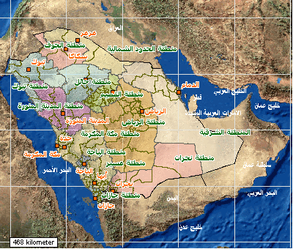

### First Saudi State (1744–1818)

### Second Saudi State (1824–1891)

1. **1900 and after:**
2. **Third Saudi State Declared January 8, 1926 and Recognized: May 20, 1927**
3. **United Kingdom: September 23 , 1932**
4. **Area: 2,250,000 Km2**
5. **Population: 29.994,272**
6. **Nationals : 67.6%**
7. **Expatriates : 32.4%**

**10-Capital: Riyadh**

**Area****occupying four-fifths of the Arabian Peninsula, Saudi Arabia is the largest country on the peninsula.**

**Located in the south-western corner of Asia, Saudi Arabia covers an area of about 2,240,000 square kilometers or 864,900 square miles (estimates vary) of which more than half is desert.**

**The country is bordered by the Red Sea and the Gulf of Aqaba to the west, by the Republic of Yemen and the Sultanate of Oman to the south, the Arabian Gulf, the United Arab Emirates and Qatar to the east, and Jordan, Iraq and Kuwait to the north.**

**The richest oil fields in the world are found in the eastern region.**

**Riyadh, the capital and largest city, is located in the east central region of the country.**

**Jeddah, the second largest city, is the country's main port on the Red Sea.**

**It is also the main port through which pilgrims enter to perform Umrah, Haj, or to visit the holy cities of Mecca and Medina.**

**Saudi Arabia is a monarchy ruled by the Al Saud family.**

**The Al Saud dynasty dates back to the mid-18th century with Mohammed bin Saud, who was the ruler of Diriyyah in central Arabia.**

**The late King Abdul’ Aziz Al Saud founded the modern Saudi state, established 23 September 1932. The written constitution and bill of rights were introduced during the 1982-2005 reign of King Fahd bin Abdul’ Aziz Al Saud. Since August 2005, Saudi Arabia has been ruled by King Abdullah bin Abdul Aziz Al Saud.**

**Oil is the most important industry in Saudi Arabia.**

**The Kingdom has the world's largest proven reserves and is the largest producer in OPEC, totaling one-third of output.**

**Saudi Arabia has the capacity to produce 10 million barrels per day (bpd).**

**Working toward diversifying its economy, the Kingdom is promoting heavy industry, such as petrochemicals, fertilizers, and steel.**

**Traditionally fishing and agriculture were sources of revenue for the Kingdom and today Saudi Arabia is one of the world's leading producers of dates and the fishing industry continues to grow.**

**Kingdom of Bahrain**

1. **Bahrain** get independence from **Portugal 1602,**from **Persia** **1783** ,from **United Kingdom** **December 16,1971**
2. The total area : **765 Km2**
3. Population estimate: **1,343,000.**
4. Nationals: **51.1%.**
5. Expatriates: **48.9 %.**
6. Capital: **Manama**

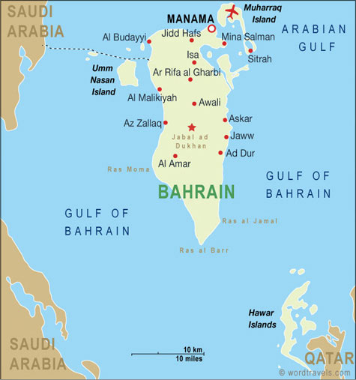

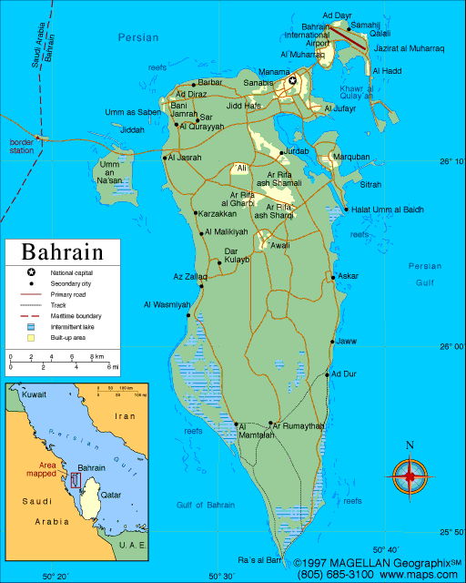

**An archipelago of thirty-three islands, the largest island, Bahrain (from the Arabic word for "two seas"), is believed to have separated from the Arabian Peninsula around 6000 BC.**

**Located in the Arabian Gulf, the islands are about twenty-four kilometers from the east coast of Saudi Arabia and twenty-eight kilometers from Qatar.**

**The total area of the islands is about 678 square kilometers or 262 square miles (estimates vary).**

**The capital, Manama, is located on the northeastern tip of the island of Bahrain.**

**The main port, Mina Salman, and the major petroleum refining facilities and commercial centers are also located on the island.**

**Causeways and bridges connect Bahrain to adjacent islands and to the mainland of Saudi Arabia.**

**Al Muharraq, the second largest island, is linked to Bahrain by the oldest causeway, originally constructed in 1929. The country's second largest city, Al Muharraq, and the international airport are located there.**

**Bahrain is an independent state with a traditional monarchy.**

**On 14 February 2002, a new constitution was published and Bahrain declared itself a kingdom.**

**The ruling family of Bahrain, the Al Khalifa, arrived in the islands in the mid-18th century after they first established a settlement in the peninsula of present-day Qatar.**

**Sheikh Hamad bin Isa Al Khalifa is the King, and has ruled Bahrain since 6 March 1999.**

**Sheikh Khalifa bin Salman Al Khalifa is the prime minister.**

**In February 2001, proposals for political reform put forward by the ruling family received almost unanimous support in a national referendum.**

**The proposals are due to come into effect in 2004, and will mean that Bahrain becomes a constitutional monarchy with an elected lower chamber of parliament and an independent judiciary.**

**Oil was discovered in commercial quantities in Bahrain in June 1932.**

**The first Gulf state to discover oil, it was also the first to reap the benefits that came with the revenues, in particular a marked improvement in the quality of education and health care.**

**By Gulf standards, Bahrain’s oil reserves are quite small. To decrease its reliance on oil revenues, the government is striving to diversify Bahrain’s economy by attracting more commercial companies, particularly in the IT field.**

**Kuwait**

1. First settlement 1613
2. Bani Utbah tribe foundation 1705
3. Anglo-ottoman Convention 1913
4. Independence from the United kingdom 19 June 1961
5. Area : **17.820 Km2**
6. Population : **4,044,500**
7. Nationals : **31.5%**
8. Expatriates : **68.9%**
9. Capital: **Kuwait City**

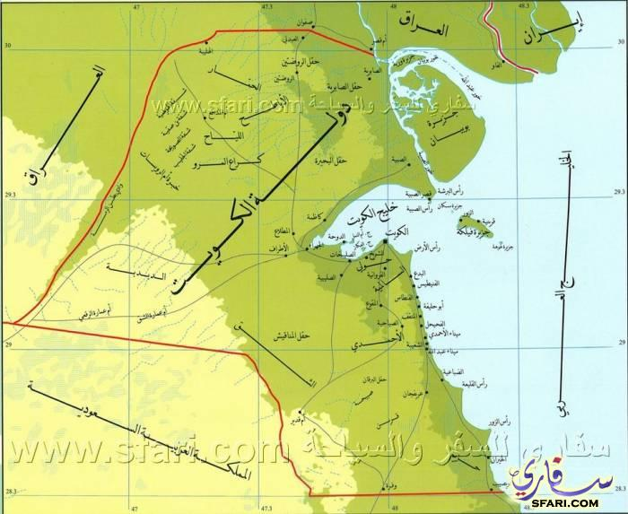

**Kuwait is located in the northeastern corner of the Arabian Peninsula.**

**Bordered by Iraq on the north, northwest and by Saudi Arabia on the south, southwest, it fronts the Arabian Gulf to the east.**

**A small state of 17,818 square kilometers (6,880 square miles), Kuwait includes nine gulf islands within its territory.**

**In addition to being the country's capital and center for trade and commerce, Kuwait City is an important port for oil and the production of petroleum products.**

**The nearby city of Al Jahrah is the center of the country's agricultural industry, which primarily produces fruits and vegetables.**

**A prominent geographic feature is Kuwait Bay, which extends for 48 kilometers (30 miles) inland.**

**Kuwait is a constitutional monarchy governed by the Al Sabah family, the ruling family since 1756.**

**The constitution, which was approved on 11 November 1962, authorizes the Al Sabah family council to select the emir, traditionally from the Al Sabah line.**

**Sheikh Sabah Al Ahmed Al Jaber Al Sabah is the current Emir of Kuwait. Crude oil and refined products account for most of the country's exports.**

**The reserves of crude oil are estimated to be 10% of the world total, the third largest quantity in the world.**

**Kuwait's other main industries include desalination, food processing, and the manufacturing of building materials, which include plastics, cement, and metal pipes.**

**State of Qatar**

1. Current ruling family came to power December 18,1878
2. Termination of special treaty with the United Kingdom September 3, 1971
3. Area: **11,437 Km2**
4. Population: **2,155,446**
5. Nationals : **14,3%**
6. Expatriates : **85,7%**
7. Capital: **Doha**

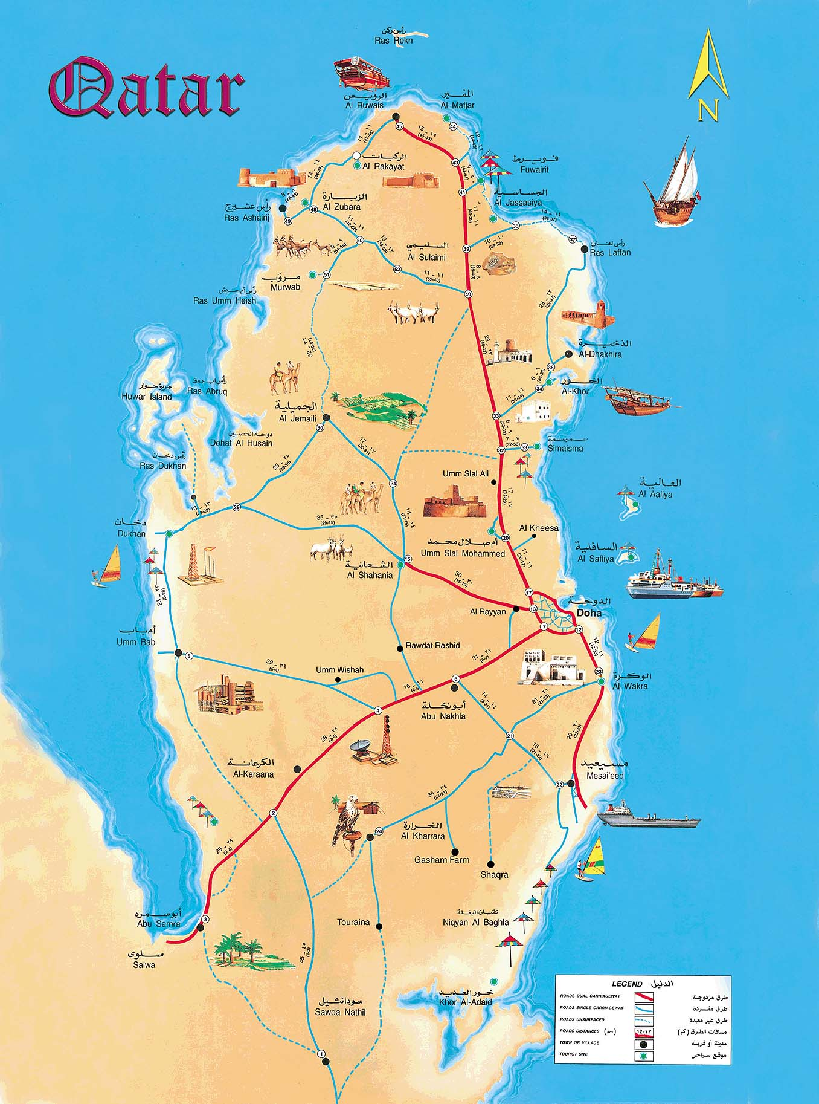

**Qatar occupies a peninsula, which extends northward for about 180 kilometers (100 miles) into the Arabian Gulf from the Arabian Peninsula.**

**The country is bordered to the south by Saudi Arabia for a stretch of 56 kilometers or 35 miles.**

**The total area of Qatar is 11,437 square kilometers or 4,260 square miles. Doha, the capital city, is located on the east coast.  
A traditional monarchy, the State of Qatar is ruled by the Al Thani family.**

**The Al Thani family arrived in Qatar in the early part of the 18th century, originally settling in the northern region of the country, and moving to Doha in the mid-19th century.**

**Sheikh Tamim Hamad bin Khalifa Al Thani has been emir since early 2013 .**

**In 1999 the country's first elections were held, to elect a 29-member municipal council.**

**Women were allowed to vote and stand for office in this election.  
The State of Qatar produces less than 1% of the world's oil output. Crude oil and liquefied natural gas account for about 80% of the country's exports.**

**The banking sector also plays an important role in Qatar's economy.**

**Sultanate of Oman**

1. Constitution: **1966**
2. Area : **309,550 Km2**
3. Population : **4,055,418**
4. Nationals : **56.6 %**
5. Expatriates : **43.4%**
6. Capital: **Muscat**

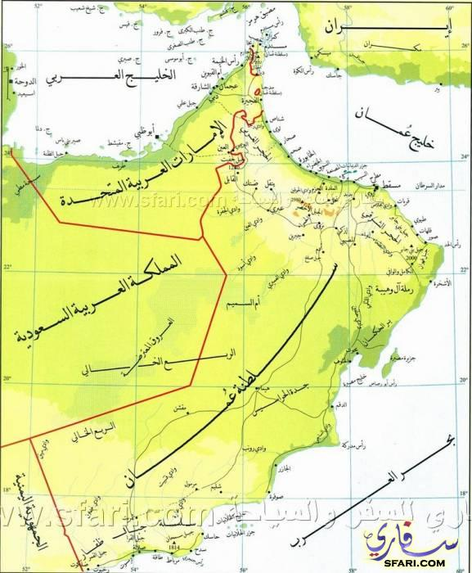

**Occupying the southeastern coast of the Arabian Peninsula, the Sultanate of Oman covers an area of about 212,457 square kilometers (82,030 square miles); however, estimates do vary considerably.**

**Oman proper is bordered by Yemen to the southwest, Saudi Arabia to the west, the United Arab Emirates to the northwest, the Gulf of Oman to the north, and by the Arabian Sea to the east and south.**

**Included in its territory is Ruus al Jibal ("The Mountaintops"), which is located on the northern tip of the Musandam Peninsula (Ras Musandam).**

**It borders the Strait of Hormuz, which is a waterway linking the Gulf of Oman with the Arabian Gulf, and separated from the rest of Oman by a strip of territory belonging to the United Arab Emirates.**

**Thanks to its location at the mouth of the Gulf, Oman has long been seen as strategically important.**

**At one time, its territory stretched down the East African coast and it competed against Portugal and Britain for influence in the Gulf.**

**Muscat, the capital of Oman since 1741, is located on the Gulf of Oman coast.**

**The country was known as Muscat and Oman until 1970.**

**Oman is a monarchy.**

**The ruling family, the Al Said, first came to rule in 1744 after the expulsion of the Iranians from Muscat.**

**Sultan Qaboos bin Said Al Said has ruled since 1970.**

**The sultan also holds the posts of prime minister, minister of defiance, minister of foreign affairs, and minister of finance.**

**There is a Council of State for consultation purposes.   
Oman’s principal natural resources are petroleum and natural gas.**

**The proved petroleum reserves (4 billion barrels) are not substantial, and the government is aiming to transform Oman into a major natural gas exporter.**

**Manufacturing is growing in importance.**

**Major products include textiles, cement blocks, furniture, fertilizers, and fiberglass products.**