**Class experiment details for Research Report Part 1**

**Information for your introduction section:**

**Original Research Question**: Do people respond differently to correction of positive and negative misinformation, and does belief in misinformation differ by correction type?

**Literature:** Here are some suggestions of the kinds of articles you might want to use in your introduction (you can find more in our library database and in the reference lists of these articles). Make sure you read and appropriately cite all your sources.

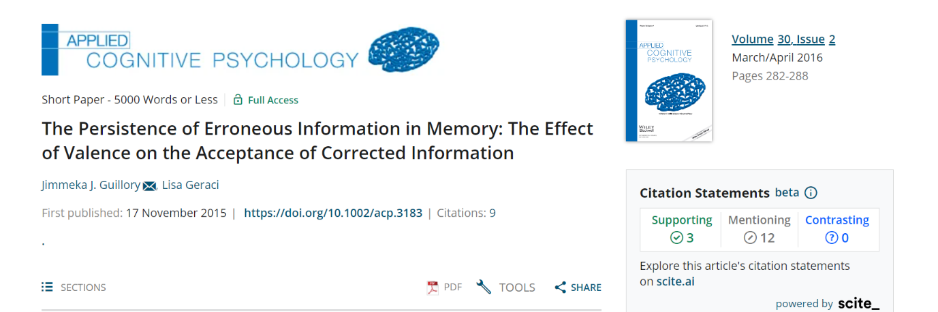

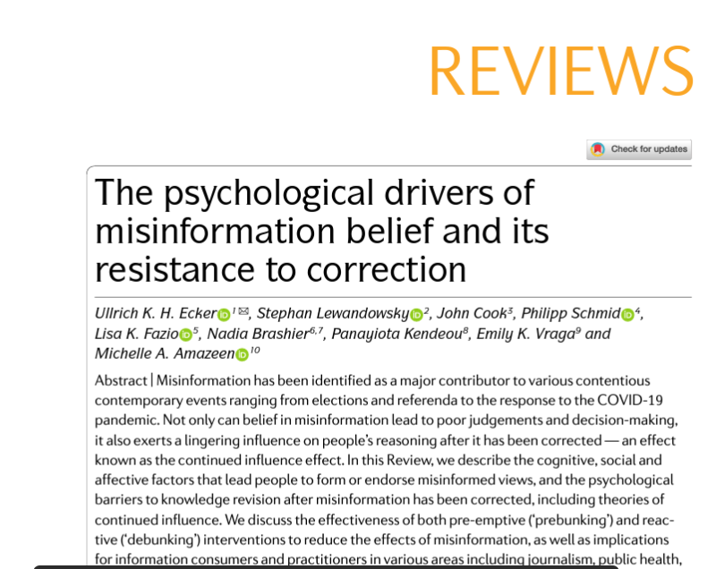

**Hypotheses:** What your hypotheses are will depend on the background literature you include. Some ideas from our class discussion that you may use, or you can come up with your own:

* Negative information is typically remembered better than positive information and may therefore be more difficult to correct.
* Social correction may be more effective than algorithmic correction, especially for negative misinformation.

**Predictions:** For you to develop based on what hypotheses you propose. We recommend you write an if...then... statement for each prediction you are making based on a hypothesis.

**Information for your method section:**

**Design:**

* 1st IV: Correction
  + 3 levels (none, algorithmic, social)
  + Between-subjects
* 2nd IV: Valence
  + 2 levels (positive, negative)
  + within-subjects
* DV Misinformation belief
  + Continuous measure, on a 6-point rating scale

**Participants:**

* Will recruit at least 200 participants who provide informed consent
* 1st year psychology students enrolled in PSYC122
* Participating for course credits
* We will collect the following demographic information: age, gender, ethnicity, how many hours a week they spend on social media platforms (Facebook, Twitter, Instagram, Tiktok, Reddit).
* Exclude data from participants who:
  + Are current PSYC242 students
  + Did not answer the misinformation questions
  + Had a reading time of the news posts that was 3 standard deviations faster than the mean
* This study has been approved by the Human Ethics Committee at Victoria University of Wellington (RM29866).

**Materials:**

* News posts
  + 4 pages of twitter news posts in total that will be generated by the researchers (each post will have post author + text + image)
  + The 1st and 4th pages are true news unrelated to conservation or environmental issues and verified to be true using Reuters Fact Check and Snopes.
  + The 2nd and 3rd pages are positive and negative misinformation posts about conservation or environmental issues that will appear in counterbalanced order.
    - Two sets of positive and negative news. Participants will be randomly assigned to only one of these sets. 1st set is positive news about sea levels and negative news about status of an animal species. 2nd set is positive news about status of an animal species and negative news about sea levels.
    - News posts will be pre-tested by the researchers for valence (positive/negative) and verified to be misinformation using Reuters Fact Check and Snopes.
    - 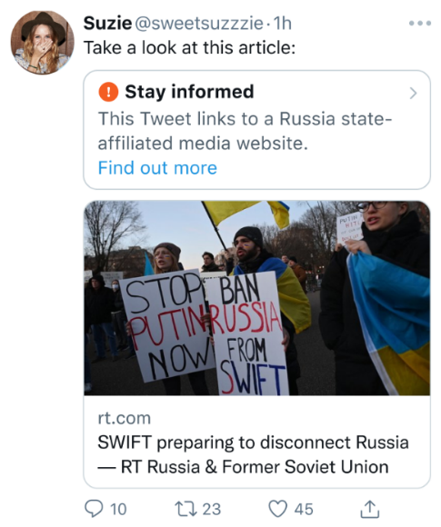Each post will be framed as a retweet depending on the correction condition:
      * Retweet by another user without any additional text (none)
      * Retweet by another user identifying the news as false that cites a source (social)
      * Retweet by another user with an algorithmic correction that cites a source (algorithmic)

*Note*: this image is for example purposes only. Once we have created our own tweets, we will share them with you. You don’t have to include the image in your Materials section.

* Misinformation belief scale
  + Created by us to measure belief.
  + 6-point scale ranging from 1 (Definitely False) to 6 (Definitely True)
  + For each news post, participants will be instructed to indicate the extent to which they think this post is true or false. We will measure belief for the misinformation posts, as well as some of the true news posts.
  + Sample question:

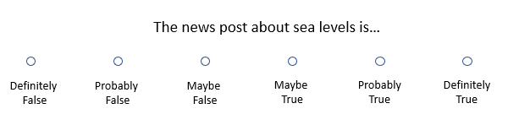

**Procedure:**

1. Study posted through an online participant sign-up system
   1. Participants can complete it in their own time
   2. Study will take approximately 30 minutes
2. Informed consent.
3. Demographic information questions.
4. Instructions
   1. Read the next few pages of Twitter new posts. You will be asked questions about the content of these posts later. Press the “Next” button when ready to progress to the next page.
5. Twitter feed.
6. Misinformation belief questions.
7. Debriefed and shown whether the news items were true or false.