Título da Reflexão Critica

Gestão Estratégica de Aeroportos

Dylan van Haasen #20220121

**Queretaro Airport Business model. Proposal to update the Airport Master Plan**

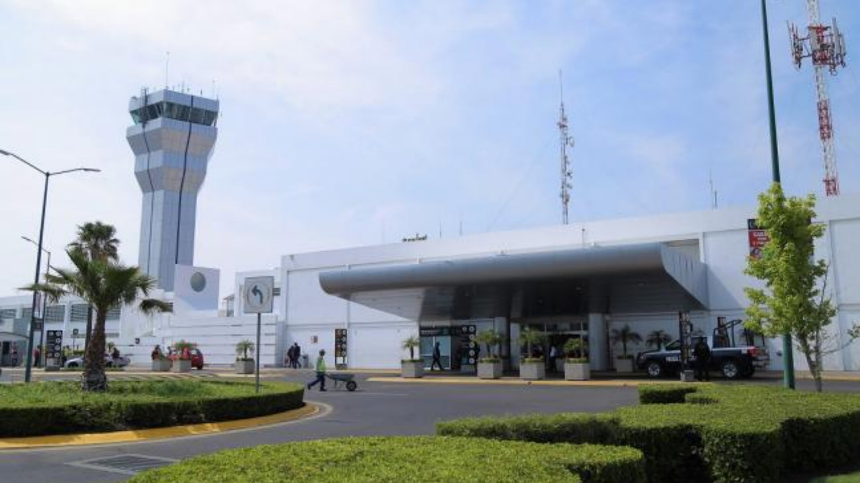

Contents

**Introduction** 3

**Analysis** 4

**The Airport Master Planning** 4

**Writer’s Approach** 4

**Problemization** 5

**Passenger and Traffic Load Peaks** 5

**Demand for LLC** 5

**Argumentation** 5

**Conclusion and Recommendations** 6

**References** 6

**Critique Writing**

# **Introduction**

The research paper selected for analysis and critical review is the **Queretaro Airport Business model. Proposal to update the Airport Master Plan.** The aviation industry has been developing globally and this growth has helped economies to grow and become more stable. The doors for a large number of aviation as well as non-aviation businesses have opened. Liberalization, globalization, digitalization, and globalization are the primary factors that led to expansion in the aviation industry and caused revolutionary changes to the industry. This report is structured to highlight the business model of the airport and how it can help in achieving the strategic vision for 2040-2050 (Zuniga and Boosten, 2021).

Airport master planning is a technique that is utilized to help airports become capable enough by aligning the competencies of the specific airport with the future need of the aviation industry. It is the structured planning between the capacity of the airport and efficient resource planning. This report has been written and divided into three main sections. In the first part of this report, a brief and general understanding of Airport Master Planning (AMP) has been explained. The section gives the reader a deep understanding of what exactly this plan is and what are its characteristics. The second section provides an overview of the methodology being proposed and an analysis of this methodology is presented. The phases of this methodology are described thoroughly and the third section of this report discusses the implementation of the airport master planning at the Queretaro airport. This part also analyses the benefits of this methodology and the impacts this methodology has posed on the airport (Zuniga and Boosten, 2021). A conclusion and recommendation for the entire methodology and its implementation have been provided at the end of this report.

# **Analysis**

The report analysed is a well-structured study that first highlights the growth of the aviation industry in Europe, then presents an introduction to the airport planning methodology and its strategic planning, in the next step writer’s approach toward the airport planning methodology and all the phases from the writer’s perspective are briefly described (Zuniga and Boosten, 2021). In the final step, the Queretaro airport activity and its region are analysed and assessed in the light of Airport Master Planning (AMP).

## **The Airport Master Planning**

The primary concept being discussed in this study is Airport Terminal Planning. Airport Master Planning (AMP) which consolidate an organized air terminal improvement plan in light of strong traffic figures, with a decent plan between air terminal (airside and landside) and airspace limit; consistency with (worldwide) guidelines and systems; alleviating natural effect and ruin; and firmly supporting the local qualities, financial, social or potentially social characteristics of the district as well as country to guarantee that the air terminal will go about as a driver of provincial and national development (Zuniga and Boosten, 2021).

The vital and practical development of airports has drawn more consideration throughout the past long time due to the innate need for change in the normal act of air terminal turn of events. It has been featured that AMP ought to be created under a comprehensive methodology, where coordinated and cooperative improvements are depicted embracing adaptability and obliging powerful systems utilizing a hierarchy as opposed to base-up improvement technique (Zuniga and Boosten, 2021).

Normally AMP-procedures centre around estimating air terminal limits and the plan of air terminal offices expected to satisfy future limit needs.

## **Writer’s Approach**

The other important aspect discussed in this study is the writer’s approach toward the Airport Master Plan (AMP). The methodology proposed in this paper is a six-step methodology i.e. diagnosis, analysis, business model strategy, planning, and feasibility. Identification of social and economic factors is the starting point of this methodology and there is an analysis of how cultural development activities support these drivers.

The diagnosis stage comprises characterizing the provincial attributes and qualities fundamentally by two methods; an investigation of provincial measurements of authentic information and patterns on the monetary segment, and (air) travel improvements; furthermore, the besides, through a progression of meetings with neighbourhood specialists, driving business and social gatherings.

Socially, culturally, and economically linked to the activity base, traffic forecast is diversified per target group within the region. Traffic development (i.e. cargo and passenger) and its real drivers are understood and preconditions are required for realizing the region’s traffic potential, societal factors are also recognized as pre-conditions. These include the environment, quality of life, and climate change (Zuniga and Boosten, 2021).

# **Problematization**

The questions that are probably to be asked while designing and implementing an Airport Master Planning include:

## **Passenger and Traffic Load Peaks**

Related to these pinnacles are a lot of travellers being moved to and from the centre point air terminal. In this unique situation, travellers as well as carriers request explicit foundation prerequisites, for example, a tough runway framework and a huge entry and exit limit from one viewpoint and then again sufficient room and dealing with components in the flight zones. Because of the pinnacle structure, the issue emerges that those regions are not adequately utilized during certain periods over the course of the day, which expands the typical expense of activity for these areas (Zuniga and Boosten, 2021).

## **Demand for LLC**

One more test for the preparation of future traveller terminals is the rise of LLC and their assumptions from a terminal:

Right off the bat, LCC attempt to work from territorial air terminals, in this manner staying away from primary centre point air terminals, which are portrayed by high traffic volumes and frequently by postponements and clogs. Through these, it is generally unrealistic for LCCs to guarantee the short times required to circle back which are anyway fundamental for them to keep efficiency at a significant level.

# **Argumentation**

However, the study has succeeded in answering the above problems and questions:

As shown toward the start, the avionics business had seen significant development, however is simultaneously not so steady as in the past. This suggests that the entire avionics industry requirements to turn out to be more adaptable for having the option to acclimate to changing circumstances rapidly. While taking a gander at the airport structure a few distinct methods of adaptability can be recognized:

**Circulation of room inside the terminal structure:** Despite the fact that the aggregate sum of room required in a terminal is just changing gradually over the long haul, the capabilities in the terminal and the connected space should be adjusted exceptionally quickly. Consequently, the air terminal design can be recognized into present moment and long haul evolving components. The first contains for instance relax, registration offices, security frameworks or retail space, the last option for instance, the stuff taking care of framework and building administrations. Most significant in this manner is to keep the functional adaptability of transient components as high as feasible for having the option to conform to the changing cycles inside the terminal rapidly (Zuniga and Boosten, 2021).

**Serious level of versatility:** Despite the fact that how much travellers are expanding just progressively, an air terminal structure ought to take into consideration a specific level of versatility, consequently empowering the air terminal to stepwise make greater limit before it arrives at the stage where an entirely different structure should be constructed. A specific level of extendibility is in this way as significant as the referenced functional adaptability.

**Different assistance and cost ideas:** To adapt to expanding contest between air terminals, adaptability ought to try and reach to the degree, where different carrier types with changing prerequisites can utilize the air terminal together and ought to currently be remembered when an air terminal is recently developed. The joint utilization of a similar terminal inside an air terminal is these days restricted since, at a customary centre air terminal, administrations and the connected charges are excessively high for LCC to work there. Since an air terminal, because of carrier instability ought to anyway not to rely upon just a single carrier type, offering different help and value concepts would be significant. This would suggest that another air terminal would be isolated into two sections - one simple less expensive terminal structure for LCC and one structure with great and more space per traveller for inheritance transporters (Zuniga and Boosten, 2021).

# **Conclusion and Recommendations**

The analysed study has aimed to establish a relationship between aeronautical and non-aeronautical demands and economic and social conditions. The report also studies the impact of these developments on the economy and industry. The report has successfully analysed the import and export movement across the country and has proposed a merger of new niches at AIQ.

The AMP approach should be designed such that it engages the community, helps in the collection and analysis of relevant data, is narrowed down to better and preferable options, and should be capable enough to design a strategy to move forward.

# **References**

Zuniga, C. and Boosten, G., 2021. Queretaro Airport Business model. Proposal to update the Airport Master Plan. *Transportation Research Procedia*, *56*, pp.10-18.