**Skin Care Products Market Manufacturers Data, Opportunity, Import Export Scenario, Application and Forecast 2023-2032**

PRESS RELEASE

Published October 10, 2023

[**CDN Newswire**](https://www.digitaljournal.com/pr/news/cdn-newswire/index.html)

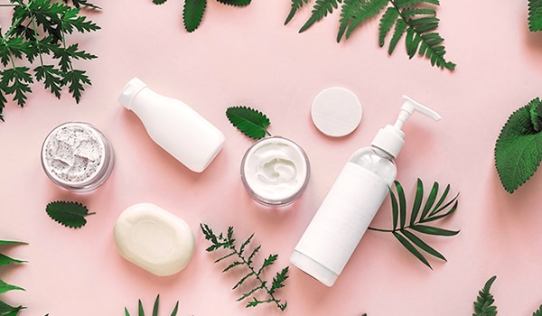

**Fior Markets** has rolled out a new report titled [**Global Skin Care Products Market**](https://www.fiormarkets.com/report/skin-care-products-market-by-ingredient-chemical-and-419898.html) aims to present an entire summary of the market where every detail associated with the market has been mentioned. The report is integrated with crucial insights on the market that will help both existing and new aspirants for global Skin Care Products to figure out and study market needs, market size, and competition. The report encompasses all the factors including growth benefits, product sales, customer demands, various applications, and entire market segmentation detailed out in an understandable format. The study guides readers in encountering the obstacles surrounding the market.

**The skin care products market is expected to grow USD 141.47 billion in 2021 to USD 204.91 billion by 2029, at a CAGR of 4.74% during the forecast period 2022-2029.**

**Market Structure Demonstrated In The Report:**

Then the report pays attention to an in-depth competitive landscape, defined growth opportunities, market share coupled with product type and applications, key companies responsible for the production. The report describes the global Skin Care Products market division based on various parameters and attributes that are based on geographical distribution, product types, and applications. The client requirements are ensured with a thorough understanding of market capacities in the real-time scenario. Industry experts and research analysts have worked extensively to prepare the research report which will explain the competitive landscape within the market.

**[PDF Brochure] Request for Sample Report:**[**https://www.fiormarkets.com/report-detail/419898/request-sample**](https://www.fiormarkets.com/report-detail/419898/request-sample)

Top key players of the market:

Beiersdorf AG, Shiseido Co., Ltd., L’Oreal S.A, Johnson & Johnson Services, Inc., Procter & Gamble (P&G), Avon Products, Inc., Colgate-Palmolive Company, Unilever, Revlon, and Coty Inc., and among others.

On the basis of product, this report displays the sales volume, revenue (Million USD), product price, market share, and growth rate of each type, primarily split into:

Global Skin Care Products Market Analysis and Forecast, by Product Type: Body Care, Facial Care, Lip Care

On the basis of the end users/applications, this report focuses on the status and outlook for major applications/end users, sales volume, market share, and growth rate for each application, including:

Global Skin Care Products Market Analysis and Forecast, by Deployment Model: Women, Men

The global Skin Care Products market covers the following geographies:

North America (U.S. , Canada, Mexico), Europe (Germany, France, U.K., Italy, Spain, Rest of the Europe), Asia-Pacific (China, Japan India, Rest of APAC), South America (Brazil and Rest of South America), Middle East and Africa (UAE, South Africa, Rest of MEA).

**Read Full Report with TOC:**[**https://www.fiormarkets.com/report/skin-care-products-market-by-ingredient-chemical-and-419898.html**](https://www.fiormarkets.com/report/skin-care-products-market-by-ingredient-chemical-and-419898.html)

**Key Insights Encompassed In The Market Report:**

* Up-to-date technological advancement in the global Skin Care Products market
* Studying pricing analysis
* An assessment of the achievements made by the players
* Regional development status of the market
* Detailing of the supply-demand chain, market valuation
* A detailed analysis of the drivers and restraints impacting the overall market

The report covers vital details about the market such as application in various sectors, product type bifurcations, supply and demand statistics, and growth factors. The research has evaluated and elucidated the research and development statuses of key companies, their financial outlooks, and their expansion plans for the forecast period from 2023 to 2032. In addition, the report discusses R&D and the demand for new product launches and applications. Global Skin Care Products manufacturing method has been demonstrated with product cost structure, and price structure.

**Pricing Question:**

How have skincare product manufacturers adjusted their pricing strategies to accommodate the increasing demand for premium and luxury skincare products, and what impact has this had on market dynamics and consumer behavior?

**Product Question:**

In response to the growing interest in natural and organic skincare products, how are companies formulating and marketing their products to meet these preferences, and what strategies are they using to communicate the authenticity and effectiveness of their natural ingredients to consumers?