|  |
| --- |
| **Our shared purpose** |
|  |

Lack of stimulation for long term patients – how to stop problem? provide daily activities that improve psychological aspects of their daily lives

|  |
| --- |
| **Leadership by all** |
| Leadership styles & approaches  Delegation |

|  |
| --- |
| **Spread and adoption** |
|  |

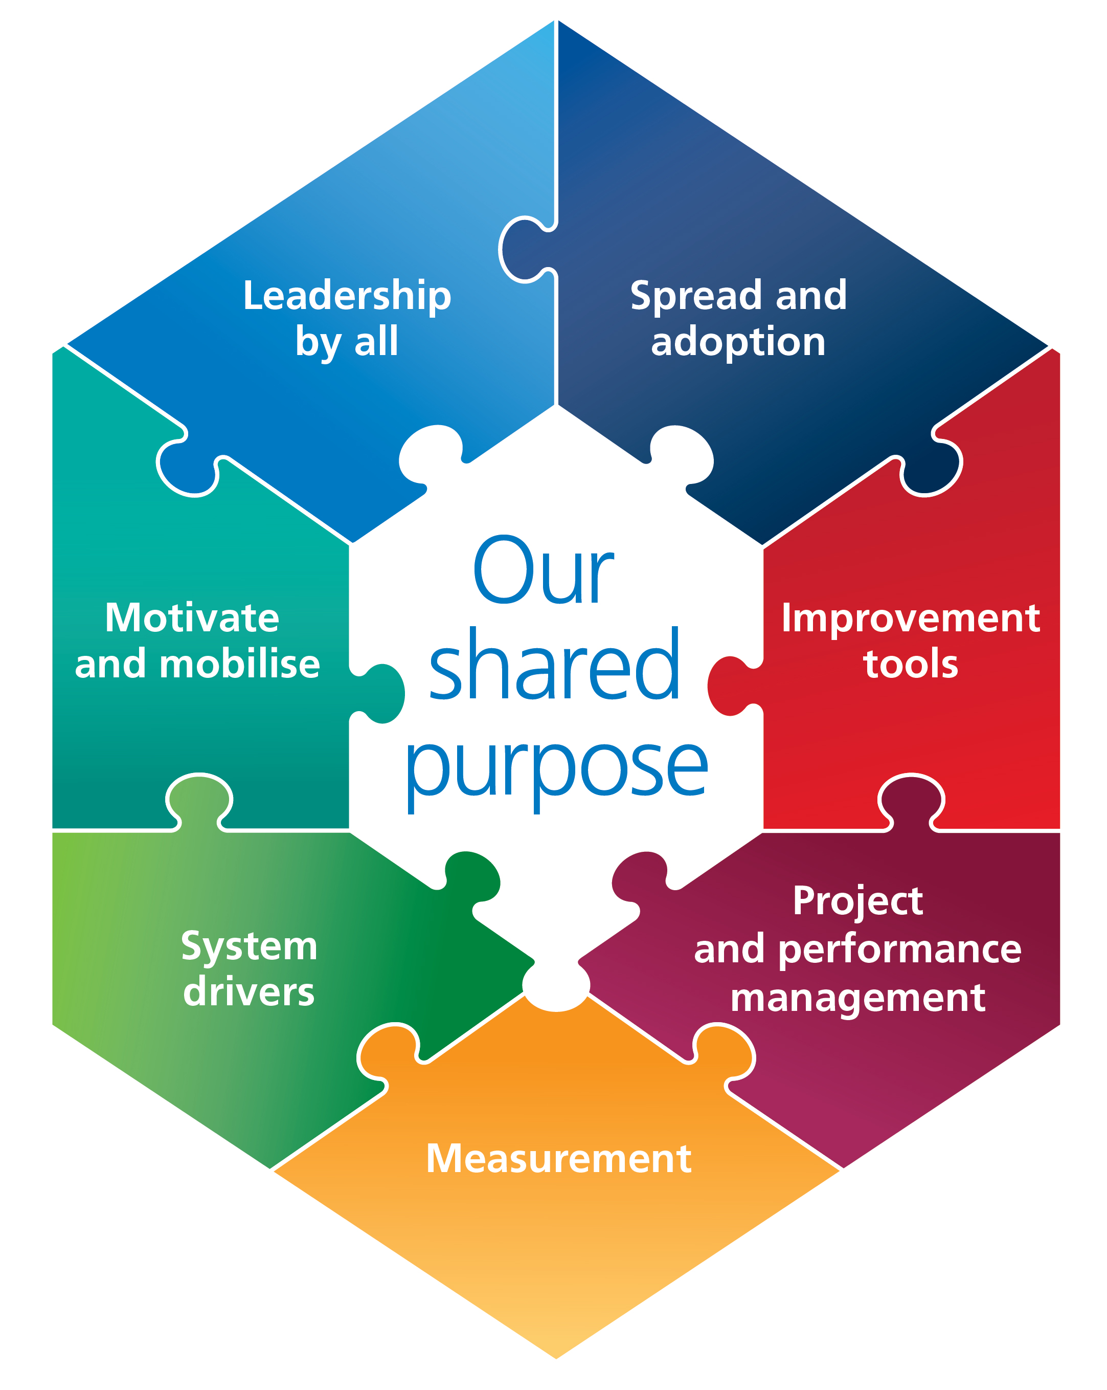

|  |
| --- |
| **Motivate and mobilise** |
|  |

|  |
| --- |
| **Measurement** |
| Nursing feedback  Pt and families feedback |

|  |
| --- |
| **Improvement tools** |
|  |

|  |
| --- |
| **System Drivers** |
|  |

|  |
| --- |
| **Project and performance management** |
| Conflict management |